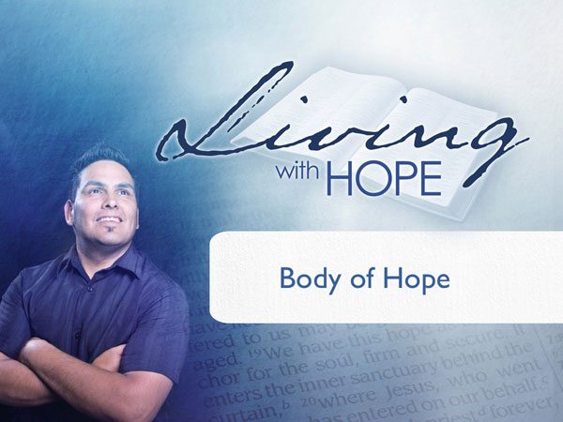
Living With Hope
Presentation 8: Spiritual Gifts
Body of Hope
Last Revision: 6/12/2009

(Note: icon means “Next Slide,” indicating when to advance to the next slide.)

How would you like to be remembered?
Several years ago, two students graduated from the Chicago-Kent College of Law. The highest ranking student in the class was a blind man named Overton and, when he received his honor, he insisted that half the credit should go to his friend, Kaspryzak. They had met one another in school when the armless Mr. Kaspryzak had guided the blind Mr. Overton down a flight of stairs.

This acquaintance ripened into friendship and a beautiful example of interdependence. The blind man carried the books, which the armless man read aloud in their common study, and thus the individual deficiency of each was compensated for by the other. After their graduation, they planned to practice law together.

Does God have a special place for you? Yes, He does. It may not be quite as unique as the partnership of Kaspryzak and Overton but God has a significant role for you to play in His overall purpose. Have you found it? Do you know what God has called you to? If your life were to be cut short, how would you be remembered? What would be inscribed on your tombstone? What difference have you made in the world?
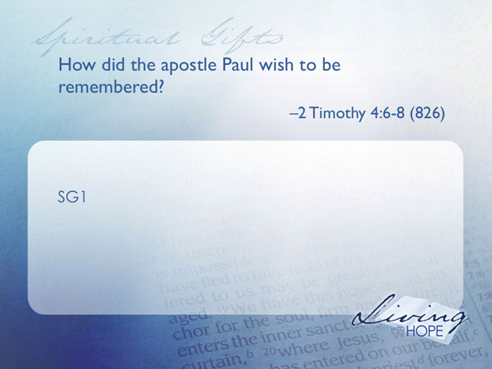
SG1 How did the apostle Paul wish to be remembered? II Timothy 4:6-8 (826)
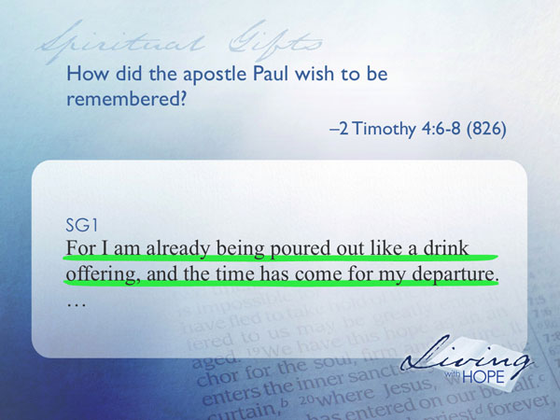
For I am already being poured out like a drink offering, and the time has come for my departure.

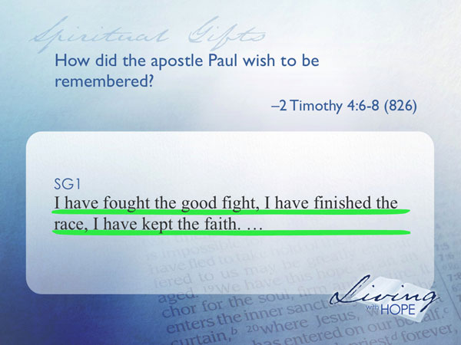
I have fought the good fight, I have finished the race,
I have kept the faith.

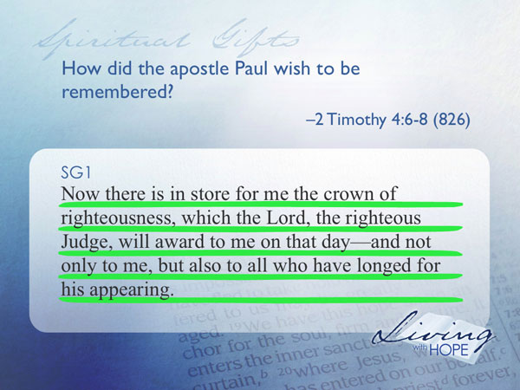
Now there is in store for me the crown of righteousness, which the Lord, the righteous Judge, will award to me on that day—and not only to me, but also to all who have longed for his appearing.

Paul wrote this passage when he knew that his death was impending. He was ready to die because his life was complete. He had found God’s purpose for his life and had lived it out with passion.

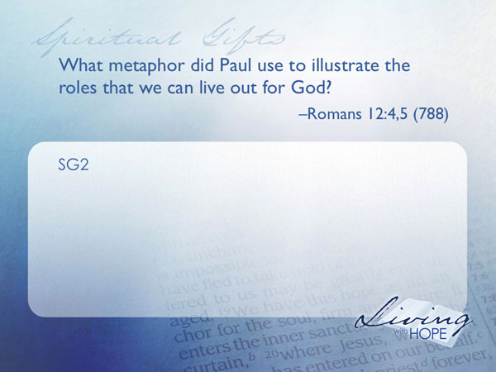
The Body Beautiful
SG2 What metaphor did Paul use to illustrate the roles that we can live out for God? Romans 12:4,5 (788)

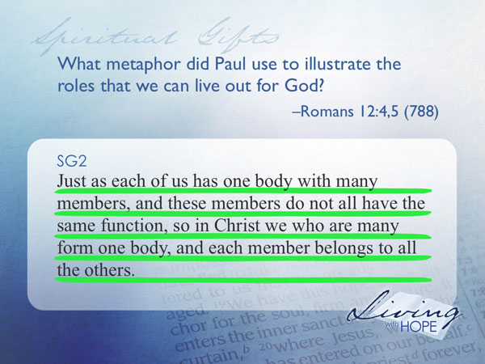
Just as each of us has one body with many members, and these members do not all have the same function, so in Christ we who are many form one body, and each member belongs to all the others.

The human body is made up of many different parts. Each has a unique contributing role to play to enable the body to function. Paul compares a congregation to the human body. Each member of a congregation makes an exceptional contribution to the whole.

Body Discovers its Parts
As a new baby enters the world, all the parts are in place; the brain, the ears, the feet, the lungs. The baby has great potential, yet it takes years for the baby to grow up into a fully functioning adult with all of the parts working together. I find it fascinating to watch an infant begin to discover body parts. Random movements begin to get organized and eye hand coordination begins. Legs go into action and the child learns to crawl and eventually walk. Vocal chords begin to make more coordinated sounds. Words emerge. Sentences develop. And before you know it your kid is all grown up!

The early Christian church was like a brand new baby, unaware that it had different body parts that could work in tandem. In fact the body of the church faced burnout and certain failure. Even though the church was growing the workload on the leaders of the church was too big to handle.
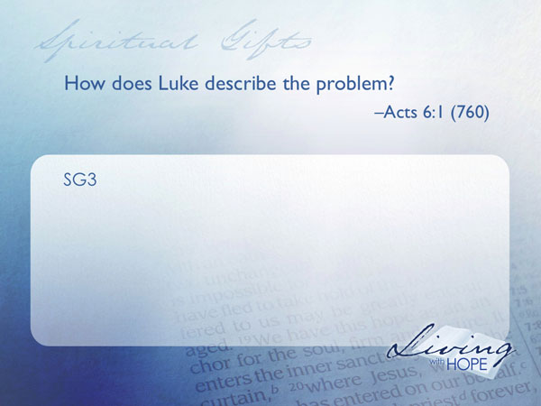
SG3 How does Luke describe the problem? Acts 6:1 (760)

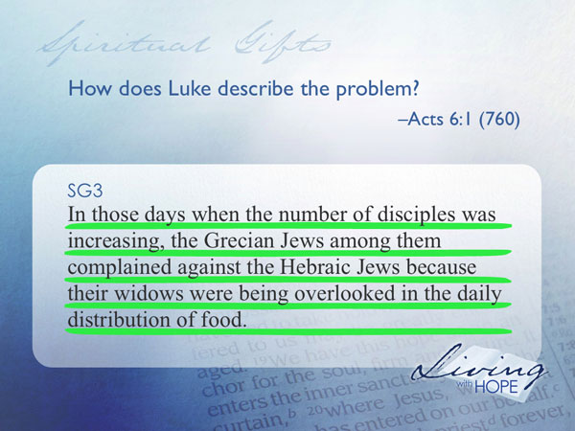
In those days when the number of disciples was increasing, the Grecian Jews among them complained against the Hebraic Jews because their widows were being overlooked in the daily distribution of food.

Apparently the leaders of the group were trying to do everything and weren’t keeping up with the workload so people began to whine.
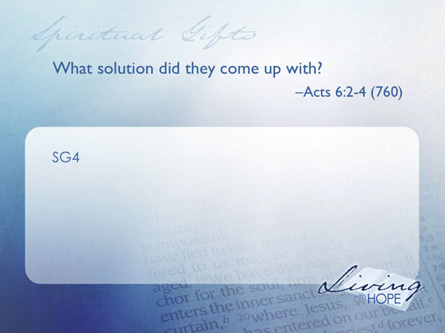
SG4 What solution did they come up with? Acts 6:2-4 (760)

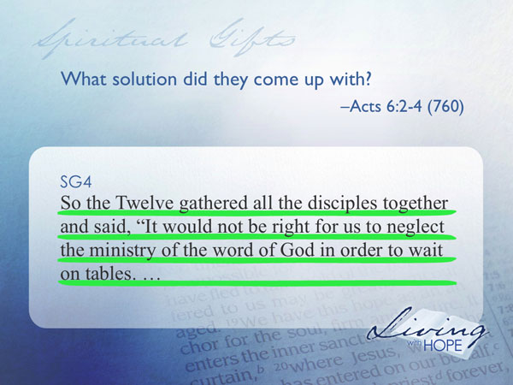
So the Twelve gathered all the disciples together and said, "It would not be right for us to neglect the ministry of the word of God in order to wait on tables.

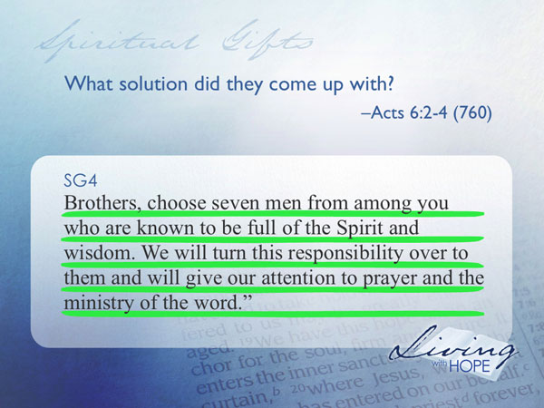
Brothers, choose seven men from among you who are known to be full of the Spirit and wisdom. We will turn this responsibility over to them and will give our attention to prayer and the ministry of the word."


SG5 How was the proposal received? Acts 6:5,6 (760)

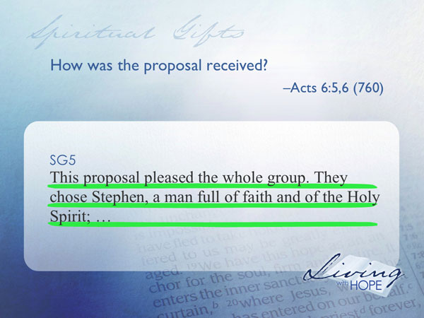
This proposal pleased the whole group. They chose Stephen, a man full of faith and of the Holy Spirit;

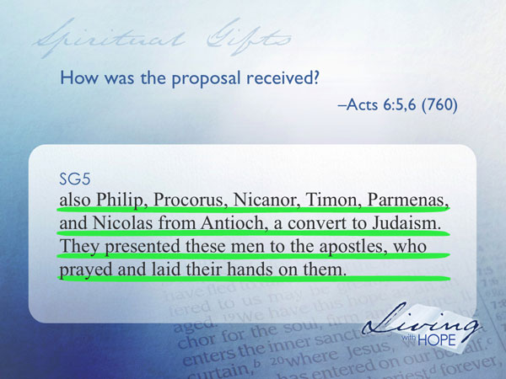
also Philip, Procorus, Nicanor, Timon, Parmenas, and Nicolas from Antioch, a convert to Judaism. They presented these men to the apostles, who prayed and laid their hands on them.
In this story we see the initial discover of specialization in ministry. The role that Philip and his friends played eventually became known as ‘Deacon’. The deacons were able to take care of grunt work of running a church, which allowed the apostles to focus their time on teaching and leading. Disaster was averted and the church was back on track again.
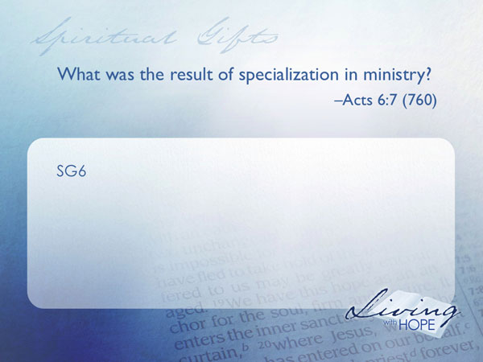
SG6 What was the result of specialization in ministry? Acts 6:7 (760)

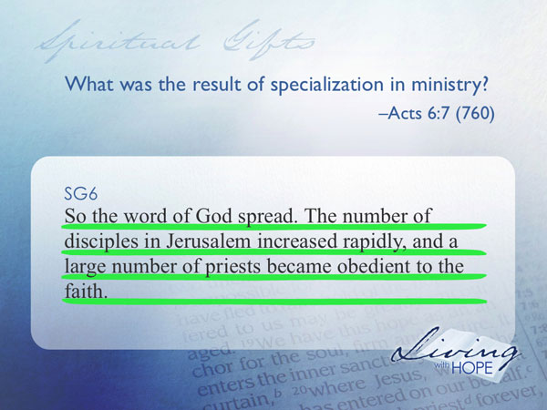
So the word of God spread. The number of disciples in Jerusalem increased rapidly, and a large number of priests became obedient to the faith.
The specialization allowed the church to begin to grow again. Burnout was decreased, and the needs of the congregation were taken care of. As time went on it became clear that there were more roles to play than just the deacon and apostle. That’s when Paul began to use the metaphor of the human body to describe a congregation.

Specialization
After conception a fertilized egg begins to divide into stem cells. These generic cells then begin to specialize into bone cells, muscle cells, nerve cells, and skin cells. Eventually they group together to form organs and limbs—heart, brain, stomach, hands, feet, eyes, ears all with the potential of playing a special function in the human body.

In the same sense, individuals in a congregation play a unique role in their contribution to the church community.
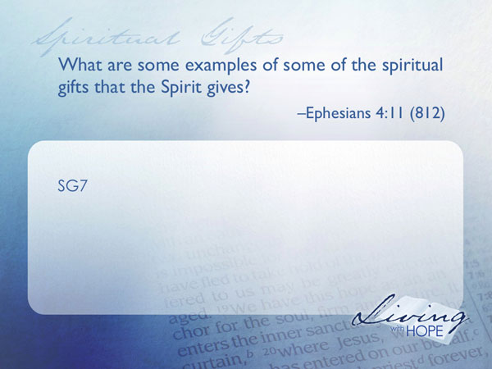
SG7 What are some examples of some of the spiritual gifts that the Spirit gives? Ephesians 4:11 (812)

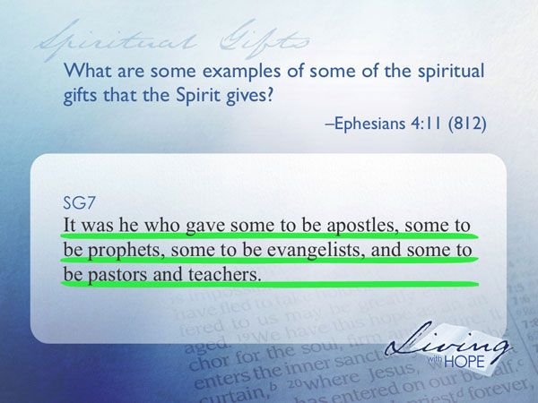
It was he who gave some to be apostles, some to be prophets, some to be evangelists, and some to be pastors and teachers.

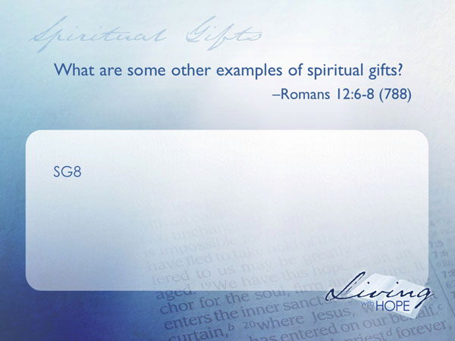
SG8 What are some other examples of spiritual gifts? Romans 12:6-8 (788)

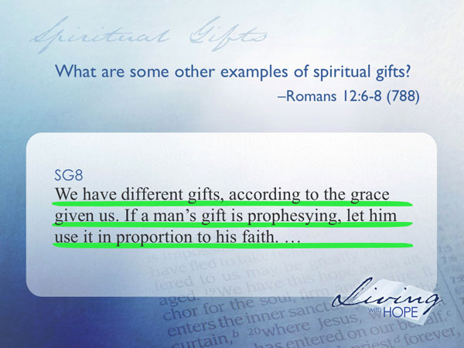
We have different gifts, according to the grace given us. If a man's gift is prophesying, let him use it in proportion to his faith.

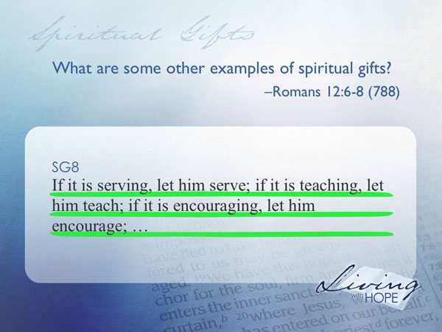
If it is serving, let him serve; if it is teaching, let him teach; if it is encouraging, let him encourage;

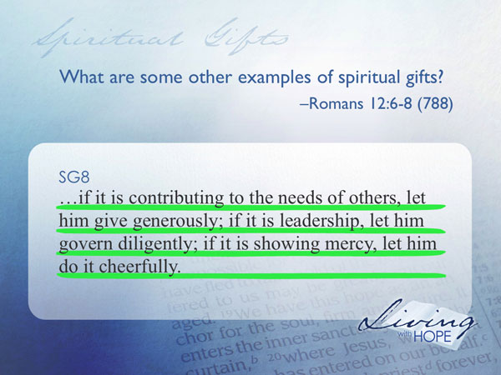
if it is contributing to the needs of others, let him give generously; if it is leadership, let him govern diligently; if it is showing mercy, let him do it cheerfully.
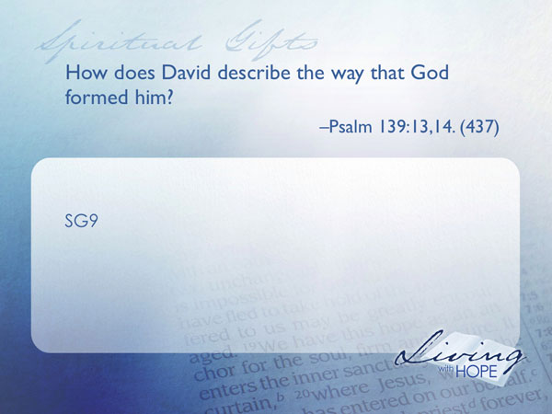
Here we see a vast diversity of spiritual gifts. Just like the parts of the human body, the roles in a congregation are varied. The gift mix that God gives you is unique. No one in the world is wired quite like you. Your personality, your passion, your experience, and your abilities all make you unique. God broke the mold when he made you. You are a complex living, breathing, moving, thinking, feeling, one of a kind piece of artwork fashioned by God.
SG9 How does David describe the way that God formed him? Psalm 139:13,14. (437)

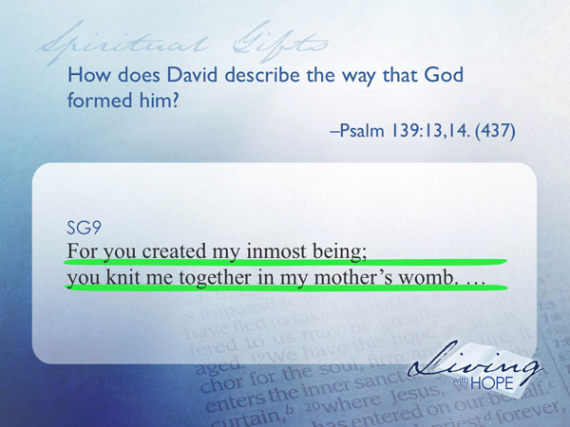
For you created my inmost being;
you knit me together in my mother's womb.

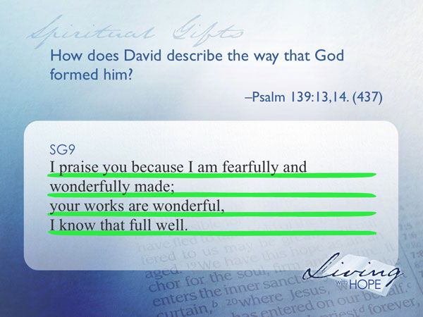
I praise you because I am fearfully and wonderfully made;
your works are wonderful,
I know that full well.
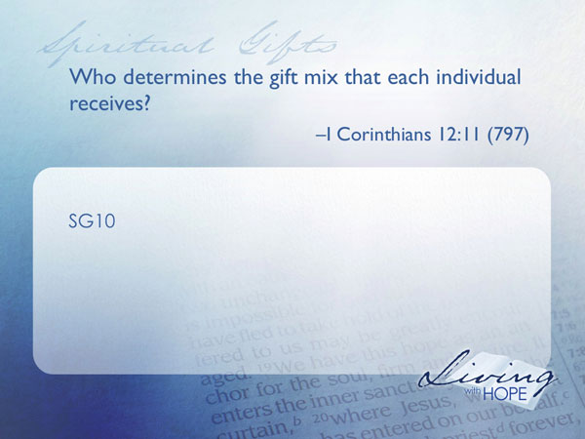
David grasped what scientists are only beginning to understand—the marvelous complexity of your individuality. The average person has from 500-700 different skills and abilities. The likelihood that you would find someone with your same gift mix is 10 to the 2,400,000,000th power.
SG10 Who determines the gift mix that each individual receives? I Corinthians 12:11 (797)

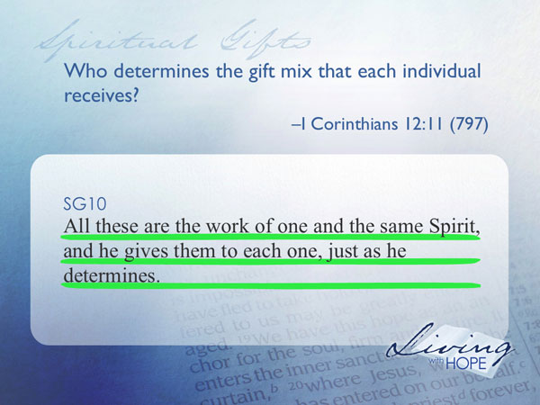
All these are the work of one and the same Spirit, and he gives them to each one, just as he determines.
Just as the stem cells of the body didn’t have much say as to whether they wanted to be a hand or a heart, so you don’t have any say in the way you came out of the womb. Your DNA makes you unique. However it is not random. The Spirit knows just what is needed to propel the kingdom of God forward. He wired you for the unique role that only you can play. Have you discovered your role yet? Do you know how you can make a significant difference in this world?

Parts Discover the Body
As a new baby begins to discover its body parts, the brain begins to coordinate the actions of the arms, legs, hands, fingers, eyes, and all of the active systems. The coordination grows in sophistication. Imagine a toddler sitting in a high chair. Eyes relay to the brain that there is something on the tray. Brain tells eyes to focus on the objects. Eyes focus and give a picture of a bowl of grapes on the tray. Brain calls out to arm, hand, and fingers to grab a grape. Arm moves hand to bowl, fingers grasp grape. Brain tells hand and arm to move grape toward mouth. Brain tells mouth to open. Mouth opens just as hand reaches the opening. Brain tells fingers to release grip. Grape falls into open mouth. Brain tells mouth to chew and swallow. All the body parts worked together. Toddler is happy.

For the toddler, it is the brain that calls all of the body parts into action.
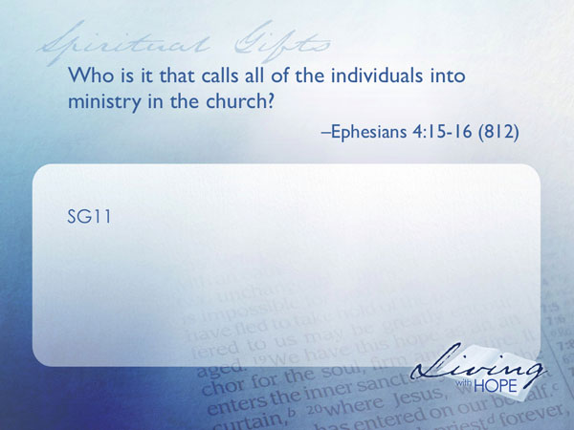
SG11 Who is it that calls all of the individuals into ministry in the church? Ephesians 4:15-16 (812)

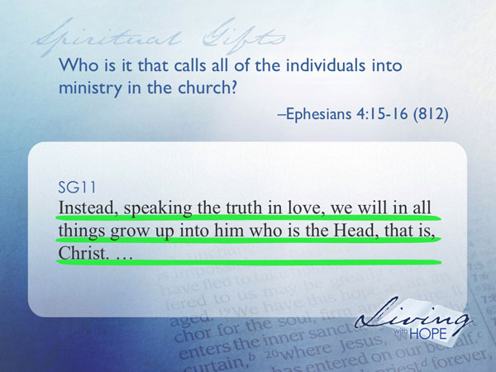
Instead, speaking the truth in love, we will in all things grow up into him who is the Head, that is, Christ.

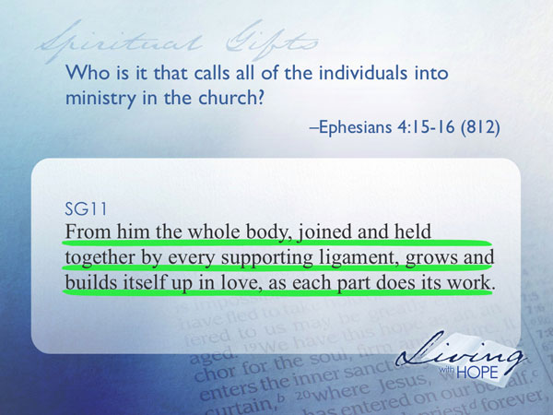
From him the whole body, joined and held together by every supporting ligament, grows and builds itself up in love, as each part does its work.

Jesus is the brain of the church. It is Christ who is calling you as an individual to find your role within the body. When we first join a congregation there is an exciting journey of discovery as we begin to find the role that Jesus designed us for. Like an infant it is a learning process to find our place. To guide us in that journey let’s take a further look at spiritual gifts to find out their purpose, how they interconnect with each other, and how we can find our significance.

The first thing we need to learn is that it’s not about us.

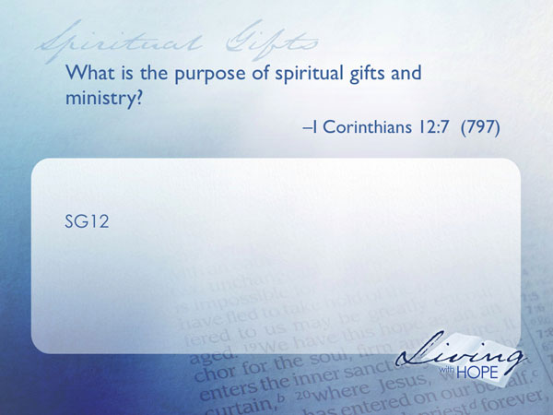
SG12 What is the purpose of spiritual gifts and ministry? I Corinthians 12:7 (797)

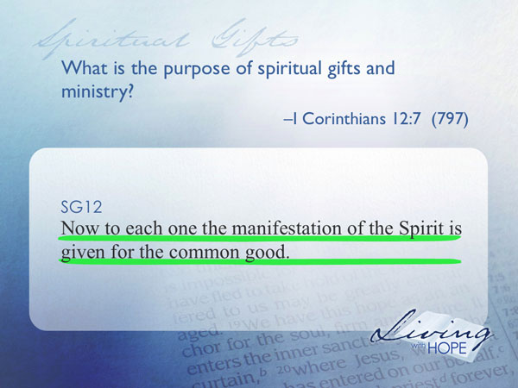

Now to each one the manifestation of the Spirit is given for the common good.

The gifts are not for our benefit. They are for the benefit of everyone. If we keep our gifts to ourselves we will not find significance.
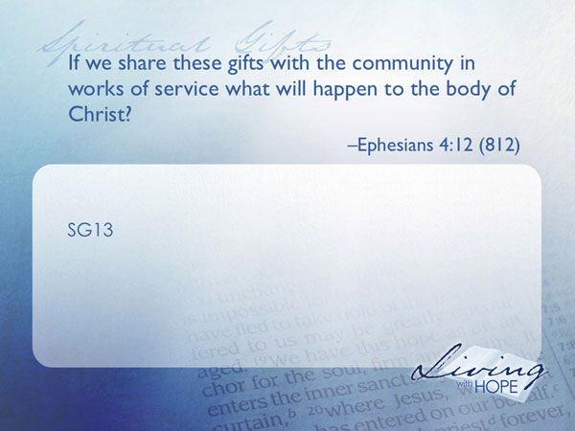
SG13 If we share these gifts with the community in works of service what will happen to the body of Christ? Ephesians 4:12 (812)

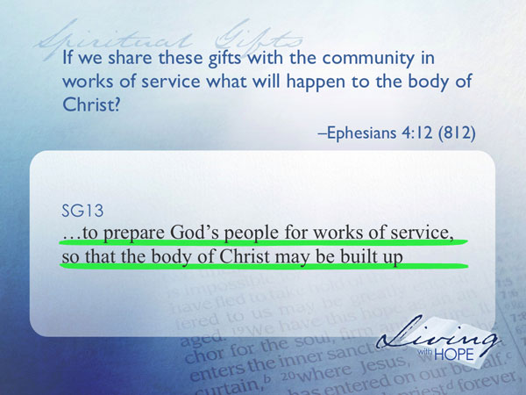
to prepare God's people for works of service, so that the body of Christ may be built up
The purpose of the gifts is to give strength to a congregation. In our world of individualism this is quite counterintuitive. In a narcissistic culture everything in life revolves around self. Not so in the community of Christ. The strength comes in the body. In fact, as individuals we can never reach our potential; only in contributing to the community do we find meaning.
The congregation is incomplete without us, and we are incomplete without the congregation. The teamwork of the members is like the interdependence of human body parts. Every part adds to the strength of the body.

You may be tempted to covet someone else’s ministry. And if you don’t get to play the role that you desire you are inclined to withdraw from the congregation.

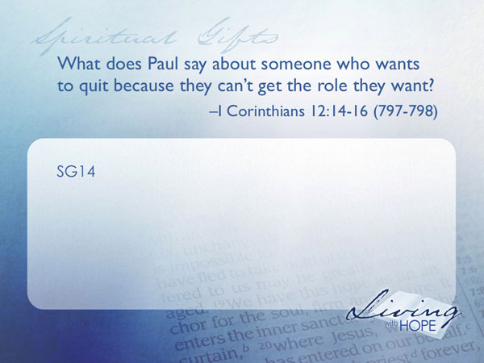
SG14 What does Paul say about someone who wants to quit because they can’t get the role they want? 1 Corinthians 12:14-16 (797-798)

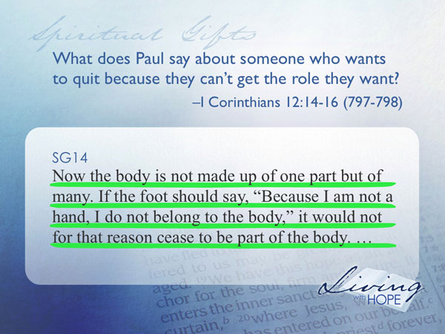
Now the body is not made up of one part but of many. If the foot should say, "Because I am not a hand, I do not belong to the body," it would not for that reason cease to be part of the body.

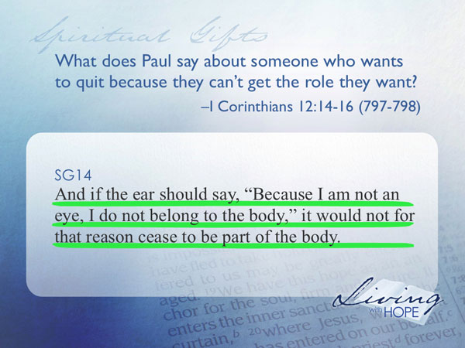
And if the ear should say, "Because I am not an eye, I do not belong to the body," it would not for that reason cease to be part of the body.

If we pull away from the body, that doesn’t mean that we don’t need a body anymore. God shaped us to belong to a congregation; and God put a hole shaped like us in a congregation that only we can fill. There is no reason to be jealous of another person in ministry because we can never fill their role. God has a special role designed just for us.

One of the other challenges of the diversity of gifts is that when you get in your gift zone you begin to excel while others are struggling at the same task. You’re tempted to get a big head and wonder what’s wrong with the other person until you realize that your ability is your unique gift, and the other person has his/her own unique gifts. And how could it be otherwise?

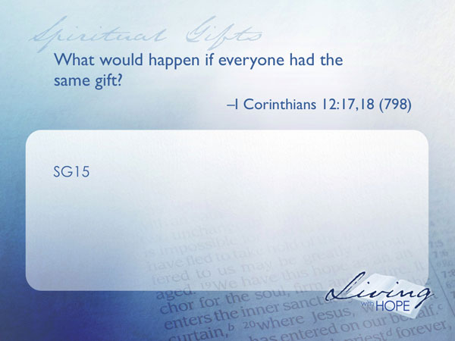
SG15 What would happen if everyone had the same gift? I Corinthians 12:17,18 (798)

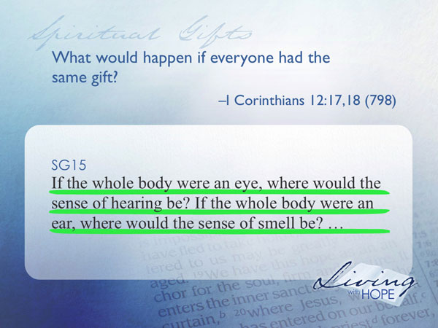
If the whole body were an eye, where would the sense of hearing be? If the whole body were an ear, where would the sense of smell be?

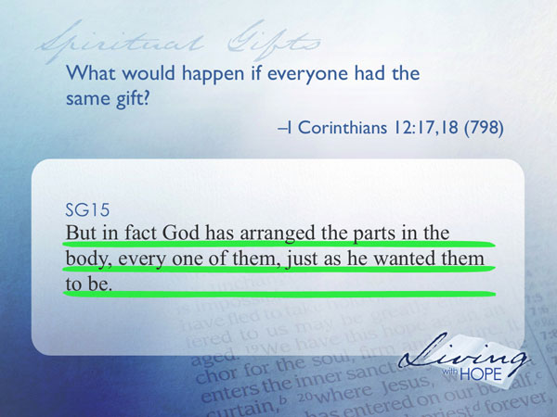
But in fact God has arranged the parts in the body, every one of them, just as he wanted them to be.

How then can we get plugged in? How can we match our unique gift set with ministry opportunities in a congregation? Some have developed simple questionnaires that might give some hints at your interests, aptitudes and giftedness. Another way to discover your niche is to ask people who know you well to give you some feedback as to where you could function best. Small groups are a great way to get to know people and find out how you fit in. Ultimately finding your niche is more of an art than a science.
The very best way to find your niche is simply to give it a try. It is a gift and like any gift, it doesn’t do any good unless the package is opened.

Talk to your small group leader or ministry placement specialist. Find out what opportunities are available and then just do it! You’ll find out right away whether it’s a good fit or not. If it doesn’t fit, try something else until you find that sweet spot of joy that comes only when you are functioning at your optimum. You’ll know it when it comes because time will fly by. You’ll receive confirmation from honest people, and you will realize that God is allowing you to make a significant difference in this world.

Just Do It
Jesus tells a parable about some guys who were given some money to invest. Each received a different amount. When the boss came back he checked in with his servants to see what they did with his money. The first two guys doubled the boss’s money, but the third guy simply buried the money because he didn’t want to lose it.
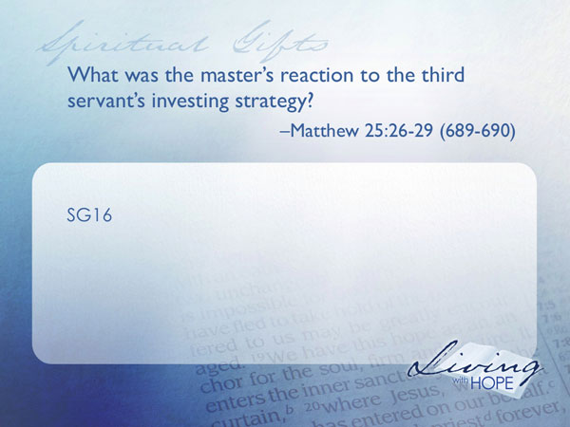
SG16 What was the master’s reaction to the third servant’s investing strategy? Matthew 25:26-29 (689-890)

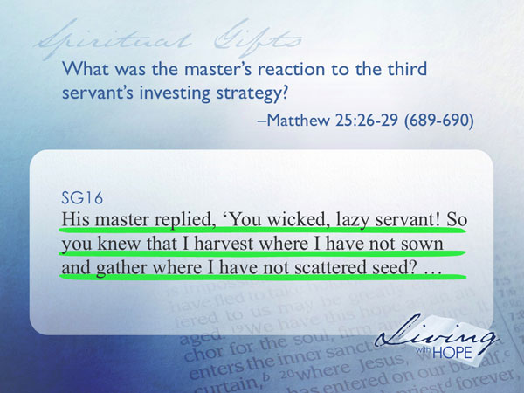
"His master replied, 'You wicked, lazy servant! So you knew that I harvest where I have not sown and gather where I have not scattered seed?

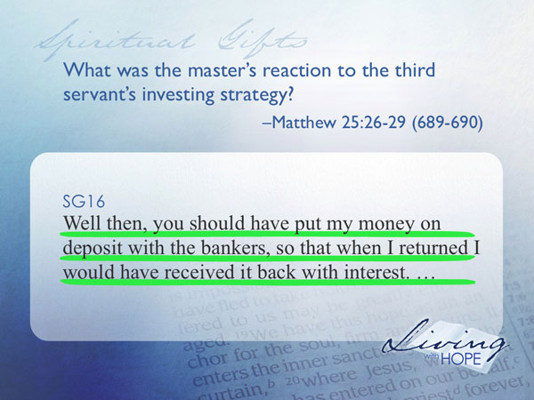
Well then, you should have put my money on deposit with the bankers, so that when I returned I would have received it back with interest. "

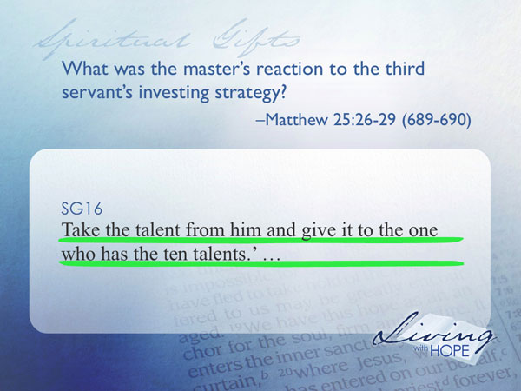
'Take the talent from him and give it to the one who has the ten talents.

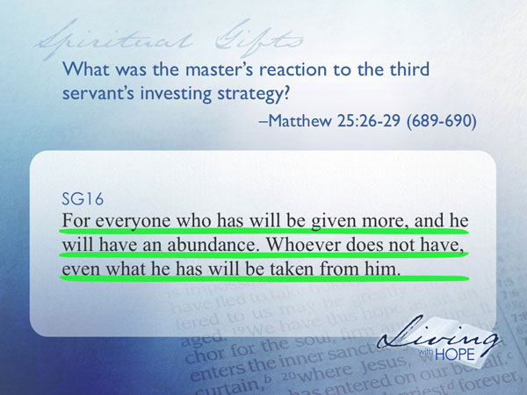
For everyone who has will be given more, and he will have an abundance. Whoever does not have, even what he has will be taken from him.
The boss didn’t appreciate the servant’s conservative approach to investing. In fact he took the money away from him and gave it to someone who was more aggressive.

God has given you a unique gift mix. You can be conservative with it and keep it all to yourself, or you can be aggressive and start using those talents to build up congregation. Have you ever had one of your limbs in a cast for a few weeks? Were you surprised when the doctor sawed off the cast and you discovered that your limb had atrophied and was weak and scrawny when compared to its counterpart? In the same way if we don’t use our spiritual gifts, they will waste away. The truth of the parable teaches us that if you don’t use it, you lose it.

For most, the journey of spiritual gifts is a lifetime. It never gets boring. Our gift mix changes and grows over time and the needs of congregations change overtime. But if we continually invest ourselves into the body of Christ He is faithful and will continue to supply us with the resources we need for service. Jesus serves as the ultimate model in service.

At Your Service

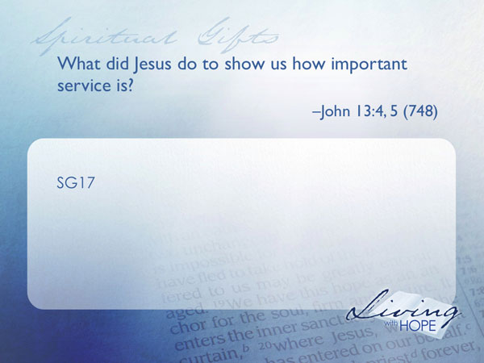
SG17 What did Jesus do to show us how important service is? John 13:4,5 (748)

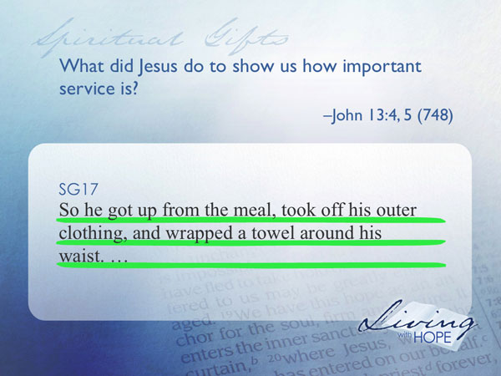
so he got up from the meal, took off his outer clothing, and wrapped a towel around his waist.

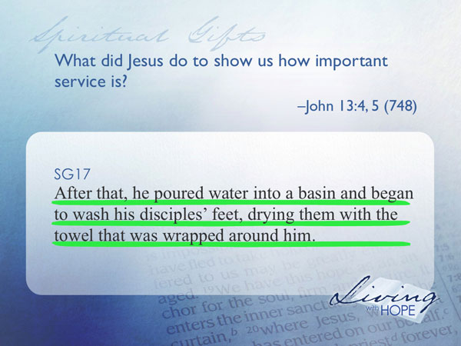
After that, he poured water into a basin and began to wash his disciples' feet, drying them with the towel that was wrapped around him.

Because of dusty trails and open sandals it was the custom of the day to provide a cool refreshing foot wash for guests. The task didn’t require much skill. Anyone could do it. In fact, it was such a common skill that typically only servants provided that service. Yet Jesus, the One with the greatest gift set of all time, freely bowed down to offer this menial service to his followers.
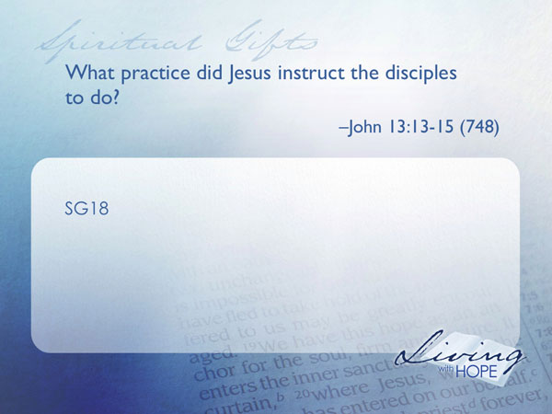
SG18 What practice did Jesus instruct the disciples to do? John 13:13-15 (748)
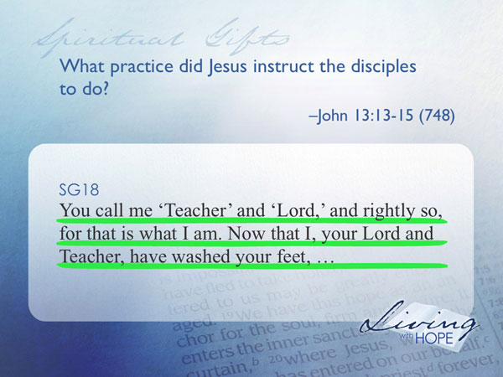
"You call me 'Teacher' and 'Lord,' and rightly so, for that is what I am. Now that I, your Lord and Teacher, have washed your feet,

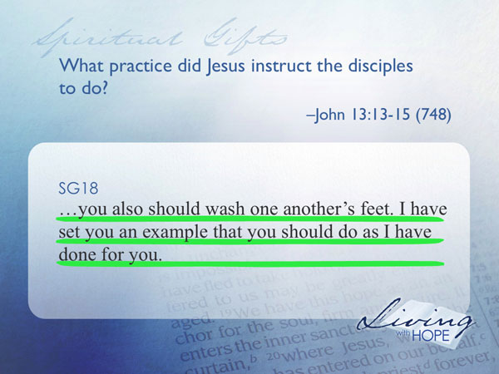
you also should wash one another's feet. I have set you an example that you should do as I have done for you.

Service is the underlying motive for all ministries. There are some things that take an extremely specialized gift set. But there are other things that almost anyone can do. A servant is willing to do both. There is no task that is too menial for someone who has a passion for service. Some things need to be done with precision and excellence and other things just need to be done.

In a world that seems to be squeezing the hope right out of us it is good to know that through service we find meaning. In fact the word for “spiritual gift” is charisma. The word means joy. Would you like to have joy in your life? Are you wondering how you can make a significant difference? You will never fully find that joy until you use your services for ministry in a congregation.
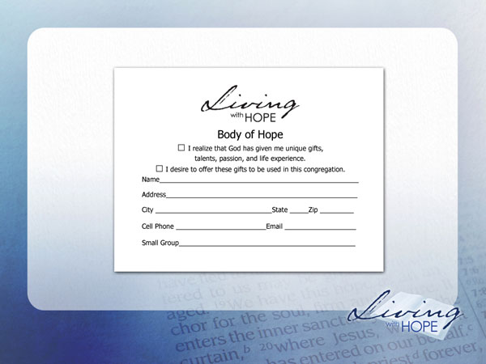
❑ I realize that God has given me unique gifts, talents, passion, and life experience.
❑ I desire to offer these gifts to be used in this congregation.
❑ I would like to be baptized.

###

Some teach that Spiritual Gifts, particularly the more exotic ones like the gift of prophecy were given exclusively to the early Christian Church but aren’t available today. Ephesians 4:13 says spiritual gifts will remain “until we all reach unity in the faith and in the knowledge of the Son of God and become mature, attaining to the whole measure of the fullness of Christ.”
Rick Warren, The Purpose Driven Life, 242
Rick Warren, The Purpose Driven Life, 244
A more complete reading of this teaching is found in the fundamental beliefs of the Seventh-day Adventist Church entitled Spiritual Gifts and Ministries: “God bestows upon all members of His church in every age spiritual gifts which each member is to employ in loving ministry for the common good of the church and of humanity. Given by the agency of the Holy Spirit, who apportions to each member as He wills, the gifts provide all abilities and ministries needed by the church to fulfill its divinely ordained functions. According to the Scriptures, these gifts include such ministries as faith, healing, prophecy, proclamation, teaching, administration, reconciliation, compassion, and self-sacrificing service and charity for the help and encouragement of people. Some members are called of God and endowed by the Spirit for functions recognized by the church in pastoral, evangelistic, apostolic, and teaching ministries particularly needed to equip the members for service, to build up the church to spiritual maturity, and to foster unity of the faith and knowledge of God. When members employ these spiritual gifts as faithful stewards of God's varied grace, the church is protected from the destructive influence of false doctrine, grows with a growth that is from God, and is built up in faith and love. (Rom. 12:4-8; 1 Cor. 12:9-11, 27, 28; Eph. 4:8, 11-16; Acts 6:1-7; 1 Tim. 3:1-13; 1 Peter 4:10, 11.)

