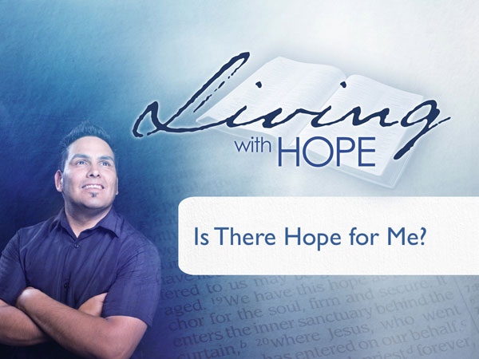
Living with Hope
Presentation 3: Salvation
Is There Hope for Me?
Metaphor: Tough Questions
Last Revision: 6/12/2009

(Note: icon means “Next Slide,” indicating when to advance to the next slide.)

Quizzed
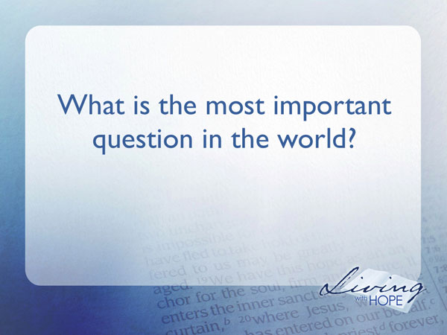
You are participating in a quiz show that will give one million dollars to the person who can answer this question: What is the most important question in the world?

How would you answer? Have you even thought of the question before? Time magazine chooses the most important person of the year. People magazine chooses the fifty most beautiful people in the world. Fortune magazine lists the top 500 companies in the world.

The timer is set, the seconds are ticking away. Thoughts of how you would spend that million dollars conflict with thoughts about what is the right answer.

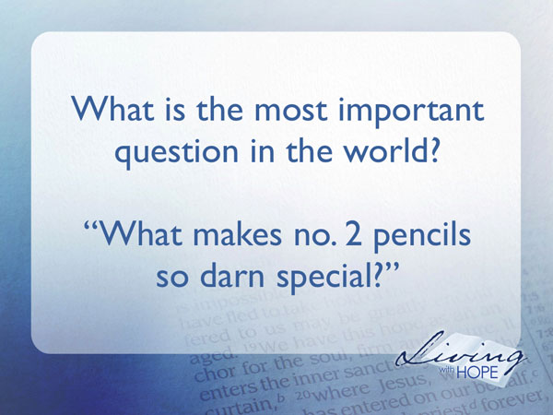
Mental Floss magazine in their November/December, 2004 issue attracted attention by the headlines on its cover: “The 25 Most Important Questions In the History of The Universe.” Here we have the question stated even more grandly, not just what is the most important question in the world but now in the whole universe. So what is the first question of the twenty-five? “What makes no. 2 pencils so darn special?”

You immediately sit up straight and say, “That question certainly would not satisfy the man with the gun in my ribs.”

By the way, the answer to why no. 2 pencils are so popular is because the lead in the pencil is graded according to how soft or hard it is. No. 1 is the softest and too soft for most writing and the higher the number the harder the lead until you can hardly write with it.

Another question in their list catches the eye,
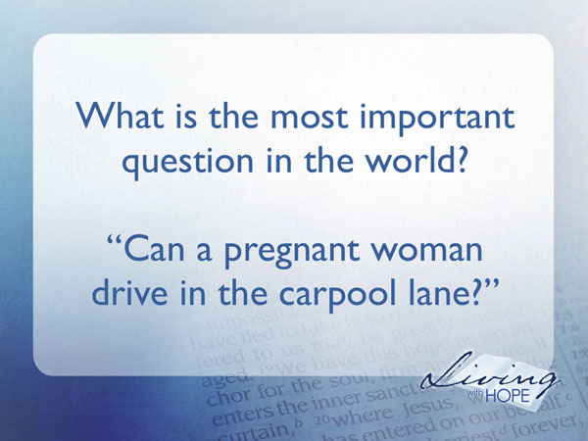
“Can a pregnant woman drive in the carpool lane?”

In 1987 a pregnant California woman was ticketed for driving “by herself” in the carpool lane. She sued, contending that her five-month-old unborn child constituted a second person. The jury agreed with her despite the prosecution’s argument that women could then just stuff pillows up their dresses to drive “carpool” on California’s freeways.

You are allowed to have a lifeline. Do you have a friend who would know that kind of answer? Let’s listen in as Robert G. Ingersoll, one of the most well-known atheists of the nineteenth century gave an oration at his brother’s funeral. Let’s listen to his Elizabethan English and see if we get any clues as to what this question might be.

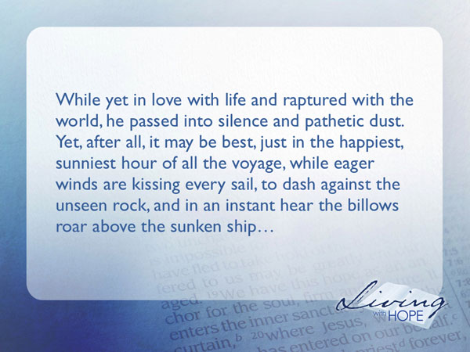
“While yet in love with life and raptured with the world, he passed into silence and pathetic dust. Yet, after all, it may be best, just in the happiest, sunniest hour of all the voyage, while eager winds are kissing every sail, to dash against the unseen rock, and in an instant hear the billows roar above the sunken ship.

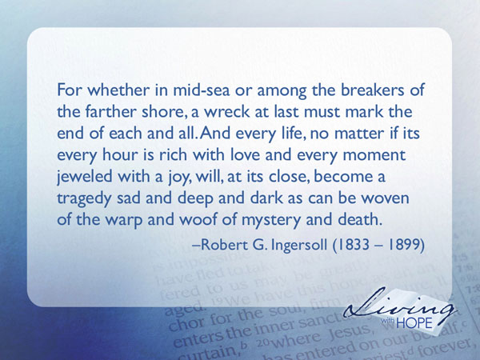
“For whether in mid-sea or among the breakers of the farther shore, a wreck at last must mark the end of each and all. And every life, no matter if its every hour is rich with love and every moment jeweled with a joy, will, at its close, become a tragedy sad and deep and dark as can be woven of the warp and woof of mystery and death.”

How would you like to live that kind of life? So what is the most important question in the world?
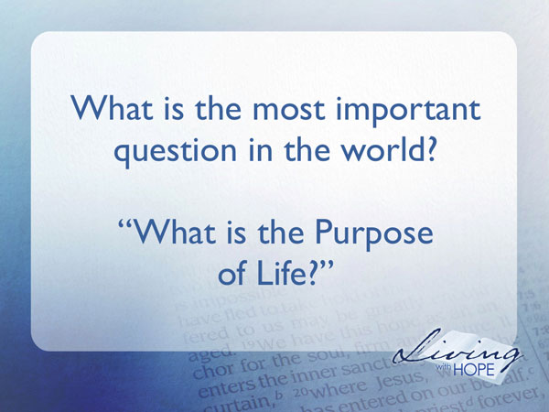
The most important question in the world is: What is the Purpose of Life? Or to put it another way: Why are we here? Is there a point to living? Does your life have ultimate meaning? Is there hope for me? Apparently there is. No matter how hard people try to eradicate it, hope springs eternal.

Communism did its best to stamp out religion in Russia but failed. China has done its best to get rid of religion but Christianity and other religions are thriving and multiplying in China today. Eighty-five percent of the world’s inhabitants belong to a religious group. Only fifteen percent make no profession of faith.

The vast majority in the world believe that there is a purpose to life. Now that we have established the question what is the answer? And here is the rub. We are very confused because of the multiplicity of answers from the world’s religions.

I’m going to display before you a number of different picture frames. They are frames with no picture. Each of these frames represents a different religion. Each religion stresses some form of doing, some form of works, in order to merit the next life. The frames are different because the requirements of each religion differ.

For example, if you are a follower of Islam you get eternal life by striving to fulfill the requirements set forth in the five pillars. The Koran states clearly that salvation is focused on strivings and works: “In the day of judgment, they whose balances shall be heavy with good works, shall be happy; but they, whose balances shall be light, are those who shall lose their souls, and shall remain in hell forever” (Sura 23:103-104).
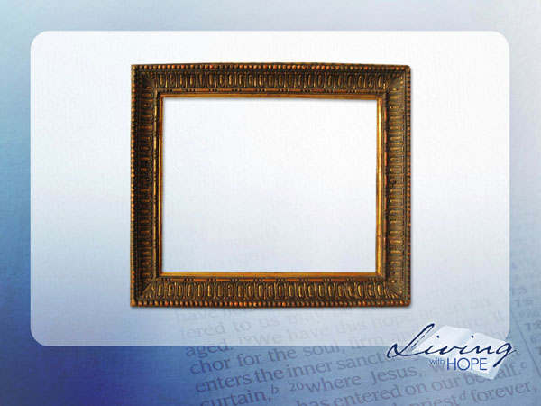
If you follow the Jewish religion, right ethical behavior gets you eternal life. God makes the final decision as to whether your behavior has been good enough.


If you are a Buddhist salvation comes through the cultivation of character and ethical stature in the present life by the fulfillment of the law and diligent obedience to the Eightfold Path.

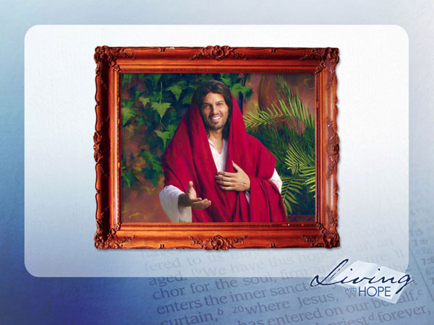
But what value does a frame have without a picture? Christianity is unique among world religions because the center of Christianity is a person, Jesus Christ. Christianity is first and foremost a religion of relationships.

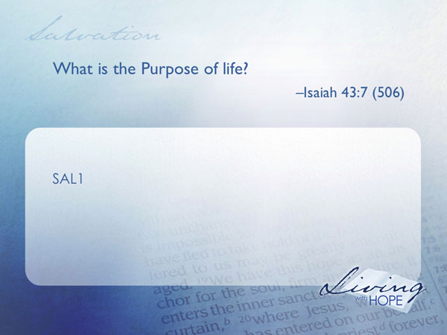
SAL1 What is the Purpose of life? Isaiah 43:7 (506)

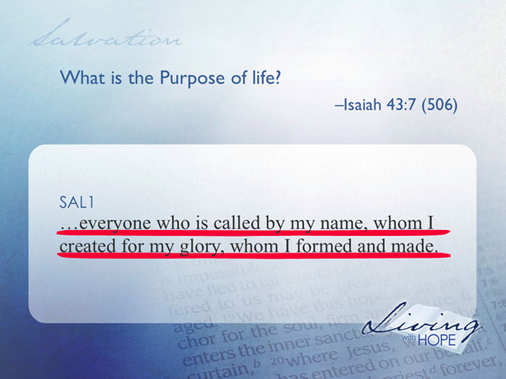
everyone who is called by my name, whom I created for my glory, whom I formed and made.

Notice that I am assuming there is a God who created the universe. Because you either believe by faith that the universe came into existence uncaused or you believe by faith that the universe came into existence through a supreme being.
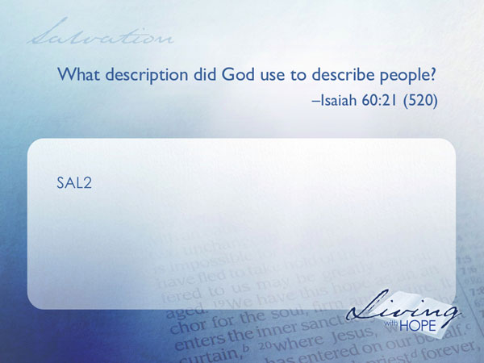
SAL2 What description did God use to describe people? Isaiah 60:21 (520)

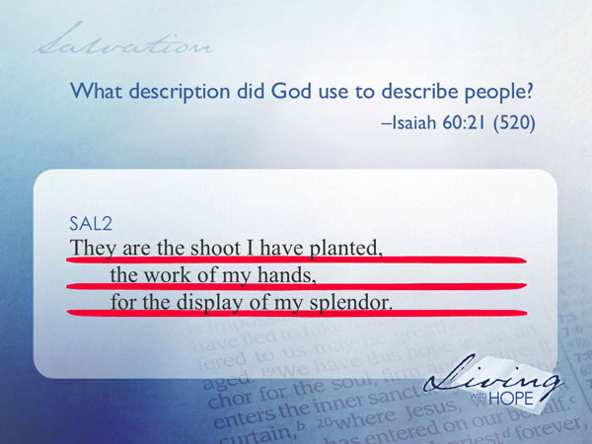
They are the shoot I have planted,
the work of my hands,
for the display of my splendor.

The seventeenth century Westminster Confession of faith asks, “What is the purpose of man?” and answers the question, “The chief end of man is to glorify God and enjoy Him forever.”

Separated
How does a person glorify God and enjoy Him forever? In the beginning human beings did enjoy a personal relationship with the God of the universe. But then our first parents rebelled against God and broke that close and personal relationship they had with Him.
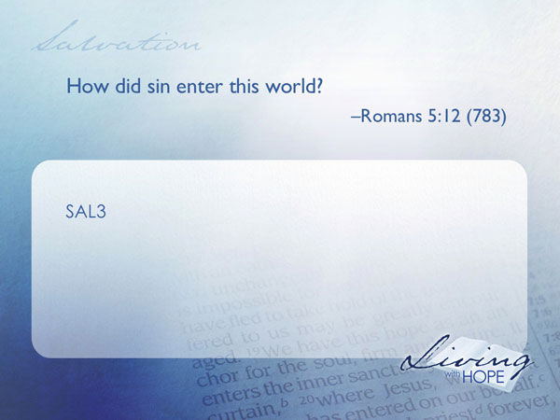
SAL3 How did sin enter this world? Romans 5:12 (783)

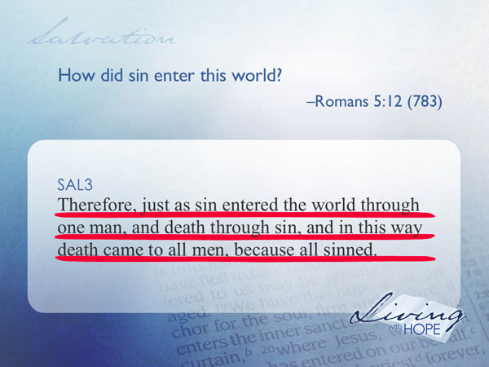
Therefore, just as sin entered the world through one man, and death through sin, and in this way death came to all men, because all sinned.

The word sin comes from the world of archery and means to ‘miss the mark,’ and from the world of hiking and means ‘to stray off the path.’ The world of Adam and Eve in the garden of Eden was a sin free world. Adam and Eve always followed after God that is until the day they chose their own path by eating from a tree that God had put off limits.
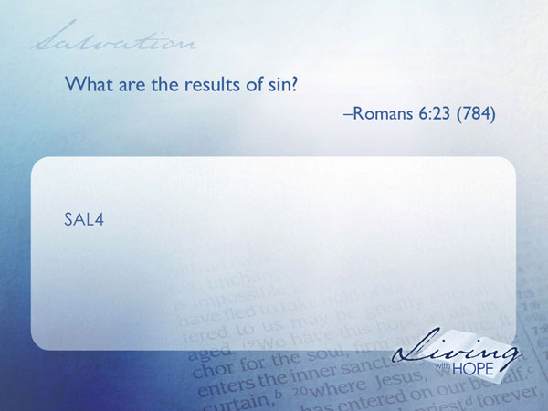
SAL4 What are the results of sin? Romans 6:23 (784)

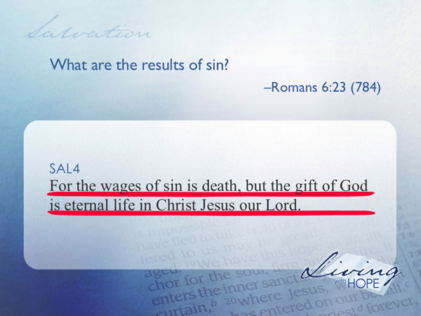
For the wages of sin is death, but the gift of God is eternal life in Christ Jesus our Lord.

Adam and Eve began dying that day and the plague of sin has been with humanity ever since.
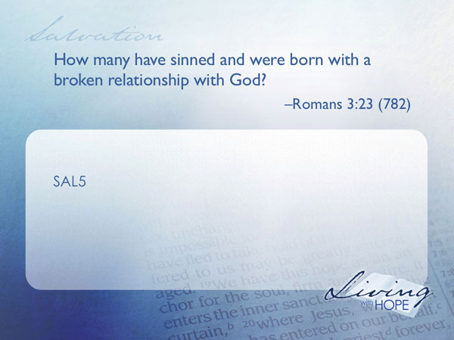
SAL5 How many have sinned and were born with a broken relationship with God? Romans 3:23 (782)

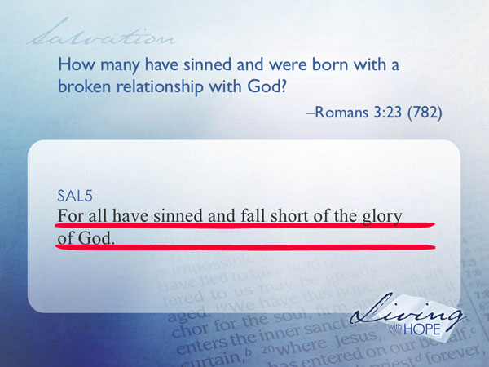
...for all have sinned and fall short of the glory of God...

That means everyone here today is condemned to live for a short while on this earth and then perish forever. Unless . . .

Reunited
Think for a moment about your greatest need–emotional and relational. The cry of humanity, the cry of every individual, is acceptance for who we are. We want to be loved, to be valued, and to be accepted just as we are–not what some other person thinks we should be.

When Adam and Eve, our first parents, took the forbidden fruit they knew they had done something wrong. They were afraid that God would no longer accept them as they had become, so when God came looking for them they hid. We have been hiding ever since. We are afraid that God will not love us.

We find it difficult to confess our sins, our problems, and our difficulties because we are afraid of how other people will judge us. Look how difficult it is for a politician to admit that he or she ever made a mistake. We are afraid of rejection just like Adam and Eve. But God does not reject us.
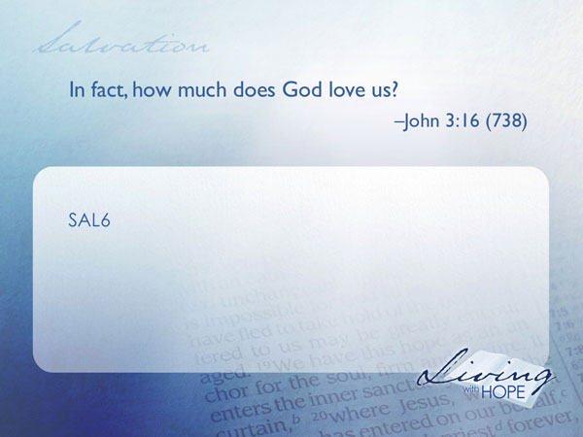
SAL6 In fact, how much does God love us? John 3:16 (738)

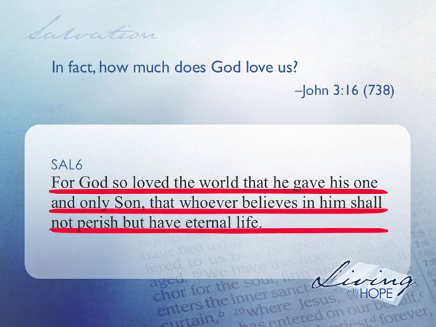
For God so loved the world that he gave his one and only Son, that whoever believes in him shall not perish but have eternal life.

I cannot even imagine the sacrifice the Heavenly Father made. The hurt must have filled all of heaven. Yet it was a demonstration of love meant to win the love of our hearts.

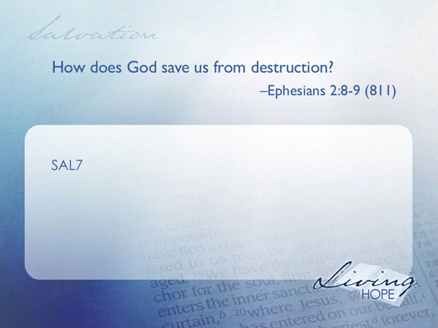
SAL7 How does God save us from destruction? Ephesians 2:8-9 (811)

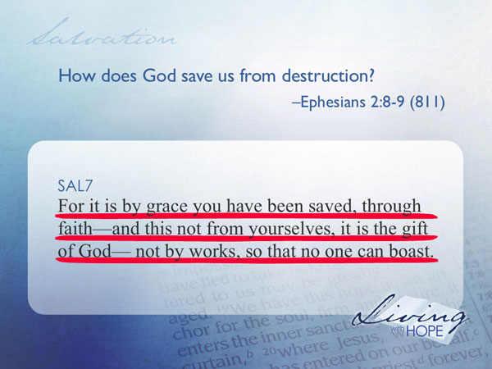
For it is by grace you have been saved, through faith—and this not from yourselves, it is the gift of God— not by works, so that no one can boast.

Christianity is pretty unique among world religions. In the picture frames of most religions mankind works hard and tries to sacrifice to please the gods. In this picture frame it is God who works hard and sacrifices His son in order to please us.

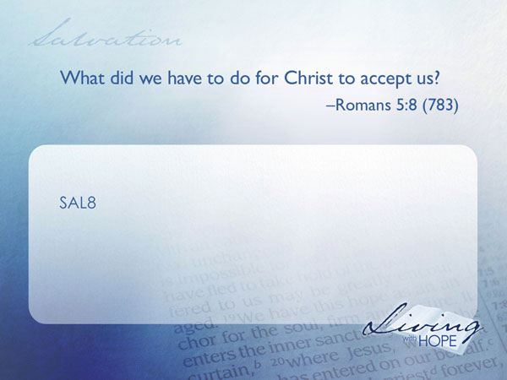
Accepted
SAL8 What did we have to do for Christ to accept us? Romans 5:8 (783)

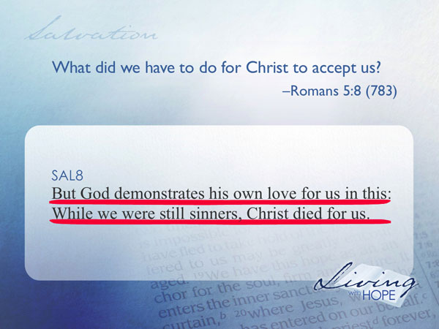
But God demonstrates his own love for us in this: While we were still sinners, Christ died for us.

We don’t have to do anything for Christ to accept us. Christ does not wait until we are good before He accepts us. The Bible is clear that no one is good and no one will ever be good enough.
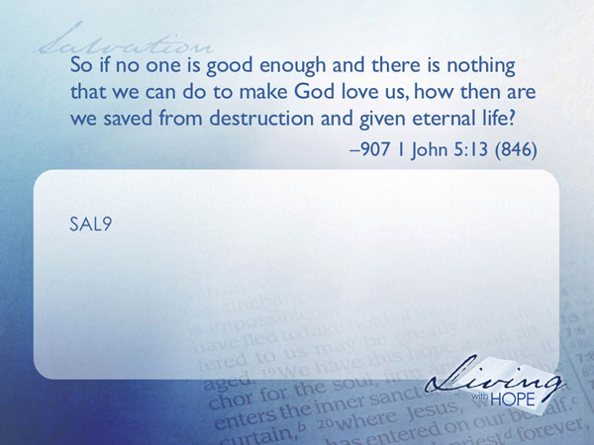
SAL9 So if no one is good enough and there is nothing that we can do to make God love us, how then are we saved from destruction and given eternal life? I John 5:13 (846)

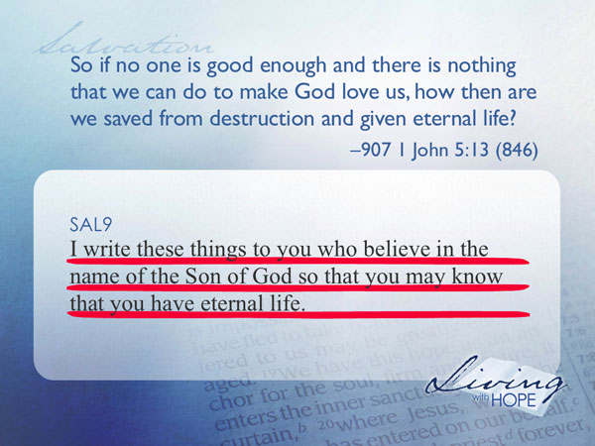

I write these things to you who believe in the name of the Son of God so that you may know that you have eternal life.

Invited
Believing in Jesus means that you have come to the place where you recognize that you are helpless and there is nothing you can do to get to heaven. You are sorry for your life of self-dependence. So you place your full trust in Jesus. You accept as yours the perfect life Jesus lived, and you change from being dependent on yourself to being dependent on Jesus. We deserve to die. Jesus did not. Yet he invites us to exchange his place for ours.
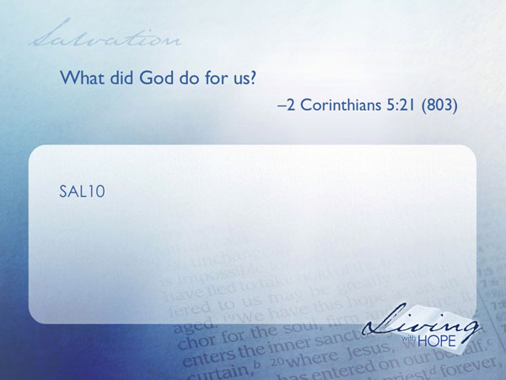
SAL10 What did God do for us? 2 Corinthians 5:21 (803)

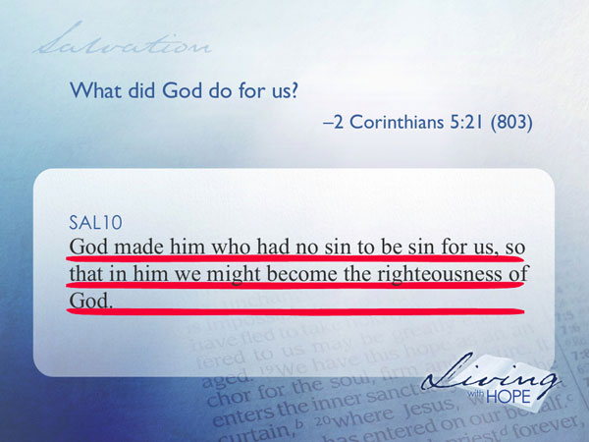
God made him who had no sin to be sin for us, so that in him we might become the righteousness of God.

Unfortunately, Christianity has too often failed to recognize that we were created for relationships and has concentrated on facts about God rather than how to enter into an intimate relationship with the God of the universe. Doctrines have their place and we are studying them the next few weeks in this series, but they are only the frame around the picture. No one buys a frame for itself but only because of the picture it contains or will contain.

Do you want to enter into a personal relationship with the God of the Universe? You can right now. It only takes a moment. When Paul and Silas were imprisoned in Philippi God used an earthquake to free them. The jailer was ready to kill himself because he thought the prisoners had escaped but Paul told him to be calm everyone was present and accounted for.

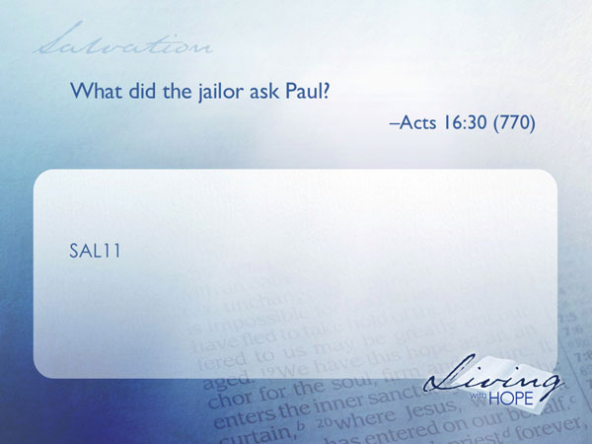
SAL11 What did the jailor ask Paul? (Acts 16:30 770)

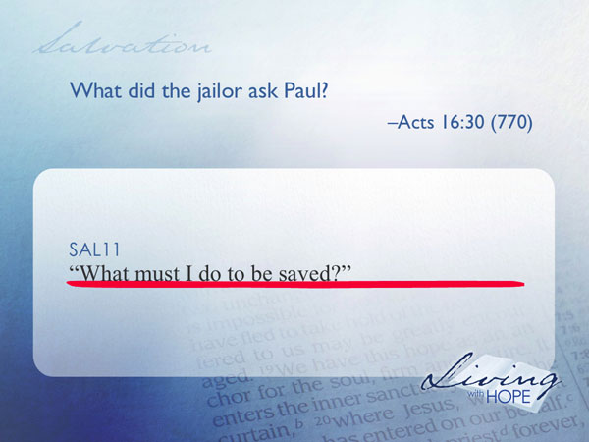
“What must I do to be saved?”

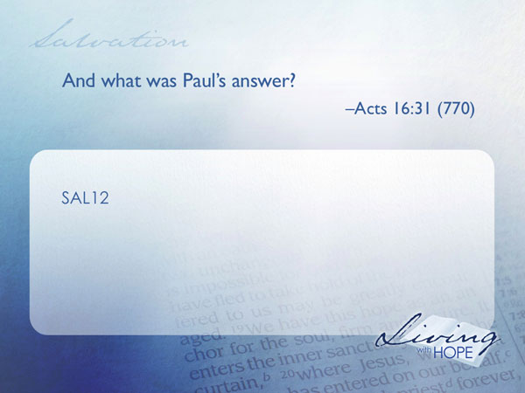
SAL12 And what was Paul’s answer? Acts 16:31 (770)

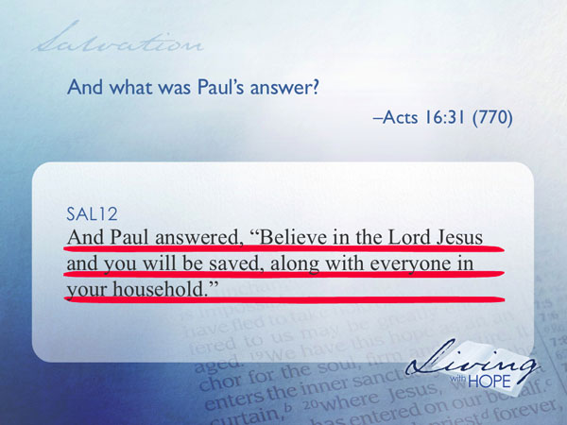
And Paul answered, “Believe in the Lord Jesus and you will be saved, along with everyone in your household.”

Transformed
Believing is not just a mental assent but a complete handing over of one’s life to God. And when you do this, God then begins a marvelous work in you to transform you and fill you with His peace and joy.

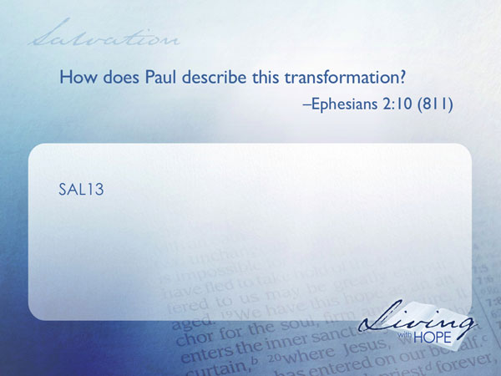
SAL13 How does Paul describe this transformation? Ephesians 2:10 (811)

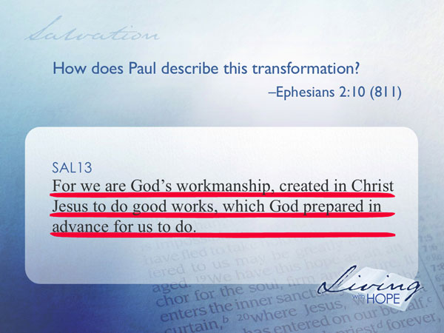
For we are God's workmanship, created in Christ Jesus to do good works, which God prepared in advance for us to do.

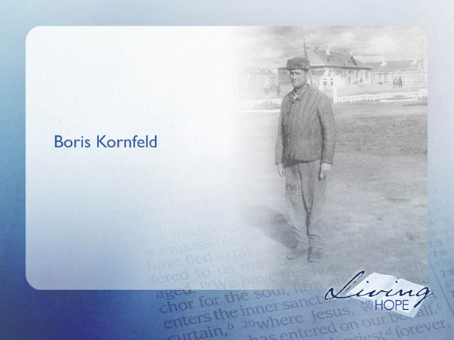
Boris Kornfeld was a Jewish physician who had fallen victim to Stalin’s purges and was sentenced to a concentration camp for political subversives at Ekibastuz. Kornfeld was an ardent communist, a cultural Jew, and an atheist. Because he was a doctor he lived a little better than the other prisoners—the prison authorities needed doctors to care for the prisoners who were constantly dying under the primitive conditions of their imprisonment. One of his patients was a Christian who witnessed to him the transforming grace of Jesus Christ. He struggled over giving his life to God.

One day as he worked to save the life of one of the prison guards who had been knifed, he was tempted to suture the severed artery in such a way that it would reopen shortly after the surgery and the guard would die. As his hands paused while tying the suture he suddenly became appalled by the violence and hatred in his own heart toward the guard and all those like him. He could gladly kill them all. He then realized that he was trapped by the very evil that he despised.

He began to retie the sutures properly and as he did he found himself repeating the words he had heard from his fellow prisoner. “Forgive us our trespasses, as we forgive those who trespass against us.”

One day he discovered an orderly stealing some of the food meant only for the patients. Kornfeld reported this infraction to the prison commandant. The commandant placed the orderly in three days of confinement. Kornfeld knew that his life would not be safe once the orderly was released so he began to sleep in the hospital, taking cat naps and trying to keep awake at all times. But he found that he was not afraid. A remarkable peace had come into his heart. He wanted to live for Jesus. He no longer turned a blind eye to injustice in the prison. All the hatred had vanished from his mind and he felt that he was the freest man in all Russia.

He wanted to share his new faith. One afternoon he examined a prisoner who had been operated on for cancer of the intestines. The eyes of this man were filled with sorrow and his face was etched with years of misery.

Kornfeld shared what had happened to him, how God had transformed his life. The patient drifting in and out of consciousness did not catch it all. But he heard enough to know that this man, this doctor was different.

The next morning this patient awoke to the sound of running feet and a great commotion. That very night someone had bludgeoned Boris Kornfeld to death. But his testimony did not die. The patient pondered the testimony of the doctor and became a Christian. He survived that prison camp and went on to tell the world about it. His name was Alexander Solzhenitsyn. He is most famous for his massive expose of conditions under Stalin in his book, The Gulag Archipelago.

Kornfeld lived out in his short Christian life with purpose as a man transformed by the gospel. Do you want to be transformed, ready to enjoy God for ever? You can right now and as you make your decision the rest of your life begins right now.
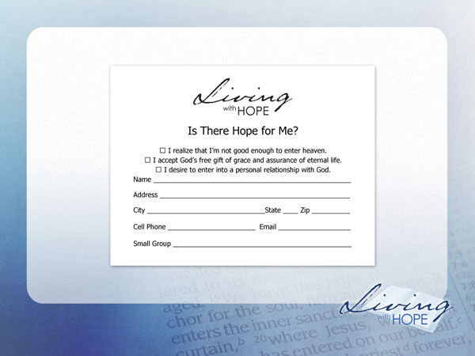
❑ I realize that I’m not good enough to enter heaven.
❑ I accept God’s free gift of grace and assurance of eternal life.
❑ I desire to enter into a personal relationship with God.

###

Larry A. Nichols, et al., Encyclopedic Dictionary of Cults, Sects, and World Religions (Grand Rapids: Zondervan, 2006), p. 149.
http://www.leaderu.com/wri-table2/salvation.html
Ibid., p. 43.
http://www.reformed.org/documents/westminster_conf_of_faith.html
The complete story is told in Genesis chapter three.
Here is the teaching of the Seventh-day Adventist church on the Experience of Salvation: “In infinite love and mercy God made Christ, who knew no sin, to be sin for us, so that in Him we might be made the righteousness of God. Led by the Holy Spirit we sense our need, acknowledge our sinfulness, repent of our transgressions, and exercise faith in Jesus as Lord and Christ, as Substitute and Example. This faith which receives salvation comes through the divine power of the Word and is the gift of God's grace. Through Christ we are justified, adopted as God's sons and daughters, and delivered from the lordship of sin. Through the Spirit we are born again and sanctified; the Spirit renews our minds, writes God's law of love in our hearts, and we are given the power to live a holy life. Abiding in Him we become partakers of the divine nature and have the assurance of salvation now and in the judgment. (2 Cor. 5:17-21; John 3:16; Gal. 1:4; 4:4-7; Titus 3:3-7; John 16:8; Gal. 3:13, 14; 1 Peter 2:21, 22; Rom. 10:17; Luke 17:5; Mark 9:23, 24; Eph. 2:5-10; Rom. 3:21-26; Col. 1:13, 14; Rom. 8:14-17; Gal. 3:26; John 3:3-8; 1 Peter 1:23; Rom. 12:2; Heb. 8:7-12; Eze. 36:25-27; 2 Peter 1:3, 4; Rom. 8:1-4; 5:6-10.)”

