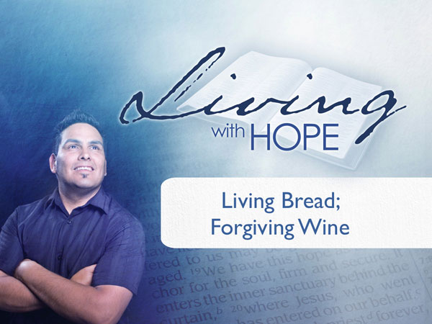
Living with Hope
Presentation 16: Communion
Living Bread; Forgiving Wine
Last Revision: 6/12/2009

(Note: icon means “Next Slide,” indicating when to advance to the next slide.)

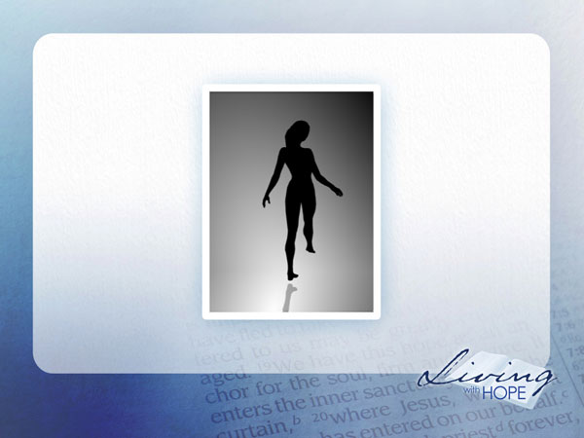
Are you left brained or right brained? “What? I thought I only had one brain” you say to yourself. While it’s true that we only have one brain, the human brain is divided into two very distinct hemispheres that are connected at the bottom through a bundle of nerves. Scientists have discovered that each side of the brain takes on different functions. Our personality and way of thinking are greatly affected by which side of our brain is dominant. So do you know which side of your brain is dominant?

There was a popular animation going around on the internet that purported to tell you whether you were right or left brained dominant by viewing a spinning dancer. You want to take the test? Do you see the dancer spinning? Is she spinning clockwise? Or counterclockwise? How many of you see her spinning clockwise? How many of you see her spinning counterclockwise? How many of you can see her spinning both directions?

If you see her spinning clockwise, the internet legend says, then your right brain may be dominant. If you see her spinning counter clockwise, then your left brain may be dominant. What does that mean? --Probably nothing according scientists who point out that right or left brain dominance is far too complex to evaluate with a simplistic 2D animation. However there is a truth to the concept that we are all God’s creation and wired up a bit differently.

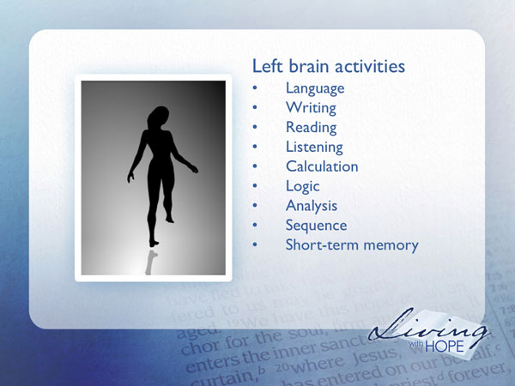
For example, here are the functions generally attributed to your left brain:

Language
Writing
Reading
Listening
Calculation
Logic
Analysis
Sequence
Short-term memory
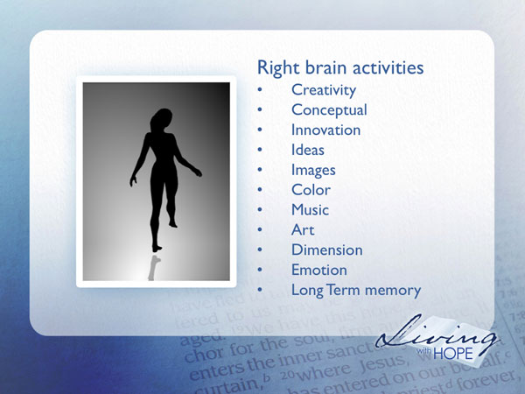
Here are the functions generally attributed to your right brain:

Creativity
Conceptual
Innovation
Ideas
Images
Color
Music
Art
Dimension
Emotion
Long Term memory

As you can see both sides of the brain are important. How many of you could switch between the two directions for the spinning dancer? I’ll give you a hint. Look just to the right of the dancer and it will be easy to see her spinning clockwise. Now look to the left of the dancer and you can see her spinning counterclockwise. Wouldn’t it be nice if it was that easy to use both sides of our brain?
As we study the teaching style of Jesus we find that much of His teaching was left brained. He presented deep theology and stretched the disciple’s religious understandings. Yet he also threw in a lot of right brained teaching as the disciples learned through experience. As we have done this flyover the scriptures in the Living With Hope seminar much of what we have learned has been left brained. In fact our systematic theology approach has been very left brained. Hopefully we threw in a few experiences here and there to feed the right brain.

Jesus closes his ministry in a way that joins the two brains together. He seals his theological teaching with a powerful worship experience that has been practiced ever since by the Christian community. And today, as we close our Living With Hope seminar we too would like to join the two sides of our brain together in one last grand worship experience as taught by Jesus. The story begins just before the Jewish Passover Feast.

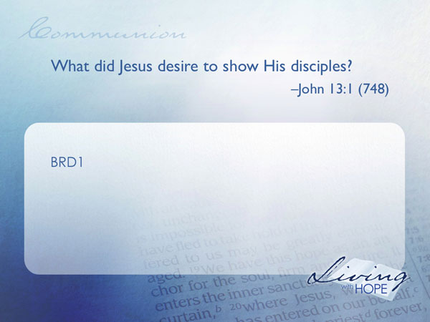
Dinner Farewell
BRD1 What did Jesus desire to show His disciples? John 13:1 (748)

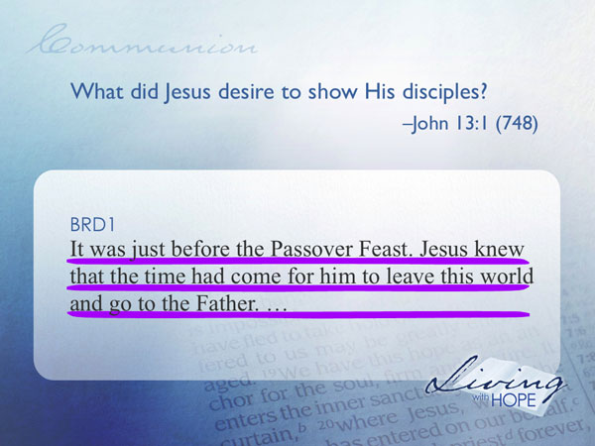
It was just before the Passover Feast. Jesus knew that the time had come for him to leave this world and go to the Father.

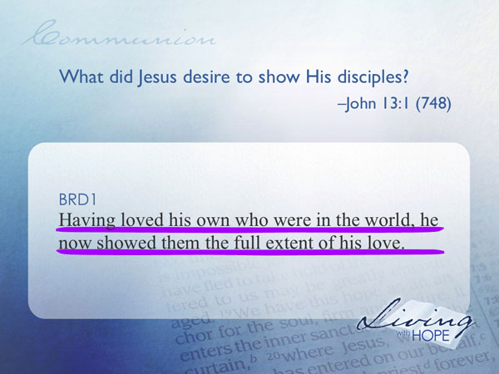
Having loved his own who were in the world, he now showed them the full extent of his love.

The Passover was a right brained Jewish experience that commemorated the freeing of the slaves from bondage in Egypt. At that eve of the escape from Egypt Moses told the Jews instructions to prepare a light meal so they would be free to travel the next morning. They were to take the blood of the lamb and paint a little bit of it over the doorposts so the angel of the Lord would ‘pass over’ the homes of those whose doorposts were marked. That night the first born of each unmarked home (including Pharaoh) was slain. The chaos that ensued the next morning gave cover for the Jews to escape in a mass exodus. Ever since that time, and even today, Jews commemorate the exodus from Egypt with a reenactment of the Passover meal. Jesus knew that this would be his last meal together with his followers so he took the Passover tradition and enhanced it with new meaning for His followers.

The Awkward Moment
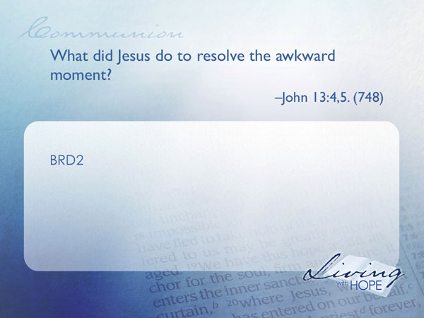
The experience begins as the followers of Jesus arrive in the upper room. There were no paved sidewalks or shoes and socks in those times. Guests would arrive at a home with tired, dusty feet. It was the hospitality custom for a servant of the house to remove the sandals of the guest and wash their feet. This created an awkward moment for the disciples. They were ready to eat but none of their feet had been washed. Somehow the hiring of a servant had been overlooked. Embarrassed at this breach of etiquette, they silently looked at the floor, wondering who was going to perform the service. No disciple rose to the occasion. It was beneath their dignity to play the part of a servant.

BRD2 What did Jesus do to resolve the awkward moment? John 13:4,5. (748)
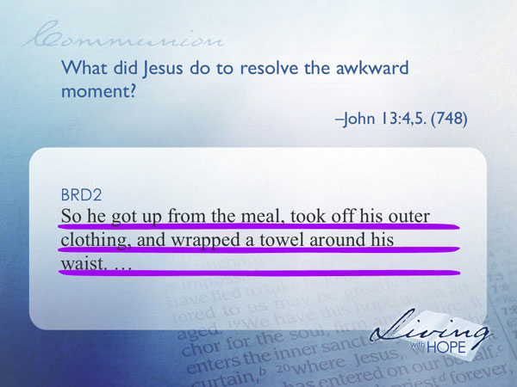
so he got up from the meal, took off his outer clothing, and wrapped a towel around his waist.
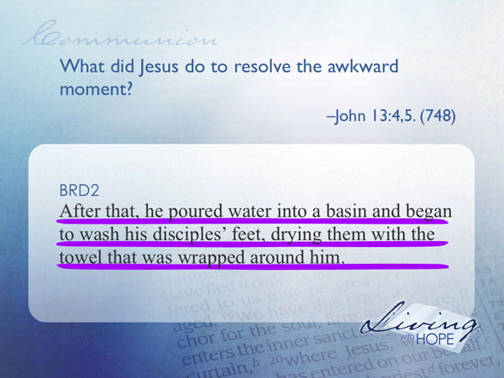
After that, he poured water into a basin and began to wash his disciples' feet, drying them with the towel that was wrapped around him.
Confusion reigned as Jesus went around washing the disciples’ feet. The question on everyone’s mind was “Why would Jesus, who ranked above the disciples, take on a position that was at the bottom of the chain of command, and wash their feet?”

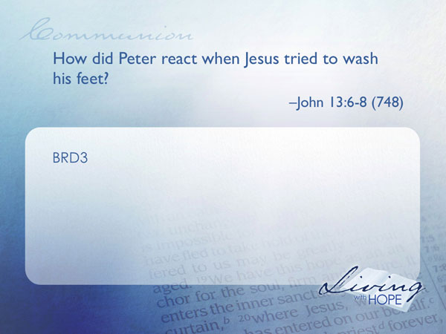
BRD3 How did Peter react when Jesus tried to wash his feet? John 13:6-8 (748)

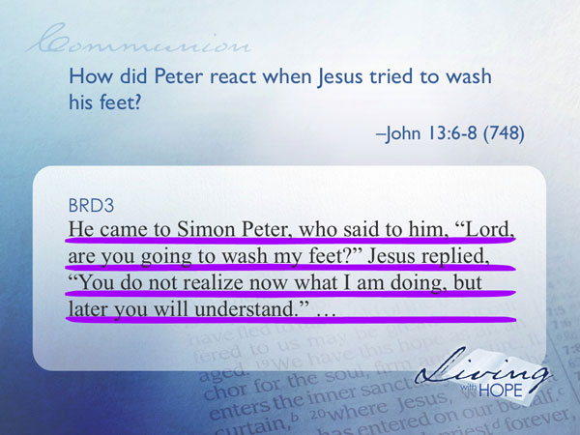
He came to Simon Peter, who said to him, "Lord, are you going to wash my feet?" Jesus replied, "You do not realize now what I am doing, but later you will understand."

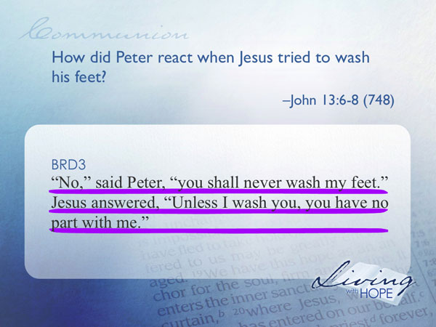
"No," said Peter, "you shall never wash my feet."
Jesus answered, "Unless I wash you, you have no part with me."
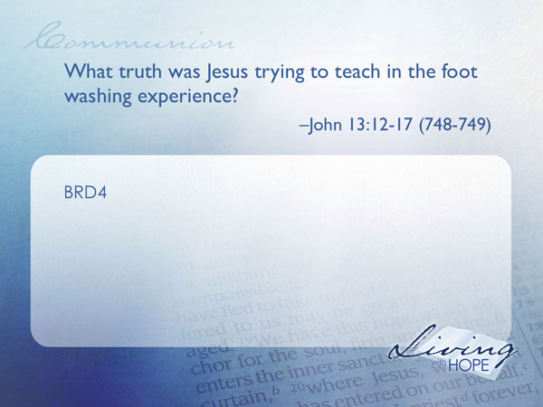
Peter assumed that if Jesus washed his feet that the teacher was giving over His leadership position to Peter. Jesus sternly tells Peter to just go with the learning experience and soon he would figure out the true meaning.
BRD4 What truth was Jesus trying to teach in the foot washing experience? John 13:12-17 (748-749)
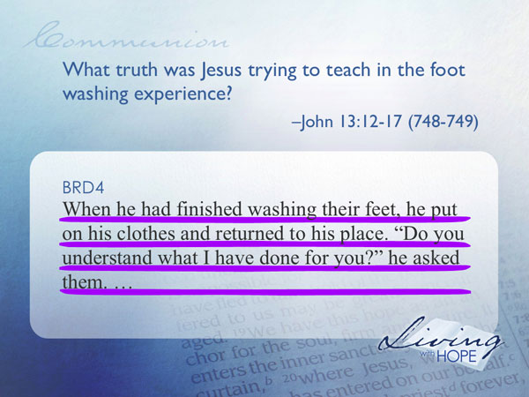
When he had finished washing their feet, he put on his clothes and returned to his place. "Do you understand what I have done for you?" he asked them.
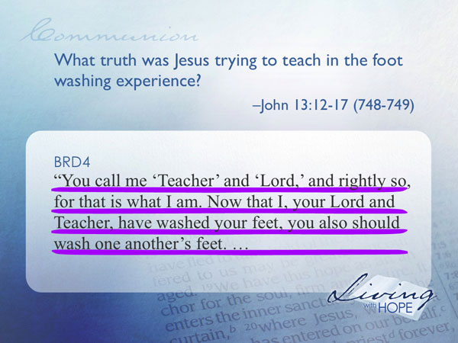
"You call me 'Teacher' and 'Lord,' and rightly so, for that is what I am. Now that I, your Lord and Teacher, have washed your feet, you also should wash one another's feet.

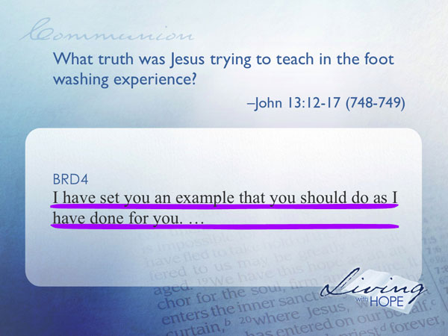
I have set you an example that you should do as I have done for you.

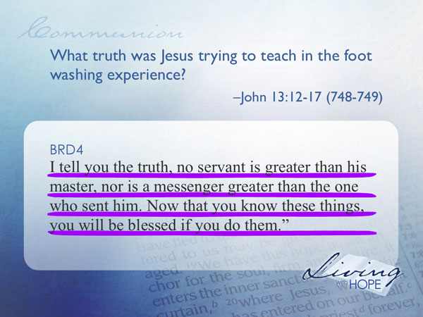
I tell you the truth, no servant is greater than his master, nor is a messenger greater than the one who sent him. Now that you know these things, you will be blessed if you do them.”

True leadership comes not in being served, but in serving others. This truth is the essence of what it means to be a follower of Jesus. Only through serving others in this world and the world to come can we can find ultimate joy.
A Buddhist monk once asked a missionary to suggest a scene that would represent Christianity. Artists were to decorate a hall on the monastery grounds with mural and reliefs that depicted major world religions. After some reflection the missionary began to share the account in John 13. The monk “said nothing as I read,” the missionary recounted, “but I felt a strange, awesome quietness and power as the passage described Jesus’ act of washing the disciples’ feet.” In that culture, discussing in public anything having to do with matters of the feet is considered very poor etiquette.
“When I finished reading, there was a moment of silence. He looked at me with incredulity and said, ‘do you mean to say that the Founder of your religion washed His student’s feet?’
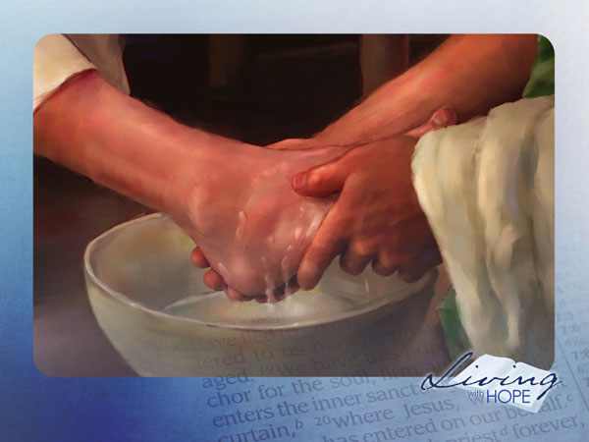
“Yes,” I replied. The usual placid moon face with shaved eyebrows and head wrinkled up in shock and amazement. He was speechless—and so was I. I swallowed very hard several times, and we were both caught up in the drama of the scene. As I gazed at him, the look of incredulity on his face changed to a reverent awe. Jesus, the Found of Christianity, had touched and washed dirty fisherman’s feet! After a few moments he gained control of himself and rose to his feet. ‘I see now the essence of Christianity.”
Jesus said that we “should wash one another’s feet.” He modeled this lesson to illustrate the primacy of service. He invites his followers to repeat this hands-on tactile learning experience so we can integrate our left and right brains. In just a moment we will return to our Bible study and experience the Lord’s Supper. But before we continue with our study we would like to follow Jesus’ example and recreate this experiential learning exercise. Our hosts/hostesses have prepared basins of waters and towels. I invite you to imagine going back to the time of the Passover meal. Your feet are tired, and dusty. It is an awkward moment. You have an opportunity right now, to follow the example of Jesus and wash one another’s feet. (At this point give very specific instructions for the foot washing service. Give an ‘out’ for those who do not wish to participate or just wish to observe. )

(After the foot washing service) Well, what did you think? How does it feel to bend down and wash someone else’s feet? Awkward? Perhaps. Some of us aren’t used to service. How did it feel to have your feet washed? Awkward? Perhaps. Some of us aren’t used to being served. Let that awkwardness help us realize that we have a long way to go before we feel comfortable about serving and being served. Yet that is the essence of the kingdom of God--that of service—looking around us—finding people who have needs that we can help with--Looking at the gifts that God has given us and finding ways we can serve Him with those gifts. It may be awkward and even unnatural at first. But in time, if we keep at it, it will become more and more natural until we long to spend eternity in service to our Lord.
Jesus now moves to the Passover meal and begins to inject a further meaning into the exodus commemoration.

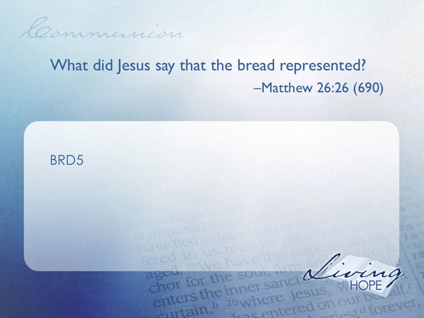
BRD5 What did Jesus say that the bread represented? Matthew 26:26 (690)

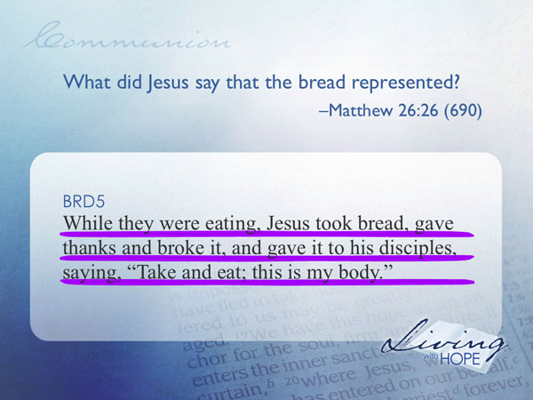
While they were eating, Jesus took bread, gave thanks and broke it, and gave it to his disciples, saying, "Take and eat; this is my body."
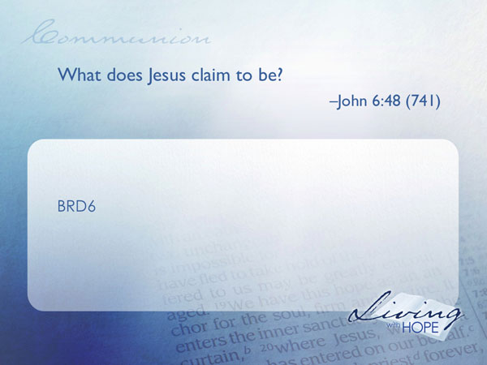
Part of the ritual of the Passover was to partake in bread without yeast. Jesus now takes this metaphor of bread and builds on it. To understand the metaphor we turn back to when Jesus taught at a synagogue in the town of Capernaum.
BRD6 What does Jesus claim to be? John 6:48 (741)

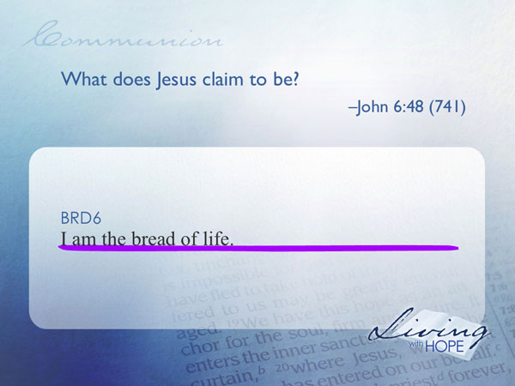
I am the bread of life.

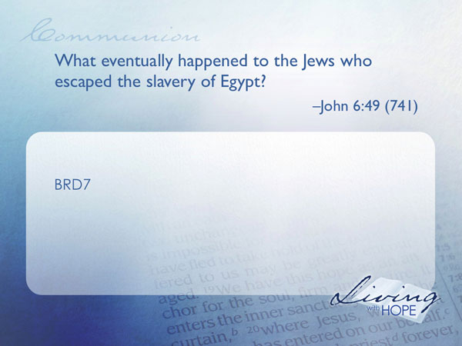
BRD7 What eventually happened to the Jews who escaped the slavery of Egypt? John 6:49 (741)

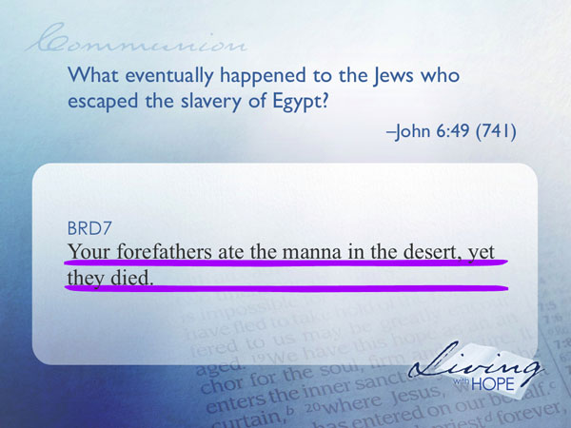
Your forefathers ate the manna in the desert, yet they died.

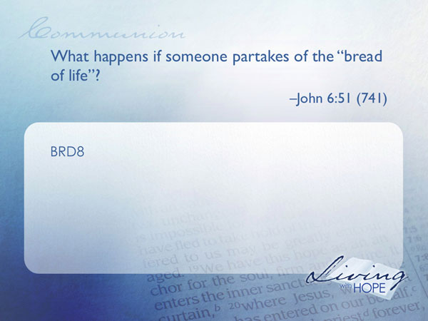
BRD8 What happens if someone partakes of the “bread of life”? John 6:51 (741)

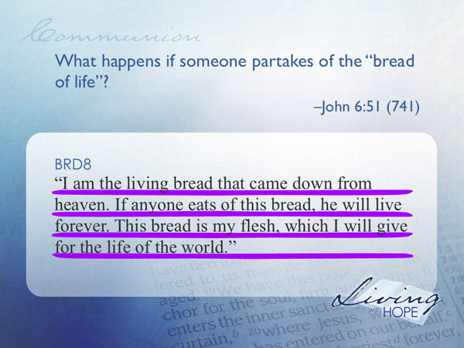
“I am the living bread that came down from heaven. If anyone eats of this bread, he will live forever. This bread is my flesh, which I will give for the life of the world."

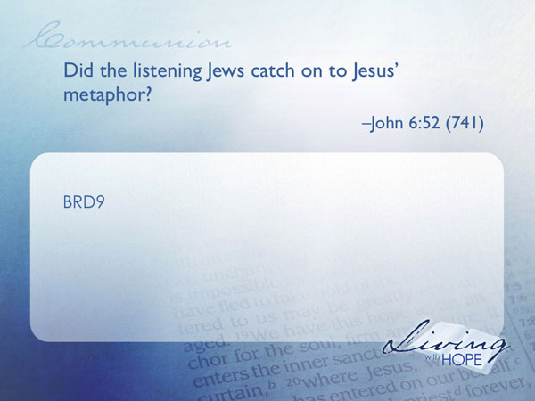
BRD9 Did the listening Jews catch on to Jesus’ metaphor? John 6:52 (741)

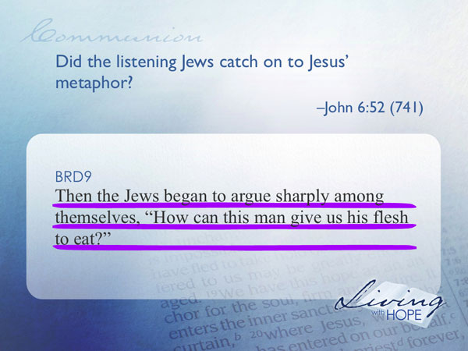
Then the Jews began to argue sharply among themselves, "How can this man give us his flesh to eat?"
They didn’t catch it. In fact it is not until the last supper that Jesus reintroduces this metaphor in his intimate time with his followers. Eating of the bread symbolizes the reliance on Jesus Christ for eternal life. Jesus’ body that will be broken on the cross at Calvary provides the living bread of the grace of God.
Let’s continue with the teaching in Capernaum where Jesus introduces one more symbol.

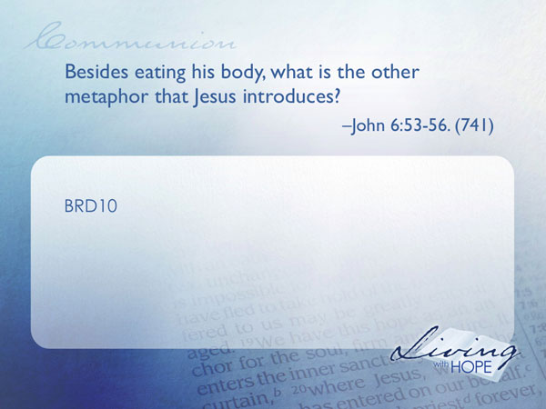
BRD10 Besides eating his body, what is the other metaphor that Jesus introduces? John 6:53-56. (741)

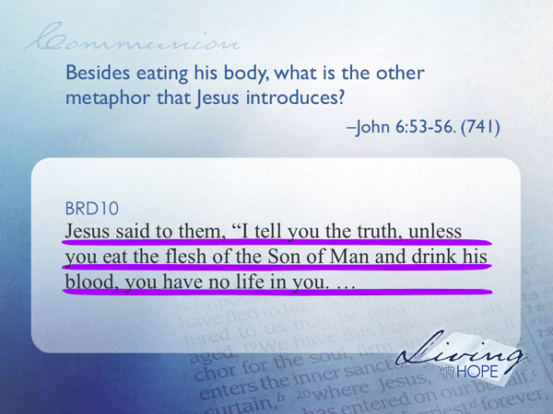
Jesus said to them, "I tell you the truth, unless you eat the flesh of the Son of Man and drink his blood, you have no life in you.

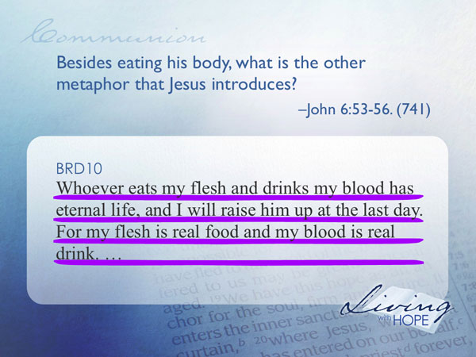
Whoever eats my flesh and drinks my blood has eternal life, and I will raise him up at the last day. For my flesh is real food and my blood is real drink.

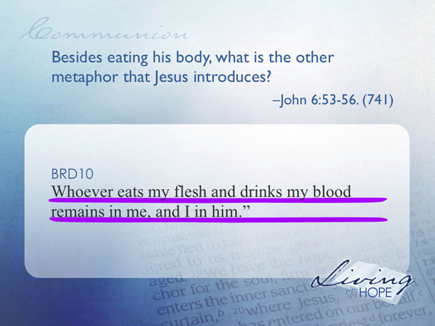
Whoever eats my flesh and drinks my blood remains in me, and I in him.

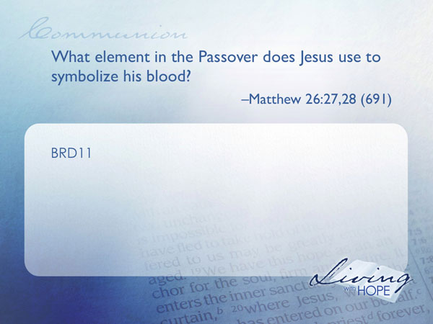
What does it mean to drink His blood? That’s a mystery that is not solved until Jesus reveals it at the Passover supper.
BRD11 What element in the Passover does Jesus use to symbolize his blood? Matthew 26:27,28 (691)
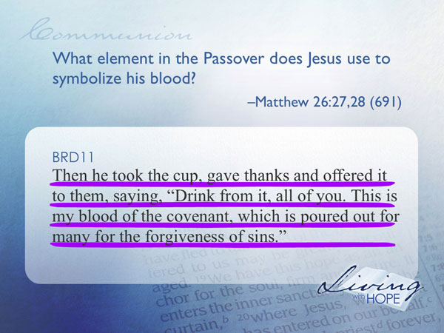
Then he took the cup, gave thanks and offered it to them, saying, "Drink from it, all of you. This is my blood of the covenant, which is poured out for many for the forgiveness of sins.
In the original Passover, the blood on the doorpost gave life to those within the home. Now Jesus says that his blood, represented by the fruit of the grape, gives eternal life to those who believe. Drinking the grape juice symbolizes the reliance on Jesus Christ for eternal life. Jesus’ blood that will be spilled the next day on the cross at Calvary provides the forgiving wine of the grace of God.
Again, Jesus is connecting the left and right brain. All through his ministry He has been teaching that eternal life comes through believing in Him. Now he uses this experiential worship to cement the meaning of God’s grace.
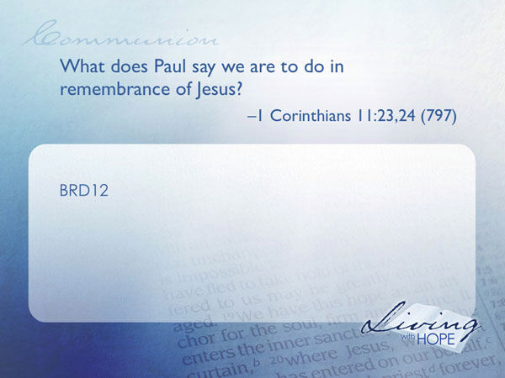
Do you believe in Jesus? Do you believe that He has the power to grant you eternal life? Do you wish to receive the blessing of that hope? If so, I invite you today to partake in the living bread and the forgiving wine as we re-enact this last supper experience. (Give specific instructions as to how the bread and wine are to be received. After it has been distributed, have a prayer of blessing on the bread)
BRD12 What does Paul say we are to do in remembrance of Jesus? I Corinthians 11:23,24 (797)

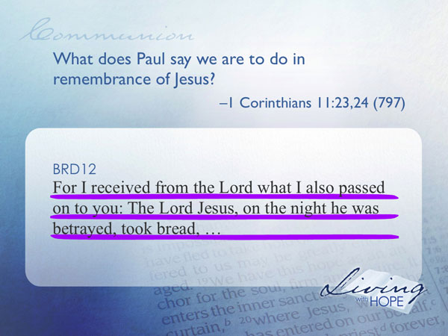
For I received from the Lord what I also passed on to you: The Lord Jesus, on the night he was betrayed, took bread,

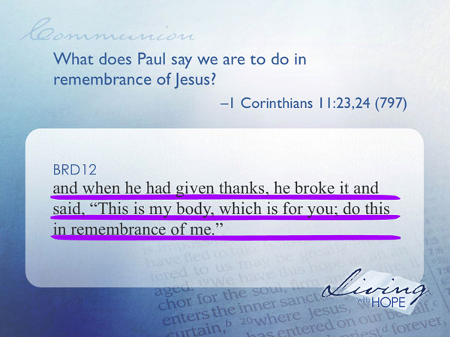
and when he had given thanks, he broke it and said, "This is my body, which is for you; do this in remembrance of me."

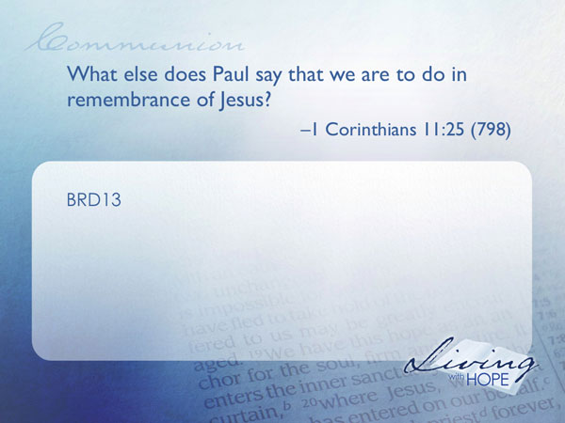
I invite you now to partake in the living bread with me. (After you have modeled eating the bread, have a prayer of blessing on the grape juice)
BRD13 What else does Paul say that we are to do in remembrance of Jesus? I Corinthians 11:25 (798)

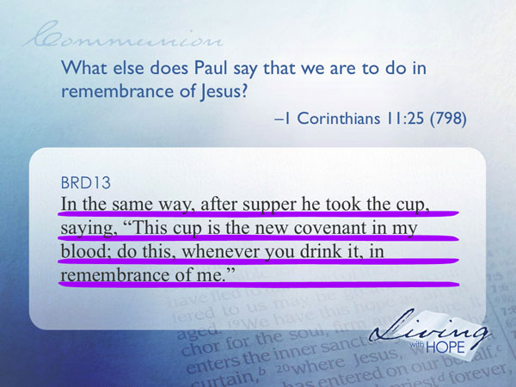
In the same way, after supper he took the cup, saying, "This cup is the new covenant in my blood; do this, whenever you drink it, in remembrance of me."
I invite you now to partake in the forgiving wine (model partaking of the grape juice)
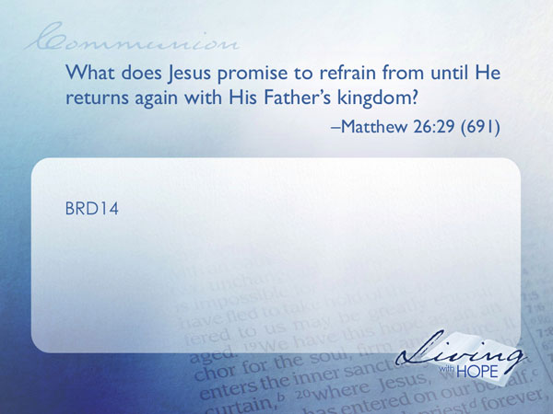
As Jesus closes this intimate worship experience where the left and right brain come together he leaves with a powerful symbol of hope.
BRD14 What does Jesus promise to refrain from until He returns again with His Father’s kingdom? Matthew 26:29 (691)

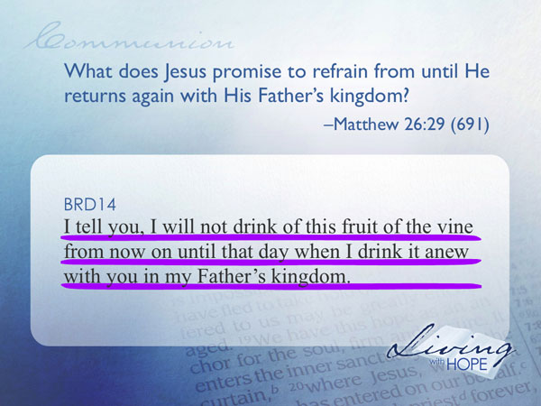
I tell you, I will not drink of this fruit of the vine from now on until that day when I drink it anew with you in my Father's kingdom."

Even as we eat and drink in this worship experience we know that Jesus is not partaking. He is fasting. He is longing to return to us. And when he does return there will be a grand feast of celebration!
Well I can’t believe that we’ve completed all sixteen lessons. The time seems to have flown by. I want to affirm you for how hard you have studied. I want to affirm the staff at this church for their hard work in assisting us in this journey. Yet this is not the end, it is simply the beginning. We’ve only done a quick flyover and highlighted some of the major teachings of the Bible. Now the journey of hope continues in earnest.
I invite you to continue the habits of Bible study that you’ve established during this journey. May this flyover be just the beginning as you dive into scripture. You know your away around the Bible now. May I suggest that you continue with your small group or join another one for some deeper Bible study? Some groups may be studying in depth some of the topics of scripture. Others may be studying a particular book of the Bible in depth. I want to also encourage you to continue your habit of worship with the body of Christ. Please consider yourself a part of this community and let us continue our journey together in service to the Lord Jesus Christ.
And now in the words of Jesus, “go and make disciples of all nations, baptizing them in the name of the Father and of the Son and of the Holy Spirit, teaching them to obey everything I have commanded you. And surely I am with you always, to the very end of the age."
❑ I wish to serve God with all my heart.
❑ I can’t wait to get more involved with this church.

###

This illustration was taken from the HeraldSun: http://www.news.com.au/heraldsun/story/0,21985,22556281-661,00.html
John Dybdal., Missions: A Two –Way Street, as quoted in Seventh-day Adventist Believe, 229.
Here is the Seventh-day Adventist church’s official statement of belief on the Lord’s Supper: “The Lord's Supper is a participation in the emblems of the body and blood of Jesus as an expression of faith in Him, our Lord and Saviour. In this experience of communion Christ is present to meet and strengthen His people. As we partake, we joyfully proclaim the Lord's death until He comes again. Preparation for the Supper includes self-examination, repentance, and confession. The Master ordained the service of foot washing to signify renewed cleansing, to express a willingness to serve one another in Christlike humility, and to unite our hearts in love. The communion service is open to all believing Christians. (1 Cor. 10:16, 17; 11:23-30; Matt. 26:17-30; Rev. 3:20; John 6:48-63; 13:1-17.)”

