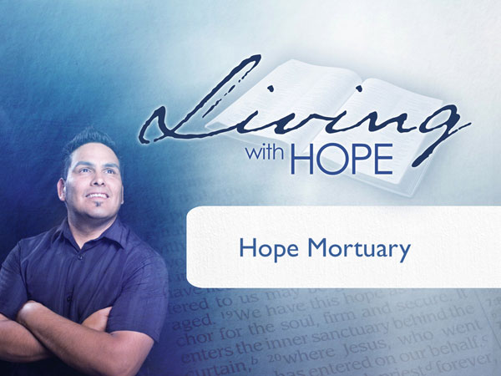
Living with Hope
Presentation 13: Heaven
Hope Mortuary

(Note: icon means “Next Slide,” indicating when to advance to the next slide.)

Have you ever noticed that people’s names somehow uncannily relate to the business they have chosen? What do you suppose the occupation of Dr. Brain from Bethesda Maryland is? --Psychiatrist. And George McGovern? --Presidential candidate. Bernard Madoff? --Architect of the worlds largest ponzie scheme.

I particularly find a certain dark humor in some real business names. They are all in the same occupation. I’ll read the name and see if you can figure out the occupation.

Peek. Boxwell brothers. Grimm. Eikenberry. Earthman. and Deady. Did you guess? These are all real names of Funeral Homes. Linguists call these names aptronyms which means that the name is aptly suited to its owner. And then there are inaptonyms, a name that is ironically inappropriate for the occupation. For example what do you suppose Jaime L. Sin did for a living? He was the archbishop of Manila. And if you were to chose an inaptonym for a funeral home, what would it be? Hope Mortuary? I tried to google that name and could not find one Hope Mortuary listed, not even a Hope Undertakers or Hope Funeral Home. Hope doesn’t seem to mix well with a funeral home. Death seems to be the antithesis of hope doesn’t it?

At funerals we use euphemisms to help soften our grief. We speak of saying ‘goodbye’ to a loved one. But if we are saying goodbye, where are they going? A little boy was so curious that he wrote the following words on a tombstone: “Dear God: What is it like when you die? Nobody will tell me. I just want to know. I don’t want to do it. Your friend, Mike.”

Sooner or later we will all have the correct answer. In the meantime here are some common answers. A small minority of people believe that at death everything is over. There is no afterlife. There is no resurrection. When you’re dead, you’re dead. The end.

Most however hope that there is more to our existence than our mortal walk in this earthy world. Hollywood recognizes hope and continually offers up movies that suggest that there is an afterlife, that there is life beyond the grave. Mummies come to life, houses are haunted, and we see dead people.

So really what happens after death? Eastern religions generally teach the doctrine of reincarnation. That means that once you have completed your journey your soul then enters another organism for the next incarnation. If you lived a very good life, you may be reincarnated as a Brahman in your next life. If you live a long succession of increasingly righteous lives eventually you become part of the world soul and enter the state of nirvana. If you lived a wicked life you might be reincarnated as a pig or a toad or some lower life form.

Monotheists such as Jews, Christians, and Muslims generally favor another thesis, and that is that you retain your current identity after death and will someday be raised back to life again in your final destiny, either heaven or hell.

Of course within that broad understanding there are many nuanced differences between the different branches of each of faith. For example Roman Catholics teach that unless you really lived a good life you don’t go directly to heaven after you die. Instead you go to a state of purgatory until you get the sins burned out of you and you are clean enough for heaven. If you lived a very wicked life you go directly to hell and bypass purgatory altogether.

Among other Christians there is a great variety of explanations of the afterlife from the universalists who declare that everyone will go to heaven after they die no matter how they lived their lives, to the hard core Calvinists who believe that God has predetermined who is going to heaven and hell and there really isn’t much you can do about it but fulfill your destiny.

Now you may not think that these viewpoints mean that much. But indeed they do. What we believe about the future affects our lives right now. For example, if you believe in the God of the puritans who relished torturing sinners in the scalding flames of hell, then how does that shape your picture of God? Is that a God that you want to have much to do with? Probably not. Spend eternity with? Definitely not.

Or if you’re a passionate young man and you are taught that those who perform extreme acts of Jihad will be rewarded in heaven with 72 virgins you might just be willing to pull the pin on a bomb and blow yourself up in a crowd of infidels.

Or if you believe that those who fall asleep in Jesus will someday be reunited with their friends and family you might do whatever necessary to be among those who fall asleep in Jesus.

Our beliefs in the afterlife affect our present life. Our hope in the future gives us power in the present. So today I would like to share another view of the future. This one is based on the Bible. Parts of it may feel familiar to you and there may be parts that are new and refreshing. Come with an open mind as we open some scriptures today to find out what the Bible really teaches about what is going to happen in the future as we enter Hope Mortuary.

I’d like to construct a timeline that can serve as a template for understanding our chronology of personhood.

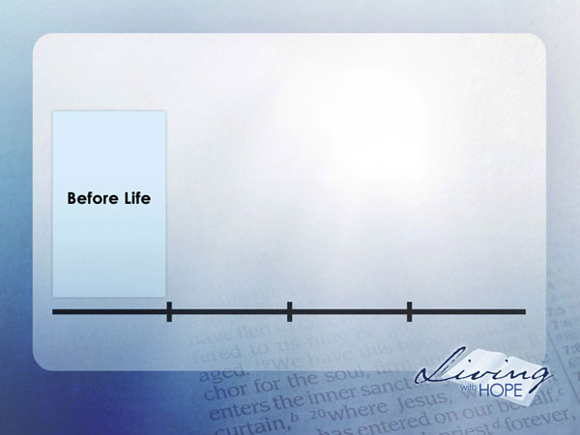
Before Life
Although the Mormon faith, Hindu, Buddhist and Church of Scientology all teach that you pre-existed as another life form, the Bible doesn’t teach pre-existence. That is not to say that God didn’t intend for you to be born. On the contrary; He planned your personhood from the beginning.
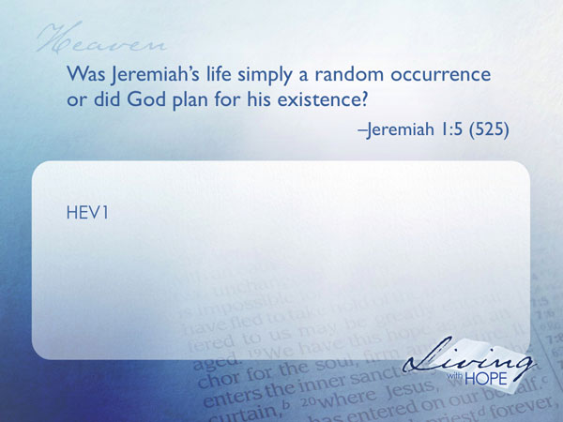
HEV1 Was Jeremiah’s life simply a random occurrence or did God plan for his existence? Jeremiah 1:5 (525)

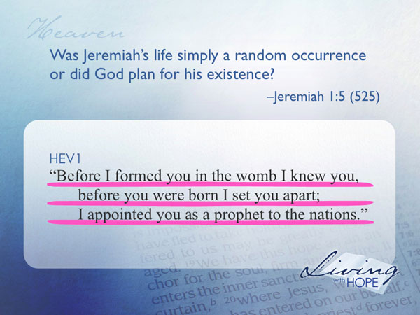
"Before I formed you in the womb I knew you,
before you were born I set you apart;
I appointed you as a prophet to the nations."

God had dreams for Jeremiah’s ministry as a prophet long before he was ever born. How about us?
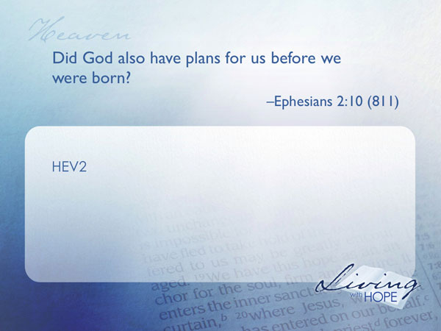
HEV2 Did God also have plans for us before we were born? Ephesians 2:10 (811)

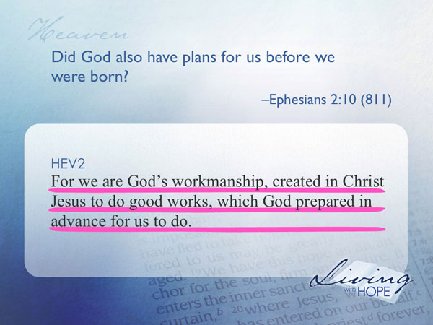
For we are God's workmanship, created in Christ Jesus to do good works, which God prepared in advance for us to do.

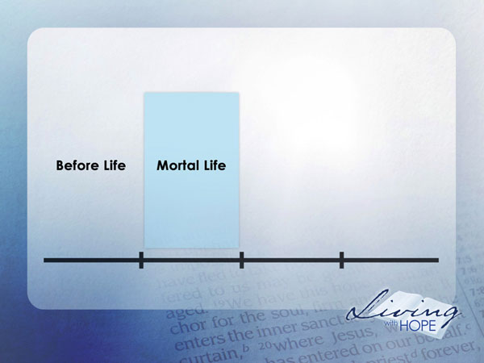
Mortal life
As we move forward in time eventually God’s plans for life come to fruition and human life is created.

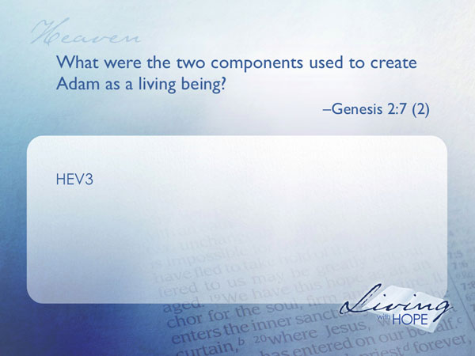
HEV3 What were the two components used to create Adam as a living being? Genesis 2:7 (2)

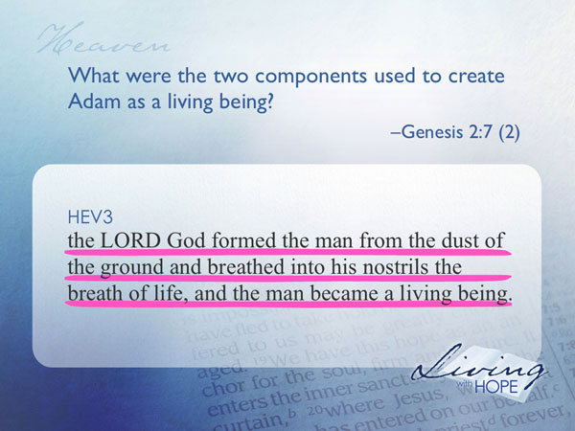
the LORD God formed the man from the dust of the ground and breathed into his nostrils the breath of life, and the man became a living being.

I picture God stooping down on his knee, assembling all of the essential chemicals from the earth, forming microscopic DNA, cell structure, tissue, organs, limbs, hair, eyes, and all of the billions of intricate components that make up the human body, but Adam wasn’t yet alive. God needed to give Adam the spark of life. Only then did Adam become a living, breathing, animated person. Keep these two components of dust and breath in mind because they help us understand the equation of life.

Unfortunately Adam’s life was not as long as God had intended. Adam and Eve were faced with a powerful temptation.
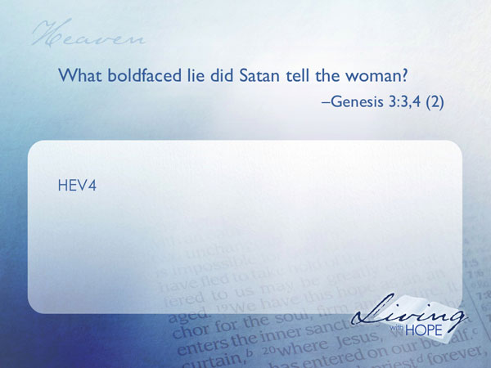
HEV4 What boldfaced lie did Satan tell the woman? Genesis 3:3,4 (2)

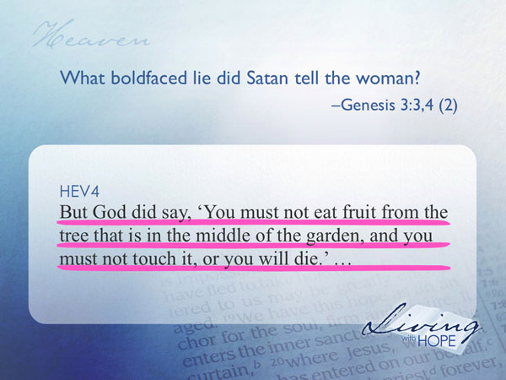
...but God did say, 'You must not eat fruit from the tree that is in the middle of the garden, and you must not touch it, or you will die.' "

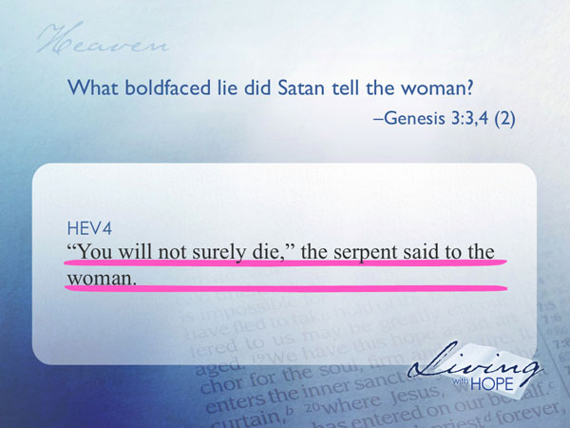
"You will not surely die," the serpent said to the woman.
And you probably know what happened next in this pivotal story. Adam and Eve ate the fruit and eventually died. Since then all humanity has been mortal--that means that we all will die sooner or later. Look to your left, look to your right. That person next to you is dying and sooner or later will be gone. You know that to be true. What a sobering thought. You’ve been to enough funerals, you’ve read enough newspapers, you’ve lived long enough, to know that everyone you know, including you, will eventually die (except of course those who are alive at the return of Jesus).

In fact, death is so predictable that statisticians can estimate your death date. There are websites that you can visit and fill out a simple questionnaire and receive a predicted death date! Try it sometime if you’re feeling just a little too happy and you need something to bring you down!
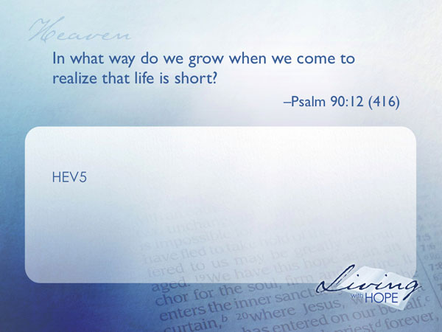
The Bible writers knew that eventually everyone dies.

HEV5 In what way do we grow when we come to realize that life is short? Psalm 90:12 (416)

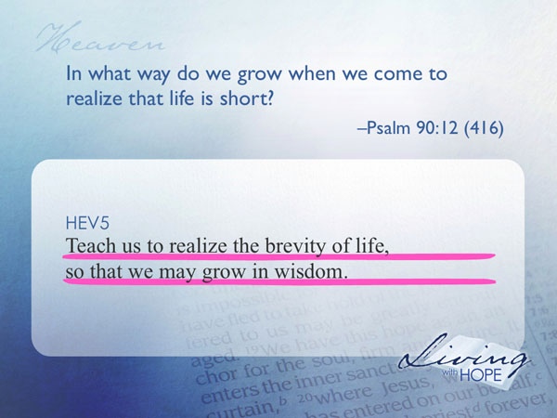
Teach us to realize the brevity of life,
so that we may grow in wisdom.

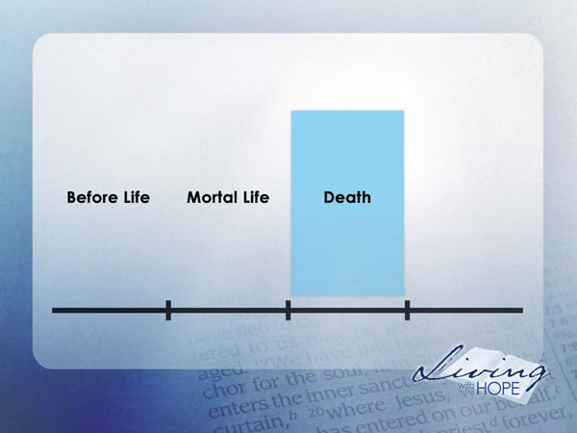
Death
Eastern religions teach reincarnation. The ancient Greeks believed in a place called Hades, a flaming inferno that contained the dead. Most religions of the world teach some kind of afterlife whether in heaven, hell, or some intermediary state. A careful reading of the Bible reveals quite a different picture of what happens after we die.
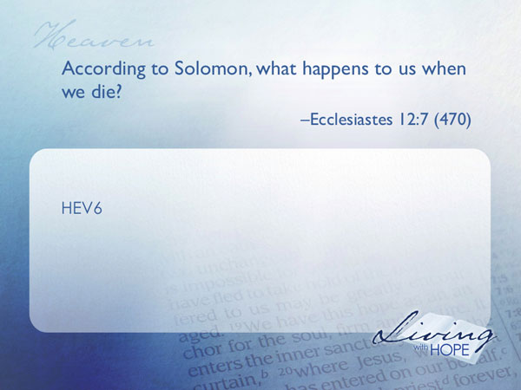
HEV6 According to Solomon, what happens to us when we die? Ecclesiastes 12:7 (470)

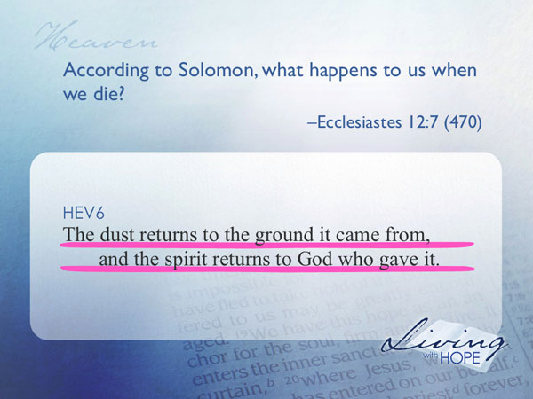
...the dust returns to the ground it came from,
and the spirit returns to God who gave it.
Life is deconstructed into the same raw material that it was built with: dust and spirit. The dust is the raw chemicals that the human body is made out of, and the spirit is the breath of life that God gave in the first place. At death what happens to the life? There is no life. It is gone.

Here’s a simple analogy. When you walk into a dark room and flip the switch, you allow electricity to flow through a wire into the light bulb and out comes light. When you leave the room you flip the light switch which cuts off the supply of electricity and the light goes out. What happens to the light when you switch it off? There is no light. When God created life, he assembled the dust, and then switched on life by breathing into Adam’s nostrils. In the same way, at death, the life giving spirit of God no longer energizes the body, and the corpse returns to dust. What happens to life when the spirit of God is gone? There is no life.

That’s a simple technical explanation of death. But what is it like experientially?
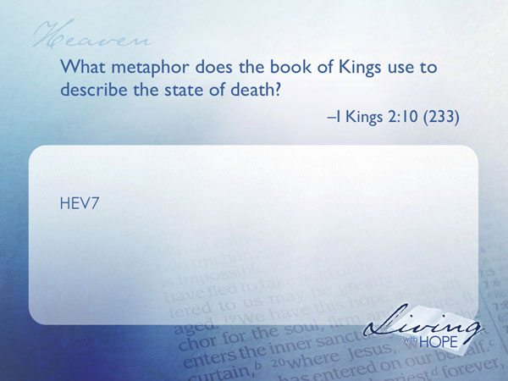
HEV7 What metaphor does the book of Kings use to describe the state of death? I Kings 2:10 (233)

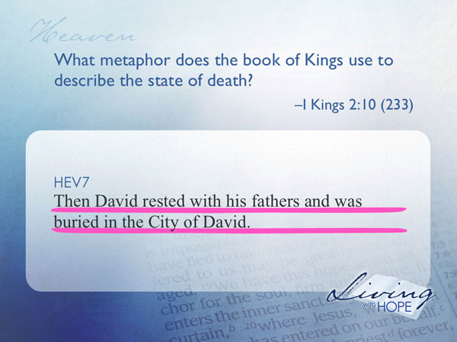

Then David rested with his fathers and was buried in the City of David.

Clearly this is speaking of the experience that David had in death. His body was buried with his ancestors in the City of David. Death for him is described as a rest.
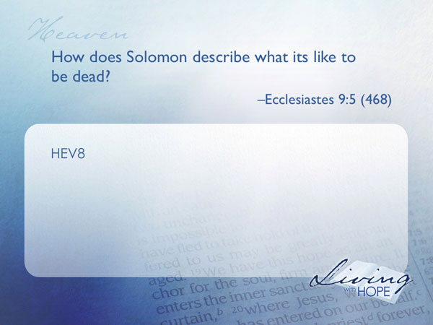
HEV8 How does Solomon describe what its like to be dead? Ecclesiastes 9:5 (468)

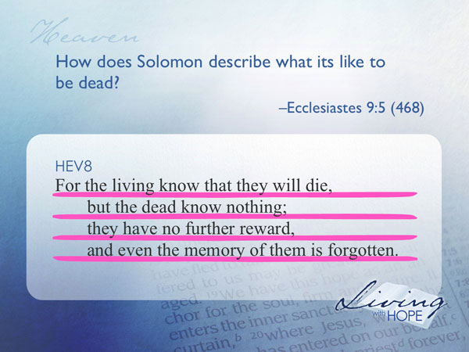
For the living know that they will die,
but the dead know nothing;
they have no further reward,
and even the memory of them is forgotten.

Solomon isn’t describing a light sleeper. This is total unconsciousness. There are not even any thoughts or dreams. The metaphor is pervasive in scripture and the New Testament writers rely heavy on the simile of sleep.

Jesus comes face to face with a grieving family who has just lost their twelve year old daughter.
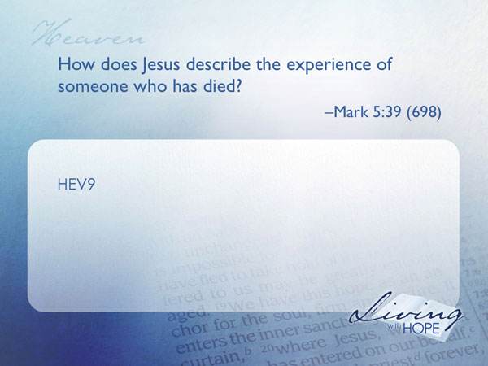
HEV9 How does Jesus describe the experience of someone who has died? Mark 5:39 (698)

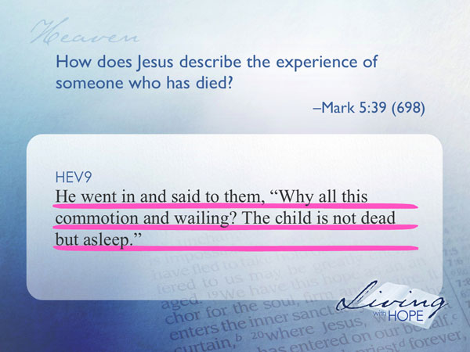
He went in and said to them, "Why all this commotion and wailing? The child is not dead but asleep."
Jesus promptly raises her from the dead. The metaphor of sleep is used because sleep is a temporary unconsciousness followed by an awakening back to full consciousness through a resurrection. This little girl is one of the few people who died and lived to tell about it! Perhaps the most famous resurrection in the gospels is the story of Lazarus. The writers clearly show that he is really dead, not just sleeping, yet Jesus stays with the sleep metaphor.
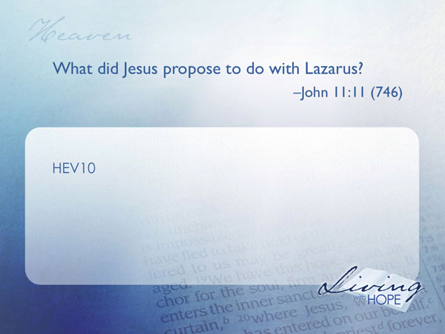
HEV10 What did Jesus propose to do with Lazarus? John 11:11 (746)

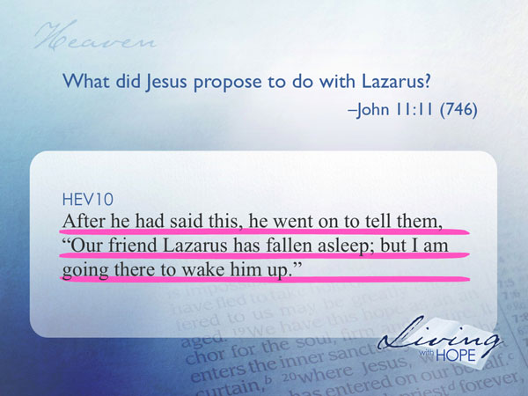
After he had said this, he went on to tell them, "Our friend Lazarus has fallen asleep; but I am going there to wake him up."

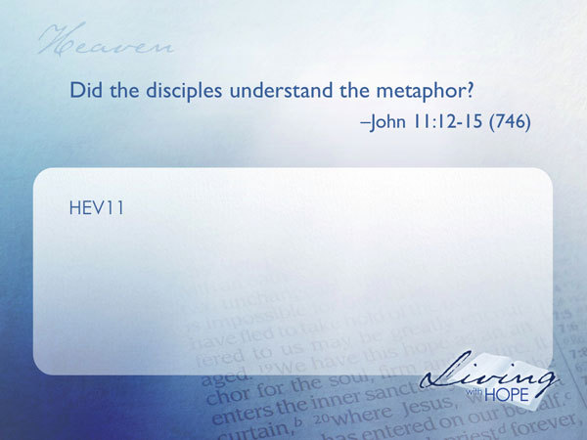
HEV11 Did the disciples understand the metaphor? John 11:12-15 (746)

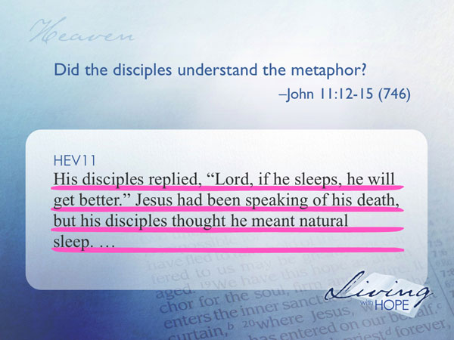
His disciples replied, "Lord, if he sleeps, he will get better." Jesus had been speaking of his death, but his disciples thought he meant natural sleep.

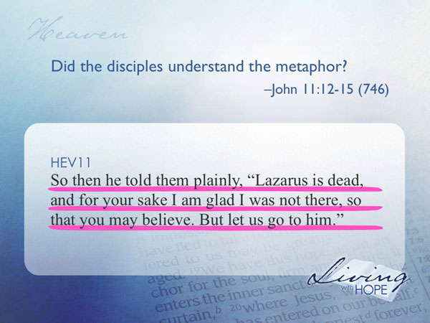
So then he told them plainly, "Lazarus is dead, and for your sake I am glad I was not there, so that you may believe. But let us go to him."
We know he was dead because he was in the tomb for four days and his sisters warned Jesus that the tomb would smell from bodily decay (verse 39).

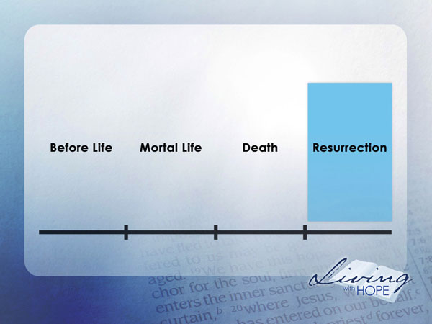
What is the experience like to be dead? The closest analogy that the Bible writers can come up with is that death is like sleeping. At death we slip into a sleep of total unconsciousness. And like sleep, this state of unconsciousness is only temporary, morning is coming.

Resurrection
But in this story of Lazarus, the Bible talks about something after death.

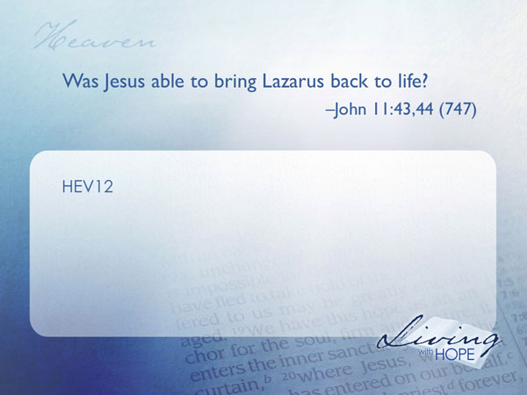
HEV12 Was Jesus able to bring Lazarus back to life? John 11:43,44 (747)

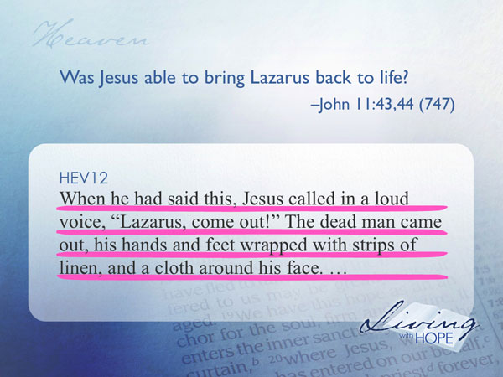
When he had said this, Jesus called in a loud voice, "Lazarus, come out!" The dead man came out, his hands and feet wrapped with strips of linen, and a cloth around his face.

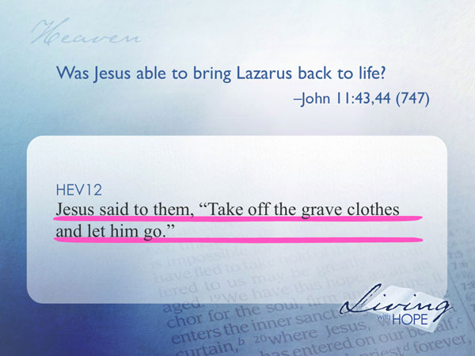
Jesus said to them, "Take off the grave clothes and let him go."

This resurrection of Lazarus was but a foretaste of a great resurrection to come.

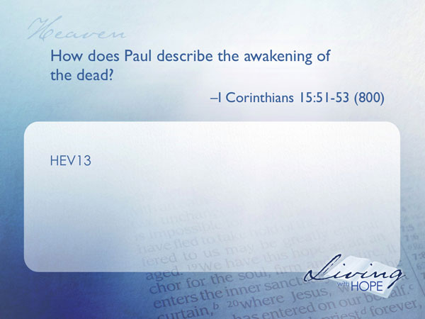
HEV13 How does Paul describe the awakening of the dead? I Corinthians 15:51-53 (800)

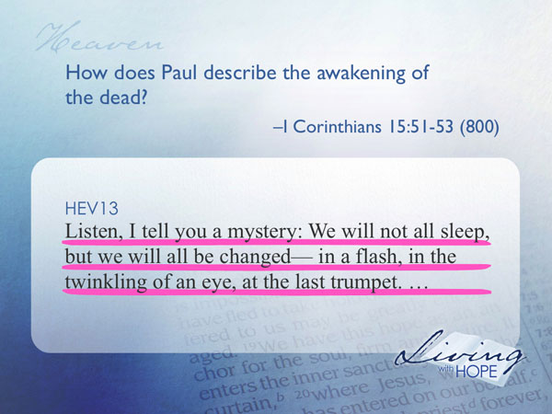
Listen, I tell you a mystery: We will not all sleep, but we will all be changed— in a flash, in the twinkling of an eye, at the last trumpet.

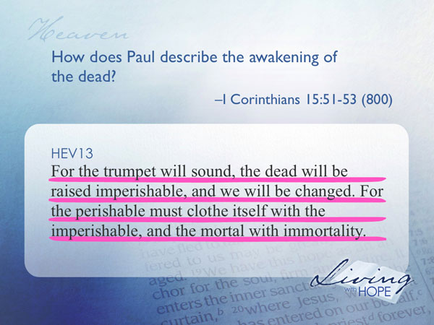
For the trumpet will sound, the dead will be raised imperishable, and we will be changed. For the perishable must clothe itself with the imperishable, and the mortal with immortality.

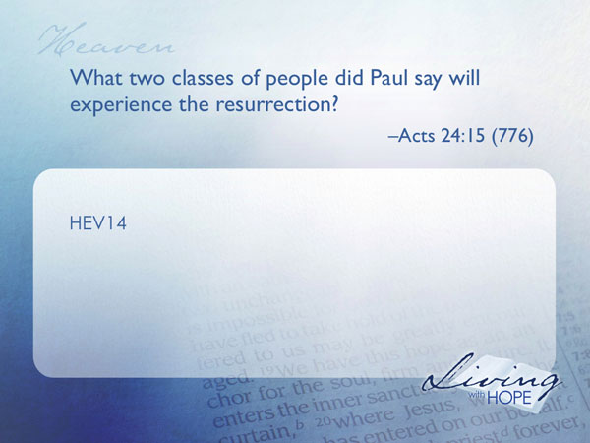
The Bible calls the awakening of the dead the resurrection. What is the experience like? There is probably no perception of the passing of time. It is as though at one moment you go to sleep in death, and the next moment you are awakened by the heavenly trumpet.

HEV14 What two classes of people did Paul say will experience the resurrection? Acts 24:15 (776)

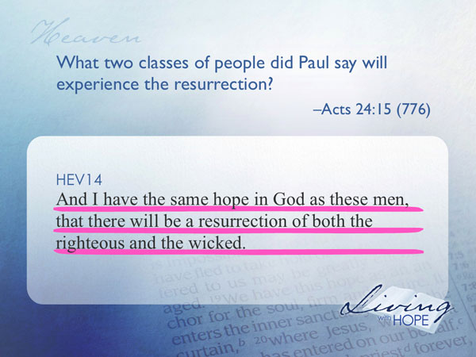
...and I have the same hope in God as these men, that there will be a resurrection of both the righteous and the wicked.

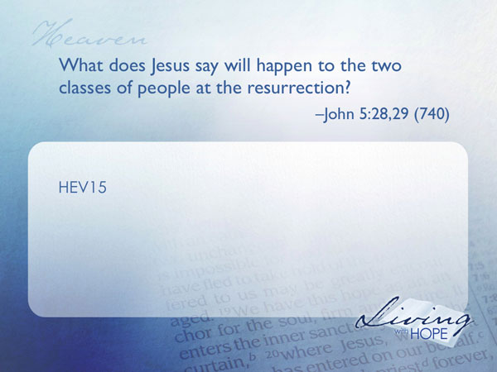
HEV15 What does Jesus say will happen to the two classes of people at the resurrection? John 5:28,29 (740)

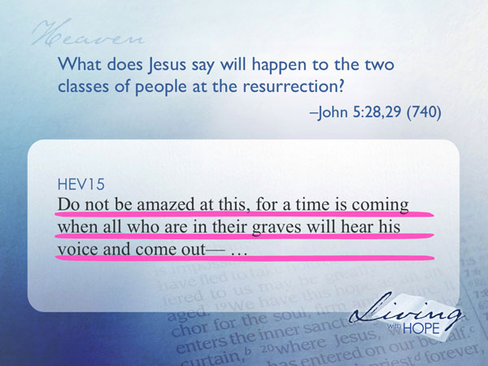
"Do not be amazed at this, for a time is coming when all who are in their graves will hear his voice and come out—
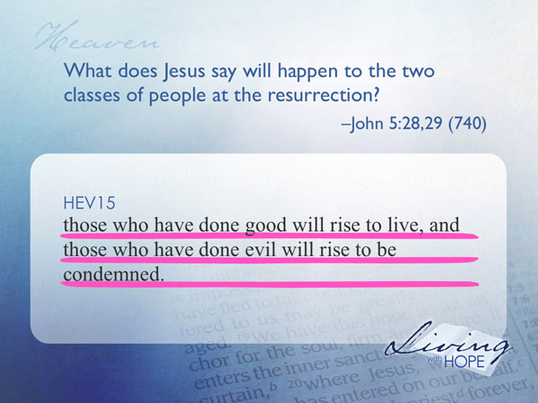
those who have done good will rise to live, and those who have done evil will rise to be condemned.
So, everyone is going to be raised to life. The important part is not that you are going to be raised from the dead, but rather, which class of people you will be raised with.
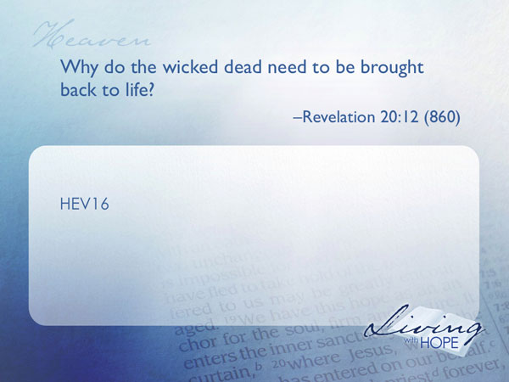
HEV16 Why do the wicked dead need to be brought back to life? Revelation 20:12 (860)

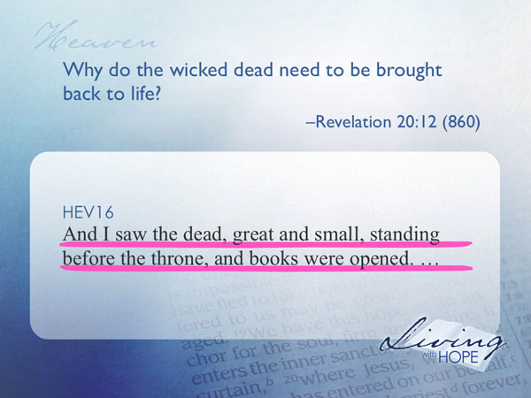
And I saw the dead, great and small, standing before the throne, and books were opened.

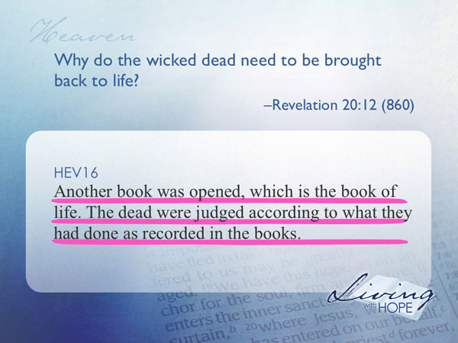
Another book was opened, which is the book of life. The dead were judged according to what they had done as recorded in the books.

There needs to be no question in anyone’s mind that these individuals have chosen a life apart from the grace of God. This is the moment when the truth of their lives is revealed to all.
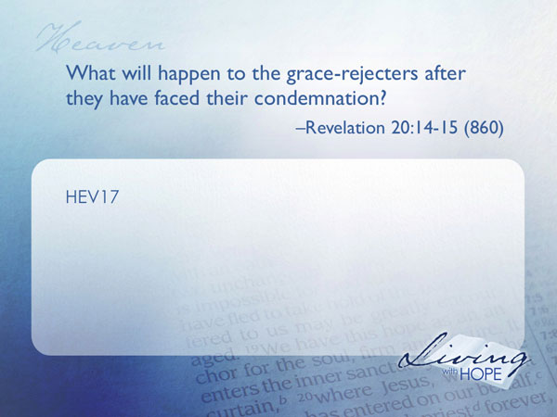
HEV17 What will happen to the evildoers after they have faced their condemnation? Revelation 20:14-15 (860)

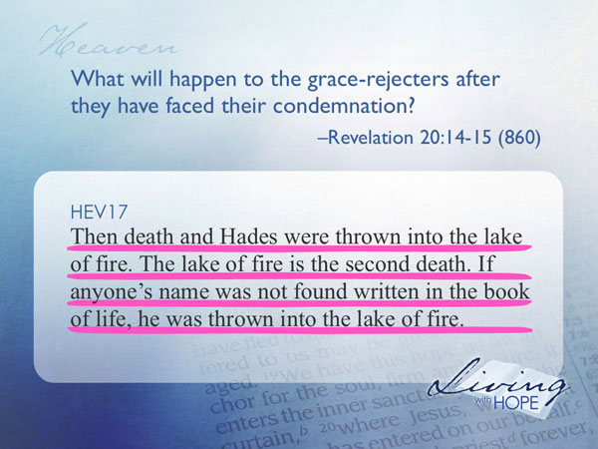
Then death and Hades were thrown into the lake of fire. The lake of fire is the second death. If anyone's name was not found written in the book of life, he was thrown into the lake of fire.

At that moment the fate of all is sealed forever. Those who have chosen to follow God will have eternal life—immortality. They will never be subject to death again. Those who have chosen not to follow God will have eternal death. They are destroyed in the lake of fire, they cease to exist, never to live again. The universe will no longer be plagued by their evil.
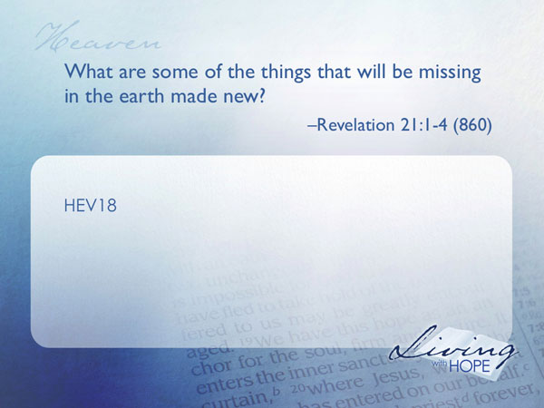
HEV18 What are some of the things that will be missing in the earth made new? Revelation 21:1-4 (860)

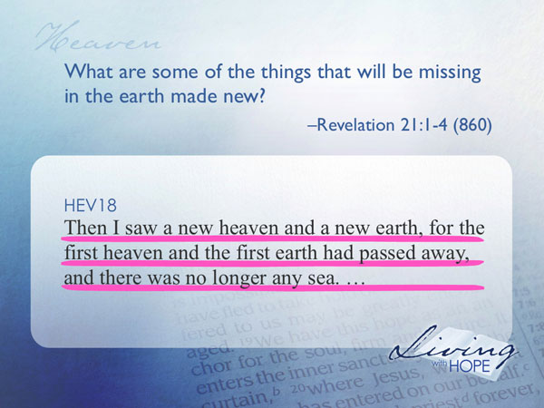
Then I saw a new heaven and a new earth, for the first heaven and the first earth had passed away, and there was no longer any sea.

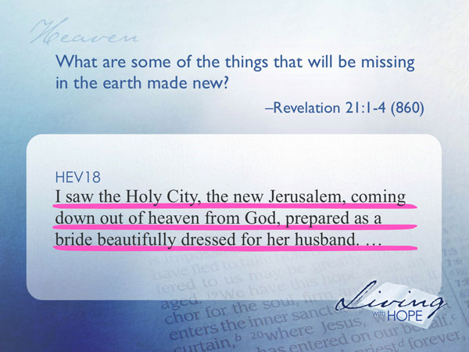
I saw the Holy City, the new Jerusalem, coming down out of heaven from God, prepared as a bride beautifully dressed for her husband.

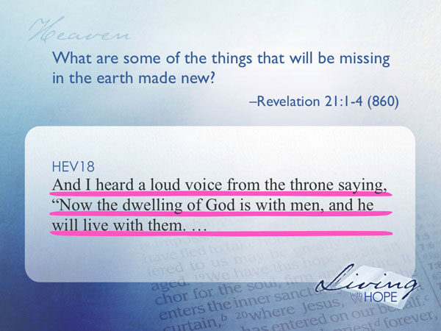
And I heard a loud voice from the throne saying, "Now the dwelling of God is with men, and he will live with them.

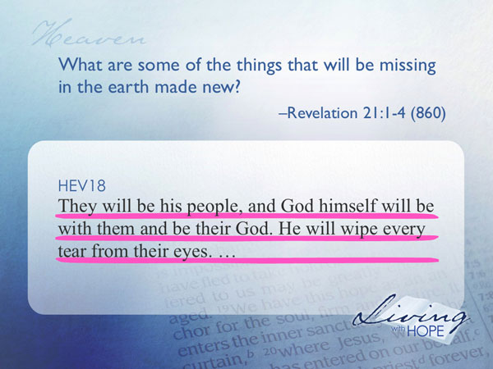
They will be his people, and God himself will be with them and be their God. He will wipe every tear from their eyes.

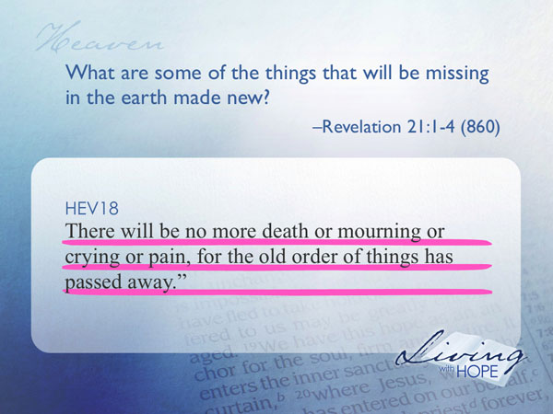
There will be no more death or mourning or crying or pain, for the old order of things has passed away."

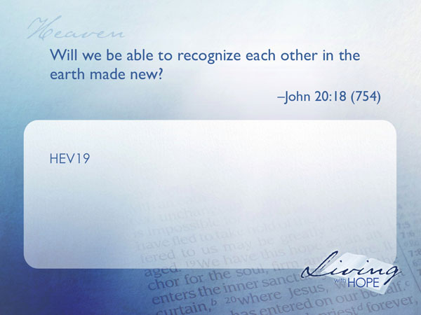
HEV19 Will we be able to recognize each other in the earth made new? John 20:18 (754)

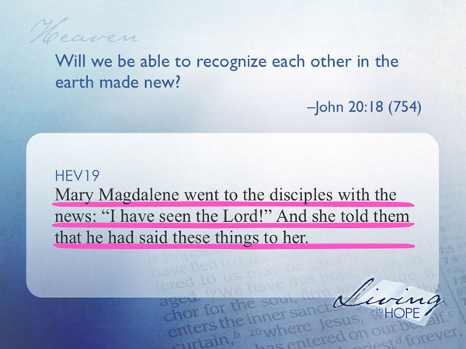
Mary Magdalene went to the disciples with the news: "I have seen the Lord!" And she told them that he had said these things to her.
Mary was so filled with grief that she didn’t at first recognize the resurrected Christ. But after He spoke her name she immediately knew it was Him and shared the good news to the other disciples.

If you’ve ever been to a high school class reunion you know there is an awkward moment when you can’t seem to pick anyone you know out of the crowd of old people. Then once you start talking, you begin to recognize your classmates despite the changes that aging brings.

Something similar is going to happen in the earth made new. We may not be able to recognize people at first with their brand new healthy young bodies, but it won’t take long until we begin to recognize our friends and family and are reunited.

After his resurrection Jesus joined up with His disciples. Some still thought he was dead so his appearance was a bit of a surprise. Jesus’ disciples had the misconception that resurrected people are simply ethereal ghosts.
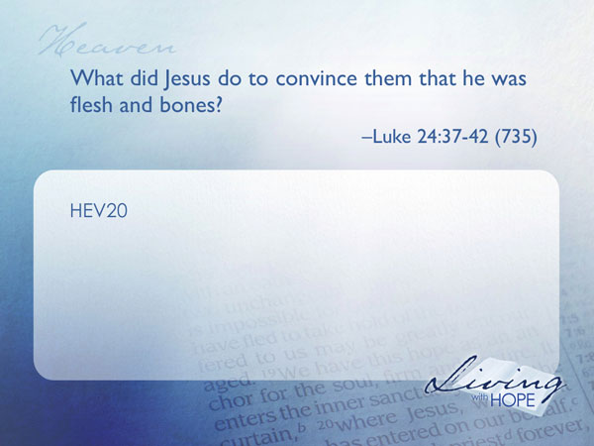
HEV20 What did Jesus do to convince them that he was flesh and bones? Luke 24:37-42 (735)

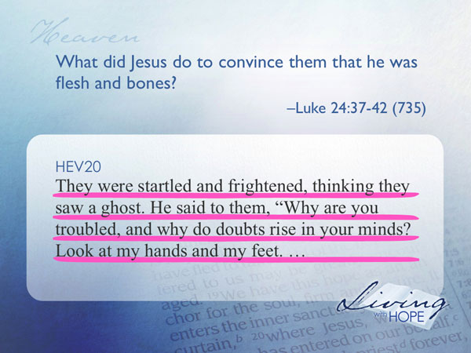
They were startled and frightened, thinking they saw a ghost. He said to them, "Why are you troubled, and why do doubts rise in your minds? Look at my hands and my feet.

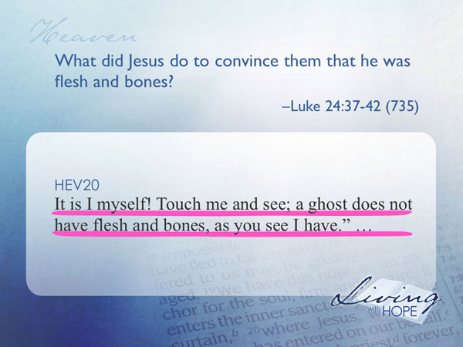
It is I myself! Touch me and see; a ghost does not have flesh and bones, as you see I have."

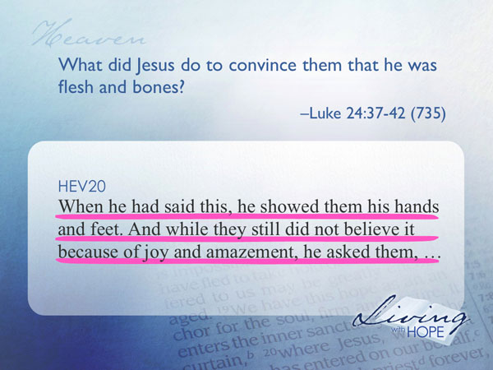
When he had said this, he showed them his hands and feet. And while they still did not believe it because of joy and amazement, he asked them,

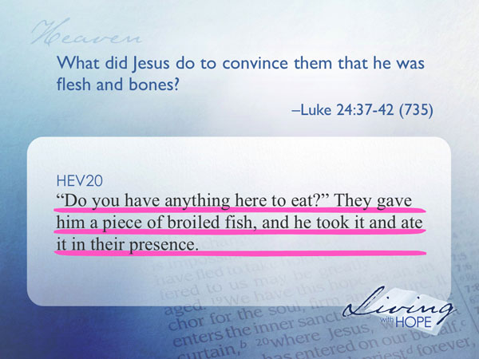
"Do you have anything here to eat?" They gave him a piece of broiled fish, and he took it and ate it in their presence.

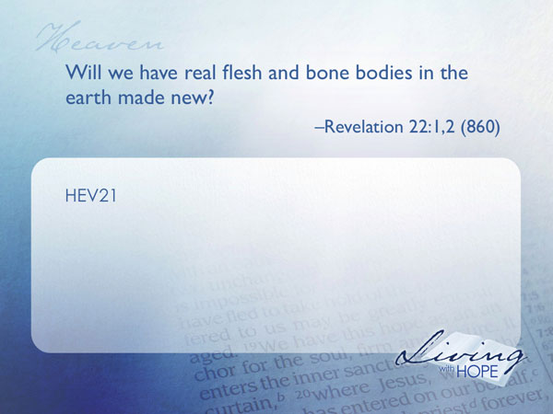
HEV21 Will we have real flesh and bone bodies in the earth made new? Revelation 22:1,2 (860)

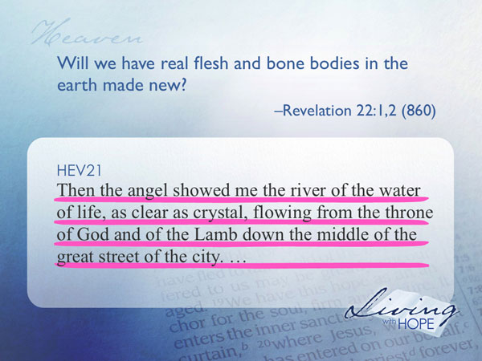
Then the angel showed me the river of the water of life, as clear as crystal, flowing from the throne of God and of the Lamb down the middle of the great street of the city.

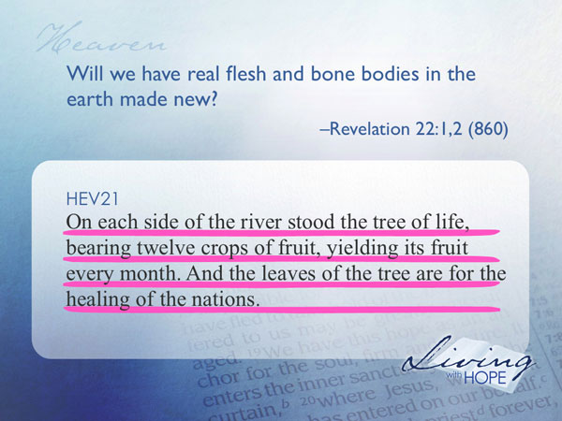
On each side of the river stood the tree of life, bearing twelve crops of fruit, yielding its fruit every month. And the leaves of the tree are for the healing of the nations.

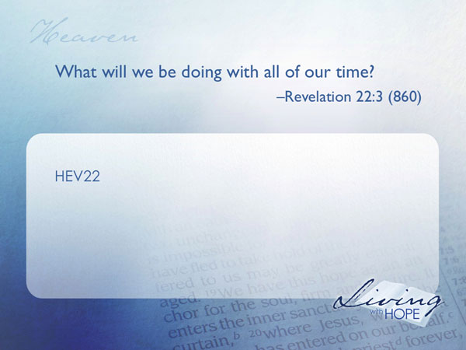
As in the original creation, God took the dust of the ground and breathed into Adam the breath of life. So too in the earth made new, the resurrected will be flesh and blood people eating fruit from the tree of life, and drinking water from they crystal river.

HEV22 What will we be doing with all of our time? Revelation 22:3 (860)

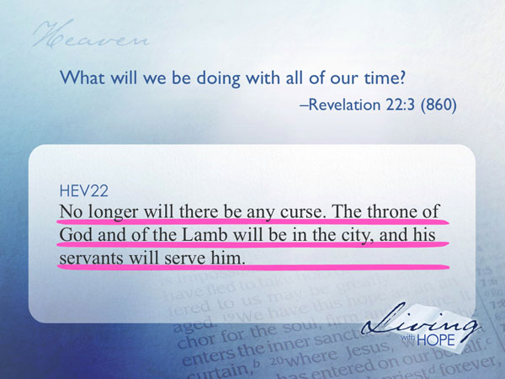
No longer will there be any curse. The throne of God and of the Lamb will be in the city, and his servants will serve him.

Nothing will distract us from a joyful life of serving the Lamb of God, Jesus Christ who redeemed us. This is not a life of self absorption and the pursuit of entertainment; this is an eternal life of service!

How about you? An understanding of what is going to happen in the future will affect our lives in the present.

In 1838 the residents of Rochester New York created a cemetery like no other in the world. It was massive, taking up 197 acres. Formed by glaciers this cemetery has high hills, deep valleys, winding eskers and almost bottomless kettles. The whole place is a forest of trees. There are mausoleums dug deep into the hillsides, stone and bronze sculptures, gothic towers gloriously decorating more than 350,000 graves. Susan B. Anthony is buried there. Frederick Douglass, and Frank E. Gannett. But what makes this cemetery unique is not its topography, or adornments, nor the famous names on the headstones. What makes it unique is its name: Mount Hope Cemetery. It is not an in inaptonyms. Mount Hope Cemetery is an aptonym. The ones who chose this unique name are correct. There is hope. This life on earth is only the opening day of eternity. When Jesus returns there’s going to be a whole lot of action at Mt Hope Cemetery and indeed throughout this entire planet.

Paul, as he is speaking of the resurrection, says to comfort one another with these words. Having hope in the future can bring great joy and meaning to our lives right now. That my friends, is what I call the Hope Mortuary. It is what I believe the Bible teaches about what is to come. As you can see, in some ways it is similar to other world religions, but in other ways it is quite unique. I find it refreshing and comforting. Here are some of my takeaways:
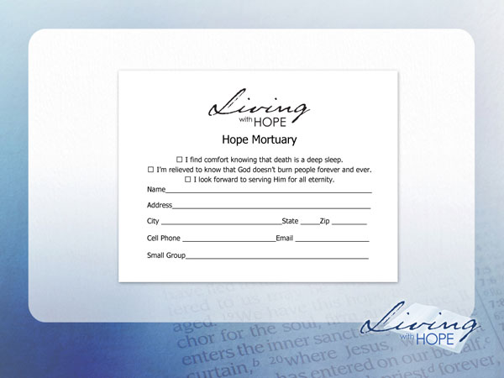
❑ I find comfort knowing that death is a deep sleep.
❑ I’m relieved to know that God doesn’t burn people forever and ever.
❑ I look forward to serving Him for all eternity.

# # #

For a more complete study of the sexual and materialistic view of Muslim Paradise see http://www.guardian.co.uk/books/2002/jan/12/books.guardianreview5
Read the entire story in Mark 5:35-43 for a thrilling description of the power that God has over death.
The resurrected Jesus and Lazarus also had real flesh and blood bodies. See John 20:26-28 and John 12:2
Here is what the Seventh-day Adventist Church teaches on these subjects: Death and Resurrection: “The wages of sin is death. But God, who alone is immortal, will grant eternal life to His redeemed. Until that day death is an unconscious state for all people. When Christ, who is our life, appears, the resurrected righteous and the living righteous will be glorified and caught up to meet their Lord. The second resurrection, the resurrection of the unrighteous, will take place a thousand years later. (Rom. 6:23; 1 Tim. 6:15, 16; Eccl. 9:5, 6; Ps. 146:3, 4; John 11:11-14; Col. 3:4; 1 Cor. 15:51-54; 1 Thess. 4:13-17; John 5:28, 29; Rev. 20:1-10.)” Millennium and the End of Sin: The millennium is the thousand-year reign of Christ with His saints in heaven between the first and second resurrections. During this time the wicked dead will be judged; the earth will be utterly desolate, without living human inhabitants, but occupied by Satan and his angels. At its close Christ with His saints and the Holy City will descend from heaven to earth. The unrighteous dead will then be resurrected, and with Satan and his angels will surround the city; but fire from God will consume them and cleanse the earth. The universe will thus be freed of sin and sinners forever. (Rev. 20; 1 Cor. 6:2, 3; Jer. 4:23-26; Rev. 21:1-5; Mal. 4:1; Eze. 28:18, 19.) New Earth: On the new earth, in which righteousness dwells, God will provide an eternal home for the redeemed and a perfect environment for everlasting life, love, joy, and learning in His presence. For here God Himself will dwell with His people, and suffering and death will have passed away. The great controversy will be ended, and sin will be no more. All things, animate and inanimate, will declare that God is love; and He shall reign forever. Amen. (2 Peter 3:13; Isa. 35; 65:17-25; Matt. 5:5; Rev. 21:1-7; 22:1-5; 11:15.)

