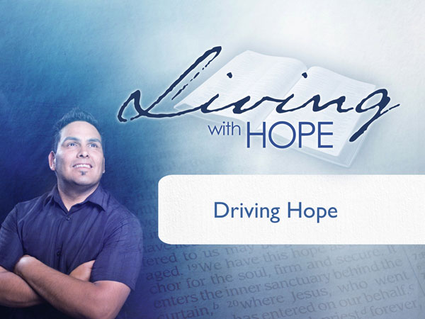
Living With Hope
Presentation 12: Healthy Behavior
Driving Hope
Last Revision: 6/12/2009

(Note: icon means “Next Slide,” indicating when to advance to the next slide.)

Imagine you’ve been given the keys to a brand new luxury car. Sit down in the leather seat. Smell the fresh interior. Rub your fingers over the hand polished wooden dashboard. Now reach over and open up the glove compartment. Go ahead and pull out that big thick book. What is it? It’s the owner’s manual--perhaps not the easiest book to read, after all there is no plot or characters, no drama, but you do have an interest in it. Why? If this car is to perform at its best, and last a long time, you need to know how to take care of it. The owner’s manual gives you the answers.

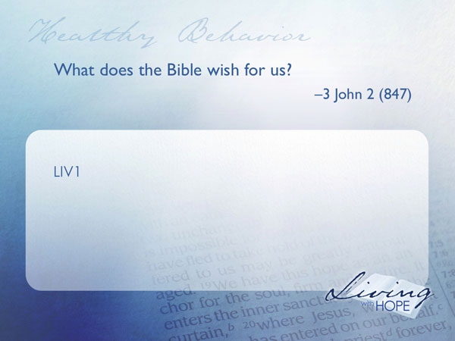
You’ve been given the keys to something more refined, more efficient, and a lot more sophisticated than the most luxurious automobile, and that is the human body. Wouldn’t it be swell if the human body came with an instructional manual? A manual that would tell us how to take care of our bodies? What to take in? What to leave out? How to service it? Actually, there is such a book. It’s called the Bible.

The Owner’s Manual
LIV1 What does the Bible wish for us? 3 John 2 (847)

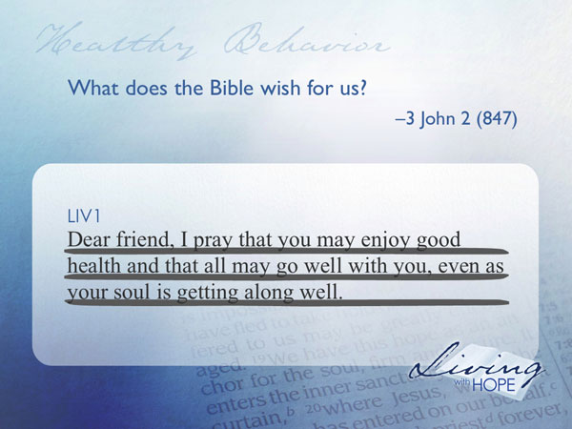
Dear friend, I pray that you may enjoy good health and that all may go well with you, even as your soul is getting along well.

The writer John is writing to his friend Gaius and starts out the letter with this Christian blessing of prosperity. Even though the letter was written almost two thousand years ago the desire for good health is still relevant today. Health care costs in the United States amounted to 15.2% of the gross domestic product. In 2007 the U.S. spent 2.26 trillion on health care, or $7,439 per person. Certainly our pocketbooks are chasing after good health. Not included in the health care costs are the TV weight loss shows, exercise classes, fitness industry, and health food stores that occupy our attention. Perhaps there is no better time in history to listen to the Creator who designed the human body to find out how to take care of it.
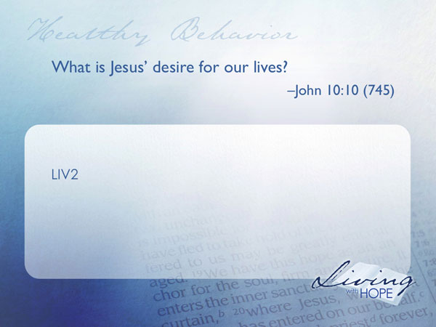
LIV2 What is Jesus’ desire for our lives? John 10:10 (745)

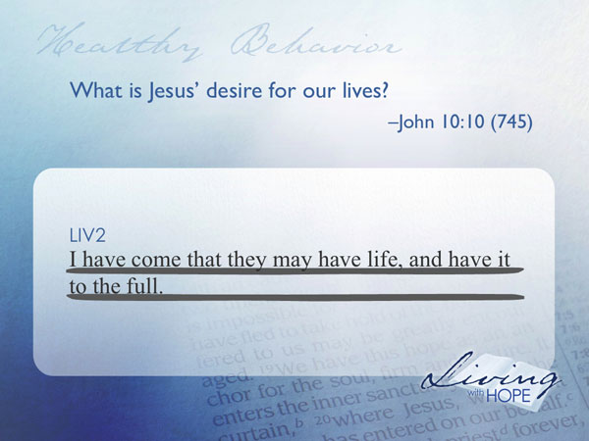
I have come that they may have life, and have it to the full.

Are you still sitting in that luxurious sports car? Why not crank the engine over. Can you hear the throaty purr? Now roll down the top. Yes. It’s a convertible. Now use your imagination to take it for a drive down your favorite country road. Isn’t that a lot more fun than just leaving it parked in your garage?

Jesus wants us to live life to the full. He wants us to crank up our engines, go out and live life to our greatest potential.

Now to make sure we can take our luxurious sports car out on more than one drive we need to take care of it. How do we take care of it? Open up the owner’s manual. There we can find out what kind of gas to put into it; what kind of oil; and how much air to put in the tires.

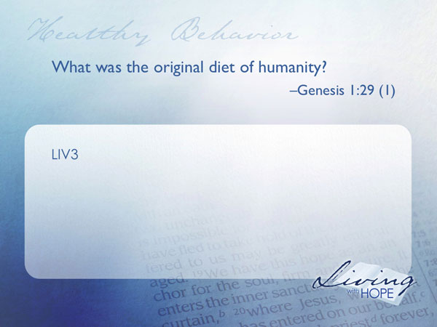
Our bodies are much more sophisticated than any luxurious sports car, and as such we need to know what to put in to our mouths to keep it running at its peak. Let’s open up God’s owner’s manual and find a little history of the human diet.

Fuel Requirements
LIV3 What was the original diet of humanity? Genesis 1:29 (1)

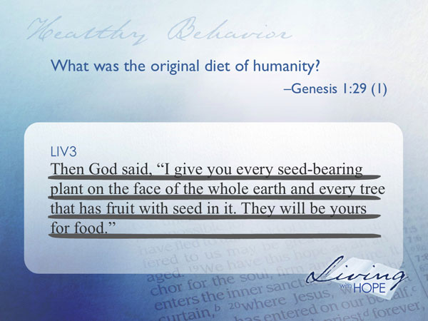
Then God said, "I give you every seed-bearing plant on the face of the whole earth and every tree that has fruit with seed in it. They will be yours for food.

The human body was originally designed to operate on a vegetarian diet. Many people today are returning to an animal free diet. They are discovering that with the right mix of fruits, nuts, grains, and vegetables they can live longer healthier lives.
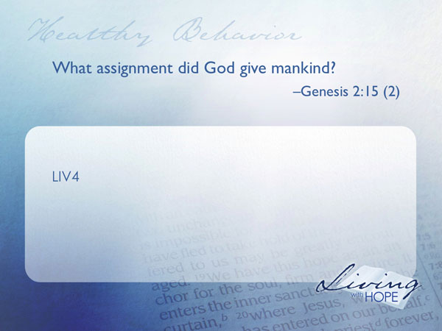
LIV4 What assignment did God give mankind? Genesis 2:15 (2)

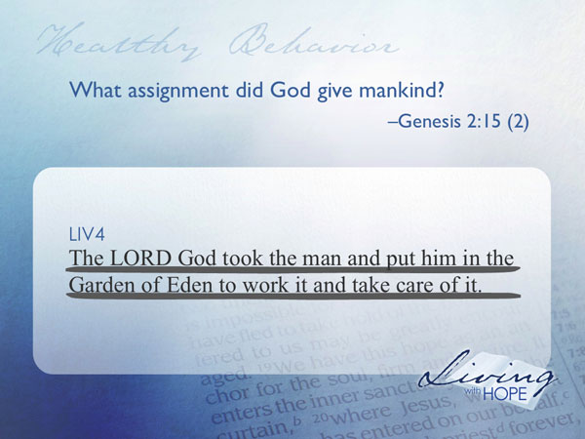
The LORD God took the man and put him in the Garden of Eden to work it and take care of it.

Not only did God give mankind the responsibility of taking care of his/her own health, but He also gave humanity the oversight of planet care. One way that we can care for this planet is to migrate toward a meat free lifestyle. It takes more energy to prepare animals for eating than it does for a vegetarian diet. In fact, one-third of all fossil fuels produced in the United States are used to raise animals for food. Just to make a comparison if the people of the United States cut down on meat eating just 20% it would have the same affect on the environment as if everyone in the country drove a switched to a Prius. If you and I would consider migrating to more of a vegetarian diet not only would we live longer and healthier, but we would be taking better care of planet earth as well.

However a vegetarian diet was not an option for Noah and his family as they were protected in the ark for many months. After the flood subsided they walked out onto an earth and found that all the fields and gardens were washed away.

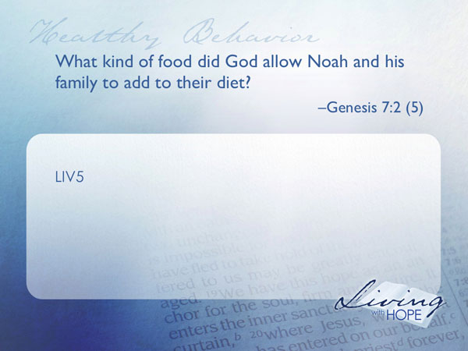
LIV5 What kind of food did God allow Noah and his family to add to their diet? Genesis 7:2 (5)

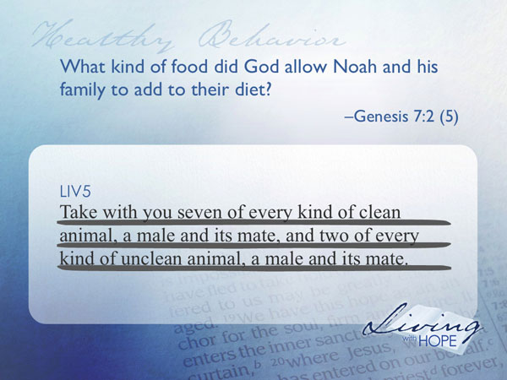
Take with you seven of every kind of clean animal, a male and its mate, and two of every kind of unclean animal, a male and its mate.

According to the flood story there were two kinds of animals allowed on the ark—the clean and the unclean. The clean came in groups of seven, and the unclean, in pairs. Obviously, Noah and his family couldn’t eat the unclean animals as that would result in the elimination of the species. However, when they utilized some of the clean animals for food, there were still enough males and females left to help replenish the earth.
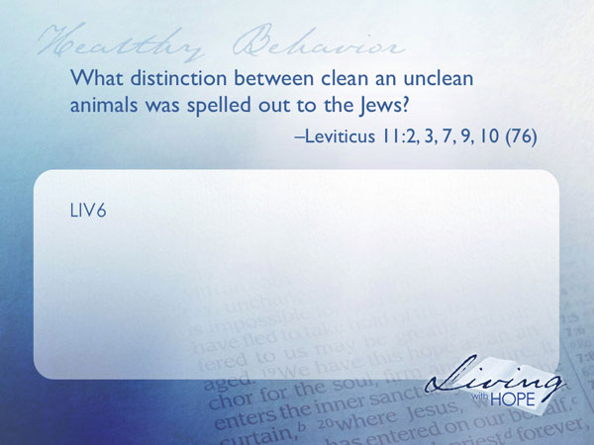
LIV6 What distinction between clean an unclean animals was spelled out to the Jews? Leviticus 11:2, 3, 7, 9, 10 (76)

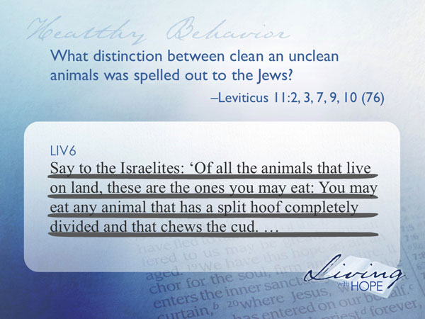
"Say to the Israelites: 'Of all the animals that live on land, these are the ones you may eat: You may eat any animal that has a split hoof completely divided and that chews the cud.

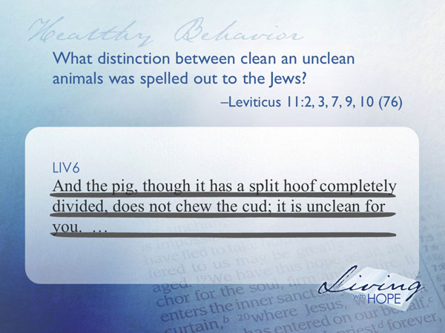
And the pig, though it has a split hoof completely divided, does not chew the cud; it is unclean for you.

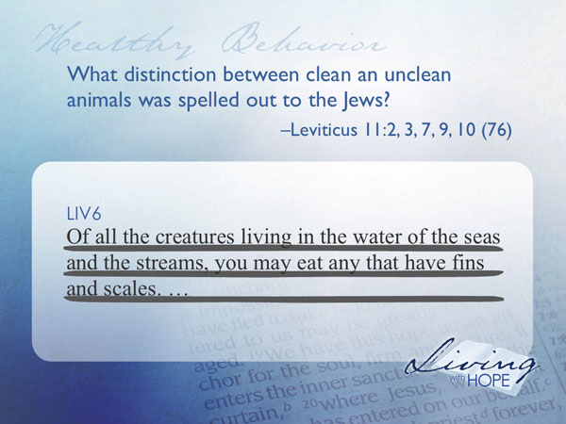
'Of all the creatures living in the water of the seas and the streams, you may eat any that have fins and scales.

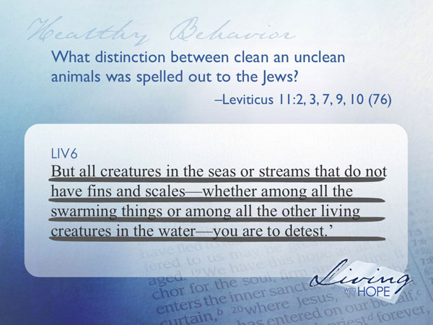
But all creatures in the seas or streams that do not have fins and scales—whether among all the swarming things or among all the other living creatures in the water—you are to detest.

Let’s do a little quiz right now. I’ll give the name of a food and you tell me if Leviticus says its clean or unclean:
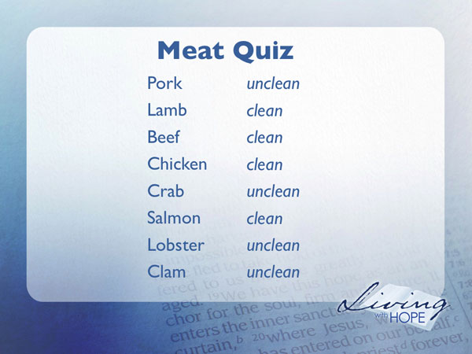
Pork (unclean)
Lamb (clean)
Beef (clean)
Chicken (clean)
Crab (unclean)
Salmon (clean)
Lobster (unclean)
Clam (unclean)

Even though these diet guidelines were part of the civil code of the Jews, many people are still choosing to follow them today for health reasons. What’s interesting to note is a general similarity in the animals that are considered unclean in Leviticus. These animals are for the most part carnivores, scavengers, and filter feeders. Since these animals are higher on the food chain they tend to have more accumulated toxins. Health scientists today are studying to find out if the fat and toxins of unclean meats listed in the Bible may bring disease and shorten life expectancy. On the other hand, the animals that are listed as clean meats are for the most part vegetarians and have lower fat content and less toxins and may cause less harm than unclean meat. The lesson learned is if you must eat meat, clean meat is better for you than unclean meat, but a vegetarian lifestyle may be the best for personal and planet health.

Yet the quality of the food still does not guarantee good health. Quantity matters as well. Too much or too little of a good thing can harm the human body. The caloric equation is really quite simple. If we burn more calories than we eat we will lose weight and eventually die. If we consume more calories than we burn off, then we will gain weight and too much weight threatens our longevity and quality of life. Either extreme is dangerous. Obesity is becoming more common and can increase the incidence of cardiovascular diseases, type 2 diabetes, sleep apnea and can reduce life expectancy. The primary treatment for obesity is dieting and physical exercise. These things may be difficult so some have discovered that it is easier to shape up with a support group such as the Loser’s Society.
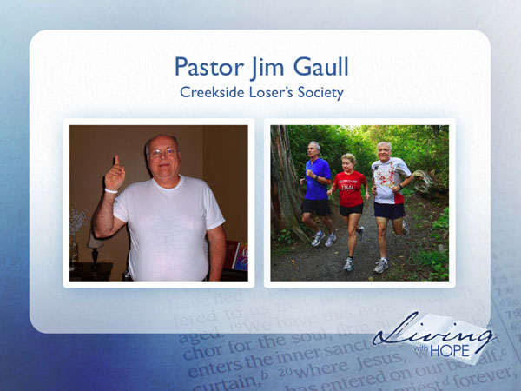
Pastor Jim Gaull of Creekside Community Church loves being a loser. Over the last two years he has lost 95 pounds and has been stable for almost a year. He finished his first half marathon on Sunday June 22, 2008. What made it work for him was that he reported his weekly gains and losses to an accountability group. When he lost, the whole group won. When he gained, the whole group lost. Now he’s started the Creekside Loser’s Society. It’s for any loser who wants to be part of something bigger. It’s the only society that as it gets bigger, it actually becomes smaller.

As you take care of the luxury car you read the manual that tells you what to put into the car—premium gasoline and oil. But what if you got creative and instead of putting gas in the gas tank you put in diesel? Or lighter fluid? Water? Maple syrup? You probably would never think of doing that to your luxury car. It could cause damage or even cease to run.

The owner’s manual for the human body also gives some warnings about dangerous things to watch out for.
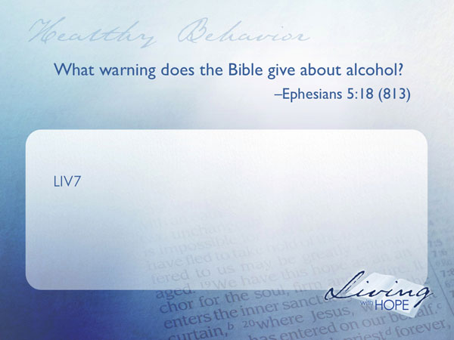
Warnings!!!
LIV7 What warning does the Bible give about alcohol? Ephesians 5:18 (813)

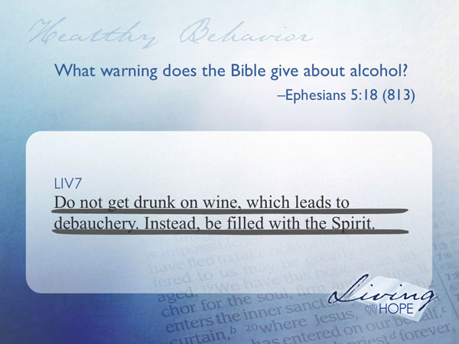
Do not get drunk on wine, which leads to debauchery. Instead, be filled with the Spirit.

Too much alcohol can dull the mind and make it difficult to concentrate on the ordinary activities of life, let alone the things of heaven. Although the Bible does not forbid alcohol consumption it certainly gives strong warnings about consuming too much. Back in the Bible times, getting inebriated resulted in harmful side effects. In today’s world the harmful effects are magnified. Drunk drivers cause approximately one third of traffic accident fatalities. “The 13,470 fatalities in alcohol-impaired-driving crashes during 2006 represent an average of one alcohol-impaired-driving fatality every 39 minutes.”

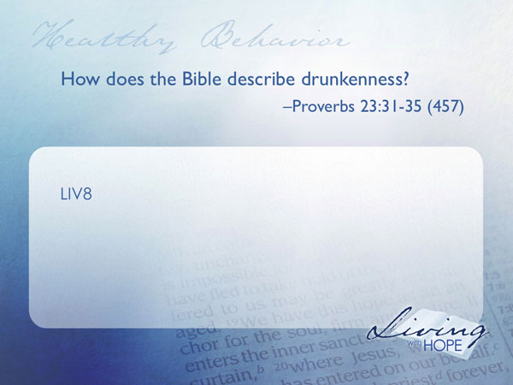
LIV 8 How does the Bible describe drunkenness? Proverbs 23:31-35 (457)

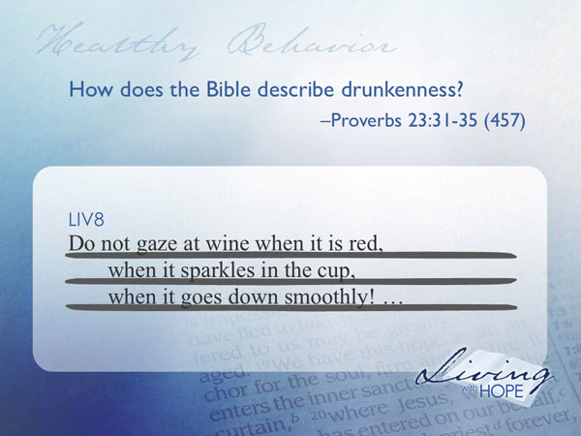
Do not gaze at wine when it is red,
when it sparkles in the cup,
when it goes down smoothly!

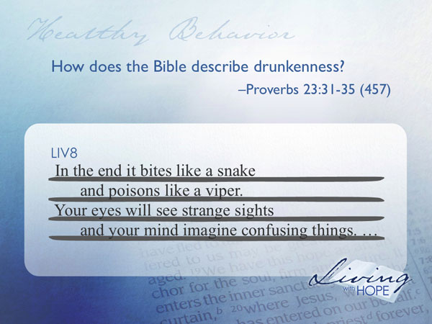
In the end it bites like a snake
and poisons like a viper.
Your eyes will see strange sights
and your mind imagine confusing things.
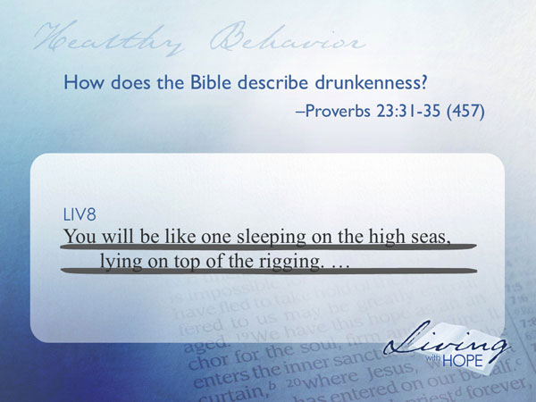
You will be like one sleeping on the high seas,
lying on top of the rigging.
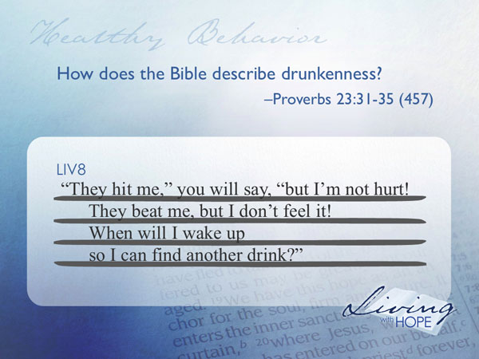
"They hit me," you will say, "but I'm not hurt!
They beat me, but I don't feel it!
When will I wake up
so I can find another drink?"
This describes the plight of the alcoholic. Alcoholism is a horrific disease that robs people of jobs, home and family. Perhaps you have suffered from the pain caused by the alcoholism. There is help available.

In Bible times the most common way to drink grape juice out of season would be to drink it in the fermented state. However with modern methods of preservation, unfermented grape juice can be found year round. It is possible today to completely abstain from alcohol. With the twofold risks of accidents from intoxication, and the long-term risk of alcoholism, many today are choosing to live alcohol free.

In Bible times and even today, alcohol is the most widespread drug of choice. In addition mankind has become quite creative in discovering many other drugs and substances that can create a dependency cycle. Tobacco, narcotics, hallucinates, and the irresponsible use of other drugs can be harmful and even deadly to the precision made human body. Today there are specialty recovery groups for most addictions. If you or someone you know are suffering from addiction you may wish to consider taking advantage of a recovery support group.

Integrated Systems
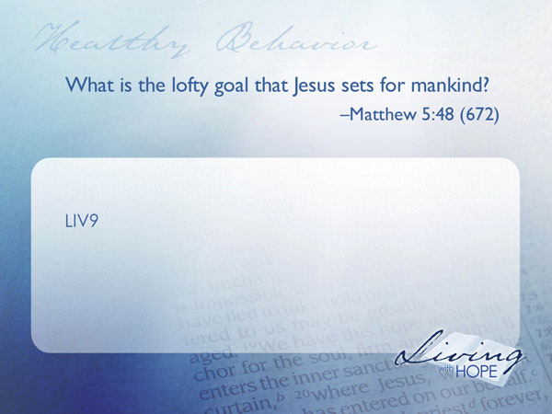
The human body is much more than just a physical machine thriving on the right mix of diet and exercise.

LIV9 What is the lofty goal that Jesus sets for mankind? Matthew 5:48 (672)

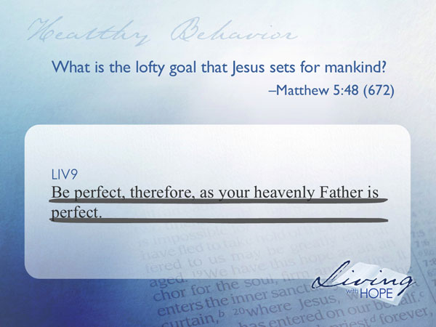
Be perfect, therefore, as your heavenly Father is perfect.

The word perfect means complete, whole, or fully integrated. The sophisticated sports car is a collection of integrated systems. The electrical components, the power train, the body, the chassis all work together to become a functioning automobile. You don’t really have a car if only a few of the systems are working. It is the same with the human body—a collection of systems all working together.

Picture a twenty-seven-year-old male in fabulous shape. He works out with weights and does yoga for strength and flexibility. For daily aerobic exercise, he runs at least ten miles or else bicycles forty miles. Moreover, he eats only what’s healthful for him--Piles of fruits and vegetables--Mounds of alfalfa sprouts--Barrels of oat bran. He drinks quarts of water between meals, sleeps eight hours a night, and approaches sweets as though they were radioactive. The guy never touches tobacco, alcohol, or other addictive drugs. He doesn’t even take aspirin. Since the day he was born, he’s never been in a hospital.

Is this person healthy? Before you answer, let me tell you a little more about him.

Yesterday, on the way out the door to his daily workout, he kicked his dog, screamed obscenities at his wife, and brushed past his children without saying a word to them. At work, he lied to his boss, angrily blaming a coworker for a mistake he made. Later, he bragged about “getting out of that one.” All in all, it was a typical day for him.

This man is impatient, unkind, and conceited. Family and acquaintances know that he’s disloyal; He sees no need to change anything about himself. He finds no ultimate purpose. He is morally and spiritually bankrupt.

Now, is he healthy?

Being healthy involves more than just our physical selves.
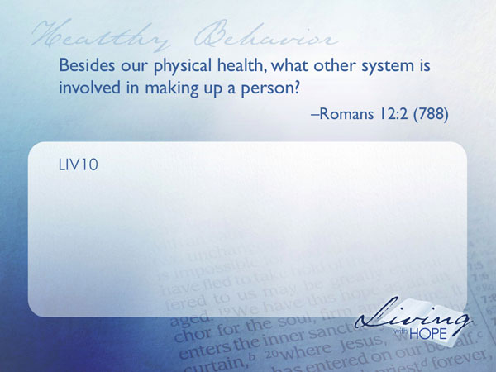
LIV10 Besides our physical health, what other system is involved in making up a person? Romans 12:2 (788)

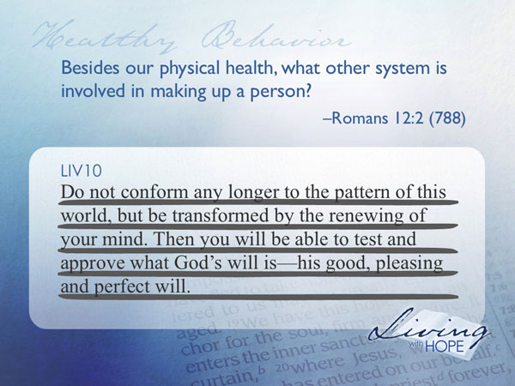
Do not conform any longer to the pattern of this world, but be transformed by the renewing of your mind. Then you will be able to test and approve what God's will is—his good, pleasing and perfect will.

The human mind is by far the most complex data machines known to mankind. Four pounds and several thousand miles of interconnected nerve cells (about 100 billion) control every movement, thought, sensation, and emotion that comprise the human experience. Within the brain and spinal cord there are ten thousand distinct varieties of neurons, trillions of supportive cells, a few more trillion synaptic connections, a hundred known chemical regulating agents, miles of minuscule blood vessels, axons ranging from a few microns to well over a foot and a half in length, and untold mysteries of how—almost flawlessly—all these components work together. To put it in computer language, the human brain can process about 100 million computer instructions per second, roughly the equivalent of the combined power of 10,000 laptop computers.

Unfortunately the metaphor of the computer can be applied another way—garbage in, garbage out! In other words, if you put junk data into a computer it will spit out junk results.

Like the human body, the human mind needs to feed on a diet of positive data in order for it to function at its best. If the brain is fed with negative thoughts all of the human systems are compromised and can begin to malfunction.
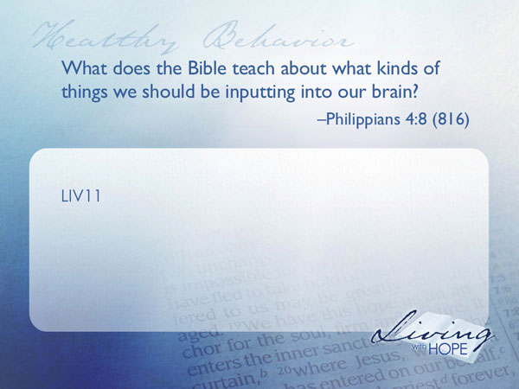
LIV11 What does the Bible teach about what kinds of things we should be inputting into our brain? Philippians 4:8 (816)

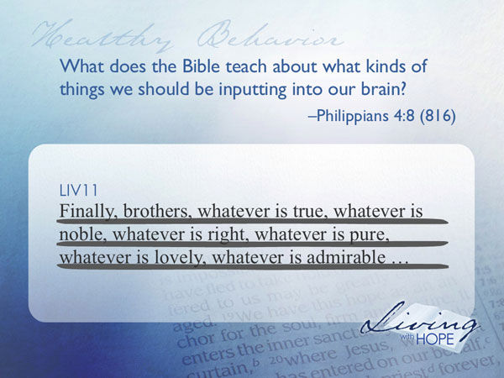
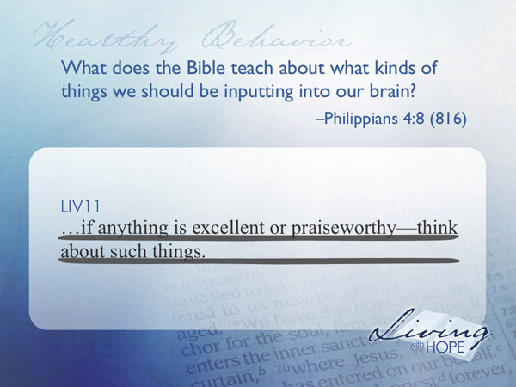
Finally, brothers, whatever is true, whatever is noble, whatever is right, whatever is pure, whatever is lovely, whatever is admirable—if anything is excellent or praiseworthy—think about such things.

Sensory information has exploded in the last few years. Each wave of communication has added to, rather then replaced the previous generation. The human brain is faced with a combined information assault from books, newspapers, movies, telephone, radio, T.V. DVD, internet, email, text messaging, podcasts, video on demand, blogs, facebook, twitter, and the list continues to propagate.

Fortunately with the plethora of new technologies of communication come ways of data selection. It is now easier than ever to choose which things to fill our minds with. Perhaps we ought to program our search engines with the values of Philippians 4:8.

Inside Out
When you take care of your car you’ll most likely be spending a little time washing, waxing, and making sure that the outside of the car matches the quality of its insides.
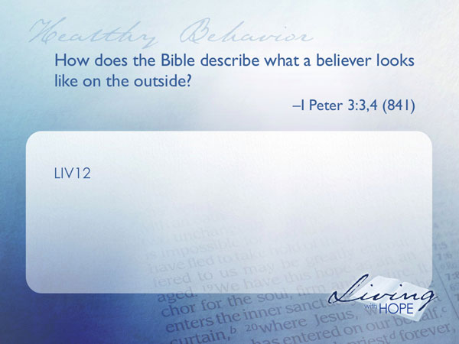
LIV12 How does the Bible describe what a believer looks like on the outside? I Peter 3:3,4 (841)

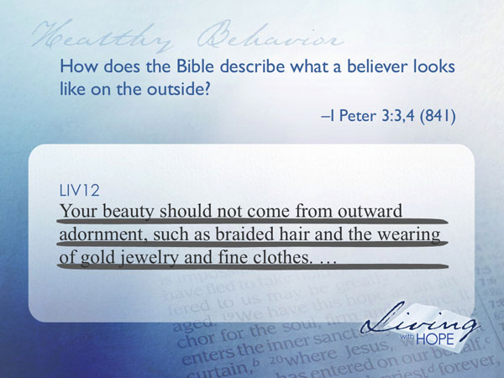
Your beauty should not come from outward adornment, such as braided hair and the wearing of gold jewelry and fine clothes.

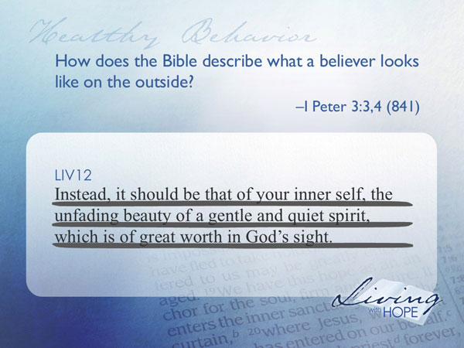
Instead, it should be that of your inner self, the unfading beauty of a gentle and quiet spirit, which is of great worth in God's sight.

Sometimes I have wished that I could travel back through time and take a digital photograph of how a believer dressed--that way I would know precisely how I should dress (On the other hand, if I dressed like a Bible character people might think I’m crazy!). Fortunately we don’t have photographs we just have principles of dress. These principles transcend time, geography, and culture. While believers may look markedly different in diverse times, places, and cultures, if they follow Jesus, they will exude the beauty of the inner self, of unfading beauty, and gentle and quiet spirit.

This is Your Father’s Automobile
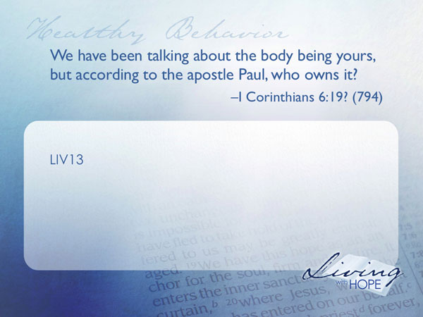
Up until this moment you may have assumed that the keys of the fancy car were handed to you because you were the owner of the car. If so, you were wrong. The car isn’t yours. In fact you are only the keeper of the car. Your mission is to keep the car in peak condition for your boss to operate.

LIV13 So far we have been talking about the human body being yours, but according to the apostle Paul, who owns it? I Corinthians 6:19? (794)

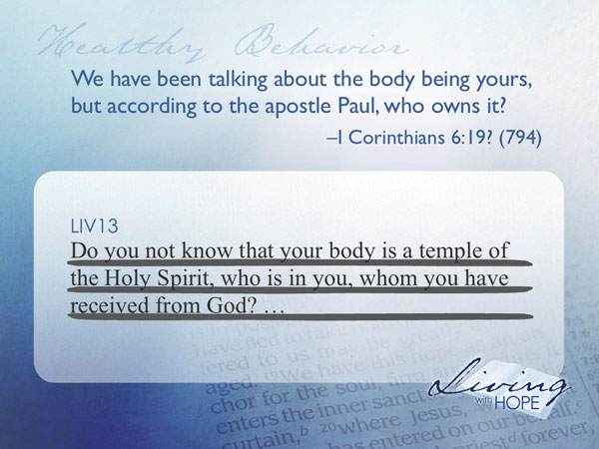

Do you not know that your body is a temple of the Holy Spirit, who is in you, whom you have received from God?

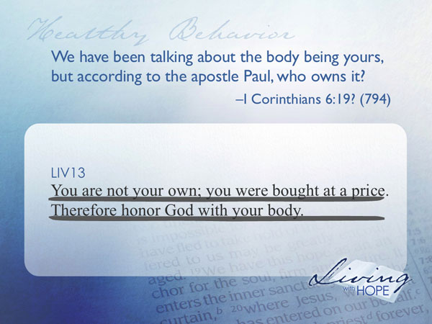
You are not your own; you were bought at a price. Therefore honor God with your body.

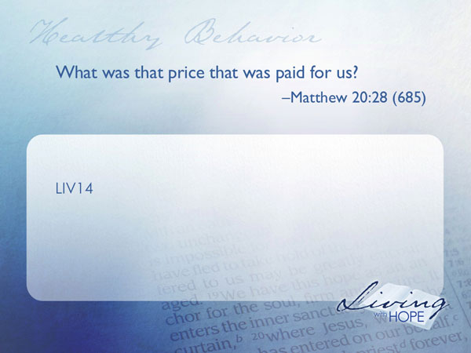
LIV14 What was that price that was paid for us? Matthew 20:28 (685)

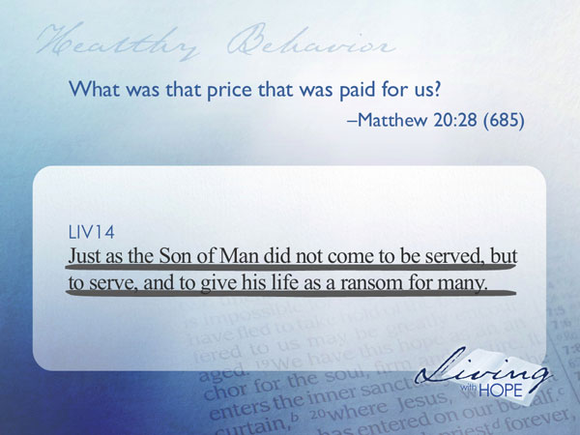
Just as the Son of Man did not come to be served, but to serve, and to give his life as a ransom for many.

Jesus died for us, and in a way, paid a great price for us. In that sense we are indebted to Him, and our bodies belong to him. Paul’s argument above is asking the question, how can we rationalize using our bodies that were paid for by the sacrifice of Jesus Christ to engage in ungodly behaviors such as sexual promiscuity? In fact it gives us pause to reconsider any behavior that we engage in. Is the behavior that we are about to engage in honoring God? Is it neutral? Or is it incongruent with heaven’s desire for our prosperity?

These are extremely difficult questions to wrestle with. And once we’ve been convicted, even more difficult to follow through on. To think that we can change our ways on our own is asking for failure. Fortunately we aren’t alone.

The God Squad
A young man was driving down the freeway in a borrowed convertible Porsche. Next to him was his bride. They were on their honeymoon. As they drove down the road in broad daylight he noticed that every once in awhile an oncoming car would flash its high beams at him. What could it mean? Was it so obvious that they were on their honeymoon that everyone was congratulating them with high beams? He posed the question to his bride and she just laughed, because she knew the answer. Then she gave a hint. See if you notice anything about the cars that flash their lights at you. A few minutes later another car flashed its lights, then another one. Finally the young man put it together. They were all Porsches. Apparently there was an inside comradeship among Porsche owners and they were cheering each other on. The bride knew about the inside language because the Porsche they were driving belonged to her dad.

Car owners are known to have a brand loyalty. They form clubs, gatherings, and support groups. Here owners can find collegiality, support, and answers to some of the challenges of keeping that particular brand of car in excellent running condition.

A far greater discipline is called for in following Christ. No one can do it alone. It takes the support of small groups and big groups, all underwritten by the power of the Holy Spirit, to enable a believer to walk after Christ.
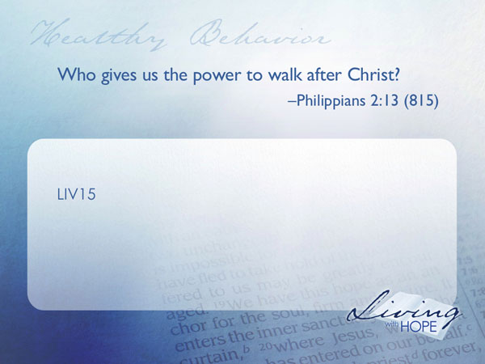
LIV15 Who gives us the power to walk after Christ? Philippians 2:13 (815)

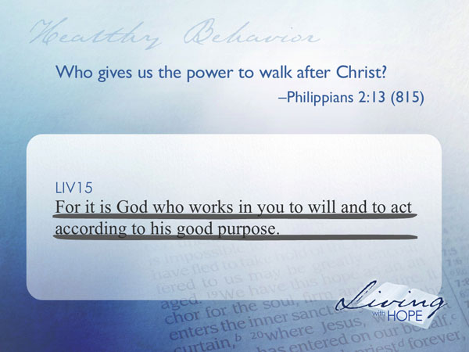
For it is God who works in you to will and to act according to his good purpose.

Fortunately we are not on this journey by ourselves. We are all in it together. I encourage you to continue your habit of attending big group where we can collectively learn about and worship our Creator. I also encourage you to continue with a small group where you can find intimate support as you follow after Jesus.

The rewards of driving a high quality, well maintained automobile can bring pleasure to the heart. Still better is the joy of maintaining and using this marvelous body that Christ is lending to us in order to serve Him.

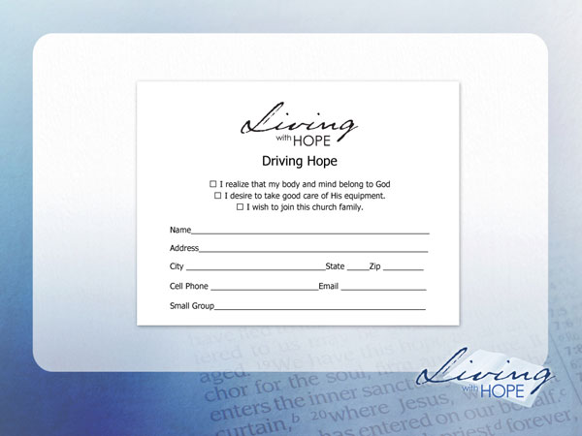
❑ I realize that my body and mind belong to God
❑ I desire to take good care of His equipment.
❑ I wish to join this church family.

###

http://en.wikipedia.org/wiki/Health_care_in_the_United_States
Read the story of Daniel and his friends as recorded in the book of Daniel chapter one (659) for a striking example of what can happen when people follow a simpler diet.
National Geographic did a story on Adventists in Loma Linda who rank among America’s longevity all-stars. Contributing factors include a lifestyle of abstinence from alcohol, tobacco and less meat in the diet than most Americans. http://ngm.nationalgeographic.com/ngm/0511/feature1. National Geographic also has a multimedia show
See Psalm 8:4-8 for humanity’s responsibility in planet care.
http://www.goveg.com/environment-wastedResources-energy.asp
http://www.npr.org/templates/story/story.php?storyId=89676010
Much more scientific work could be done in this area. Perhaps the best study so far is the Adventist Health Study www.adventisthealthstudy.org, funded by the U.S. National Cancer Institute. The study seeks to find answers to many questions including: What specific foods enhance quality of life? Do soy products really help prevent breast and prostate cancer? What foods help prevent cancer, diabetes, heart disease, Alzheimer’s and arthritis? Heredity or lifestyle—which is more important? Does faith contribute to a healthier life?
http://en.wikipedia.org/wiki/Obesity
This story was also reported in The Eleventh Commandment: Thou shalt get buff, Wency Leung, Globe and Mail, September 12, 2008.
Alcohol-Impaired Driving, Updated March 2008, National Highway Traffic Safety Administration, http://www.nhtsa.dot.gov/portal/nhtsa_static_file_downloader.jsp?file=/staticfiles/DOT/NHTSA/NCSA/Content/TSF/2006/810801.pdf
Chris Blake, Searching for a God to Love, Second Edition, Chapter Six.
http://www.brainsource.com/amazing%20brain.htm
--assuming that a laptop can do 10,000 instructions per second.
A more complete reading of this teaching is found in Fundamental Belief #22 of the Seventh-day Adventist Church entitled ‘Christian Behavior’: “We are called to be a godly people who think, feel, and act in harmony with the principles of heaven. For the Spirit to recreate in us the character of our Lord we involve ourselves only in those things which will produce Christlike purity, health, and joy in our lives. This means that our amusement and entertainment should meet the highest standards of Christian taste and beauty. While recognizing cultural differences, our dress is to be simple, modest, and neat, befitting those whose true beauty does not consist of outward adornment but in the imperishable ornament of a gentle and quiet spirit. It also means that because our bodies are the temples of the Holy Spirit, we are to care for them intelligently. Along with adequate exercise and rest, we are to adopt the most healthful diet possible and abstain from the unclean foods identified in the Scriptures. Since alcoholic beverages, tobacco, and the irresponsible use of drugs and narcotics are harmful to our bodies, we are to abstain from them as well. Instead, we are to engage in whatever brings our thoughts and bodies into the discipline of Christ, who desires our wholesomeness, joy, and goodness. (Rom. 12:1, 2; 1 John 2:6; Eph. 5:1-21; Phil. 4:8; 2 Cor. 10:5; 6:14-7:1; 1 Peter 3:1-4; 1 Cor. 6:19, 20; 10:31; Lev. 11:1-47; 3 John 2.)

