
Living With Hope
Presentation 11: Spiritual Disciplines
Growing With Hope
Last Revision: 6/12/2009

(Note: icon means “Next Slide,” indicating when to advance to the next slide.)

Craig Barnes tells the following experience. “When I was a child, my minister father brought home a 12-year-old boy named Roger, whose parents had died from a drug overdose. There was no one to care for Roger, so my folks decided they'd just raise him as if he were one of their own sons.

“At first it was quite difficult for Roger to adjust to his new home--an environment free of heroine-addicted adults! Every day, several times a day, I heard my parents saying to Roger:

"No, no. That's not how we behave in this family.”

"No, no. You don't have to scream or fight or hurt other people to get what you want."

"No, no, Roger, we expect you to show respect in this family."

And in time Roger began to change.

Now, did Roger have to make all those changes in order to become a part of the family? No. He was made a part of the family simply by the grace of his new father. But did he then have to do a lot of hard work because he was in the family? You bet he did. It was tough for him to change, and he had to work at it. But he was motivated by gratitude for the incredible love he had received.

Do you have a lot of hard work to do now that the Spirit has adopted you into God's family? Certainly. But not in order to become a son or a daughter of the heavenly Father. No, you make those changes because you are a son or daughter. And every time you start to revert back to the old addictions to sin, the Holy Spirit will say to you, "No, no. That's not how we act in this family."
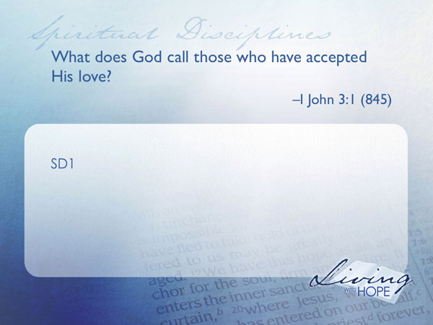
SD1 What does God call those who have accepted His love? I John 3:1 (845)

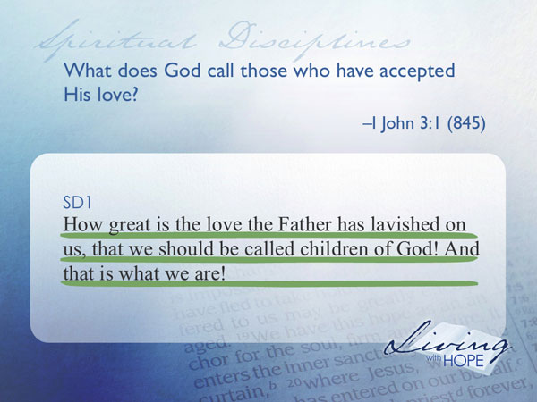
How great is the love the Father has lavished on us, that we should be called children of God! And that is what we are!

Since we have become children of God that also make us all brothers and sisters since we are all part of the same family. And, just as in any earthly family there are rules and practices to keep the family together so in God’s family there are rules and practices to follow.
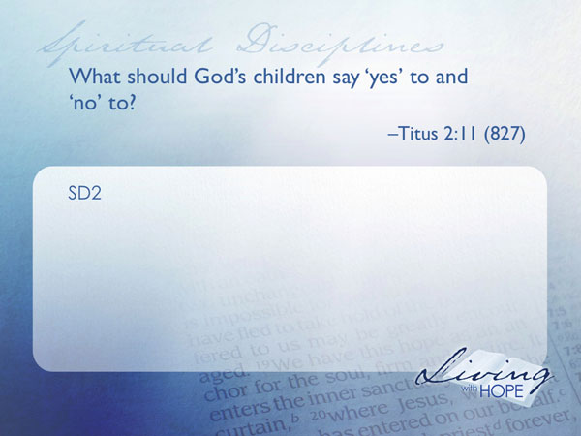
SD2 What should God’s children say ‘yes’ to and ‘no’ to? Titus 2:11 (827)

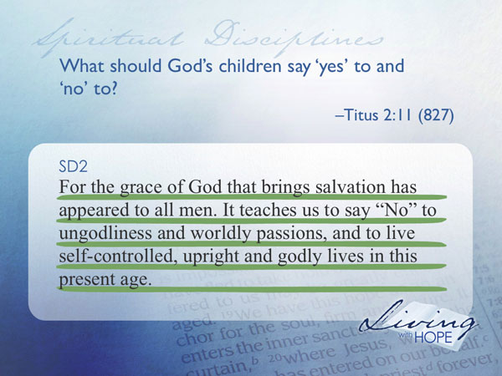
For the grace of God that brings salvation has appeared to all men. It teaches us to say "No" to ungodliness and worldly passions, and to live self-controlled, upright and godly lives in this present age...

You are saved by grace through faith as you have learned in a previous lesson. Paul in this passage says we are “to say ‘No’ to ungodliness and worldly passions.”

When a baby is born it is alive and part of the human race but it is very immature. But as it grows it learns and develops until somewhere in its late teens the person, no longer a baby, can leave the care of its parents and begin to live as a mature independent person.

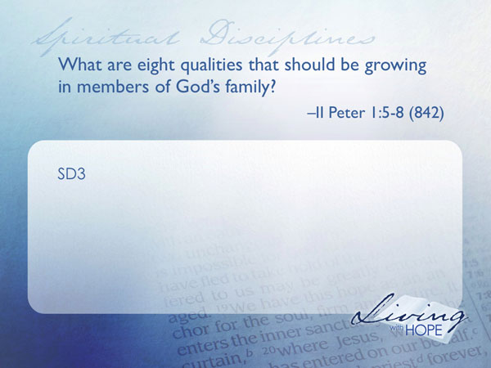
When a person is born into God’s family that person is very immature. It takes a life time to grow and become like Jesus, to develop His character.

SD3 What are eight qualities that should be growing in members of God’s family? II Peter 1:5-8 (842)

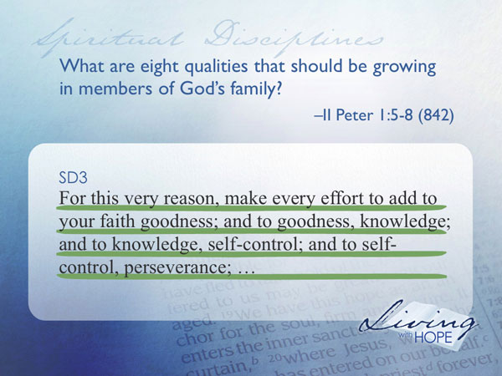
For this very reason, make every effort to add to your faith goodness; and to goodness, knowledge; and to knowledge, self-control; and to self-control, perseverance;

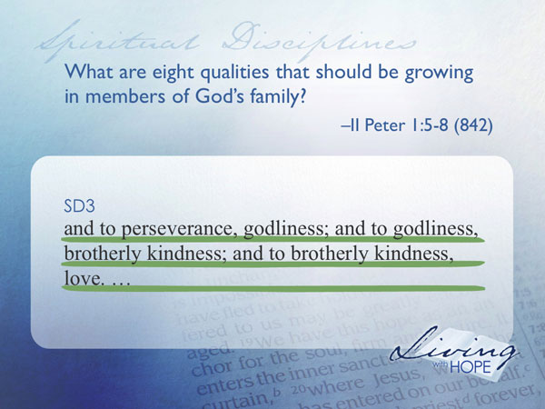
and to perseverance, godliness; and to godliness, brotherly kindness; and to brotherly kindness, love.

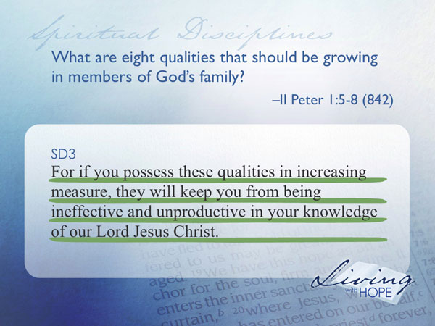
For if you possess these qualities in increasing measure, they will keep you from being ineffective and unproductive in your knowledge of our Lord Jesus Christ.


Here Peter is reminding us that there are many qualities that do not come naturally to a person. Even though we are saved there is still much growth to come. While the baby does nothing to grow itself it does come to the place where it is expected to feed itself, clothe itself, and finally provide for itself. This is also how it works in the Christian life. There is a lot of hard work in remaining a Christian.

SD4 Who does Paul say we should imitate? Ephesians 5:1,2 (813)

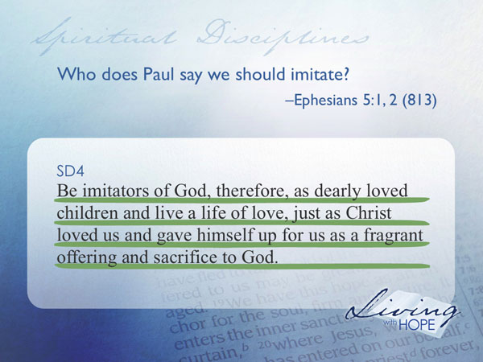
Be imitators of God, therefore, as dearly loved children and live a life of love, just as Christ loved us and gave himself up for us as a fragrant offering and sacrifice to God.

It is natural for children to emulate their parents. One of the strongest teaching techniques that a parent possesses is that of modeling positive behavior. God, in the ultimate positive behavior offered himself as a servant. As His children, one of the strongest learning modes we can engage in is to model our life after Jesus.

“So,” you say, “you have convinced me. I have a lot of growing to do to become like Jesus. Just how do I go about growing in Christ?” Ah, you have asked the right question. The answer lies in learning how to develop the spiritual disciplines in your life. Everyone needs to discipline their life if they are to get anywhere. We choose priorities. We decide how to spend our money and time based on how important certain things are in our lives. We have to give up some things in order to gain other things.

It is exactly the same way in the spiritual life. We must learn to discipline ourselves. A spiritual discipline grows the inner life of the believer in his or her relationship with God and with all of God’s family. There are many spiritual disciplines, some of which we’ll be exploring today. We will divide these into the inward, outward, and corporate disciplines.

Under the inward disciplines come meditation, prayer, fasting, and study. Under the outward disciplines come simplicity, solitude, submission, and service. Under the corporate disciplines come confession, worship, guidance, and celebration.

There is no standard list of spiritual disciplines. You may come up with a slightly different list. Some add evangelism, journaling, learning, rest, discernment, mentoring, stewardship, justice and so on, nevertheless here are some guides to get you started on your discipleship journey:

Inward Disciplines
The inward disciplines are our private time with our Heavenly Parents. They are unseen by others yet they are the foundation for all the other disciplines.
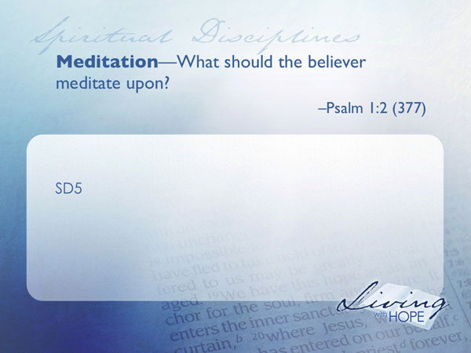
SD5 Meditation--What should the believer meditate upon? Psalm 1:2 (377)

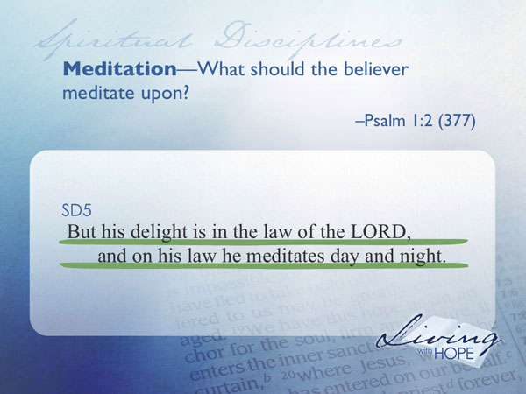
But his delight is in the law of the LORD,
and on his law he meditates day and night.

Christian meditation is very different from eastern meditation. The goal of eastern meditation is to empty the mind and become one with the cosmos. The goal of Christian meditation is to fill the mind with the word of God, which drives out harmful thoughts.

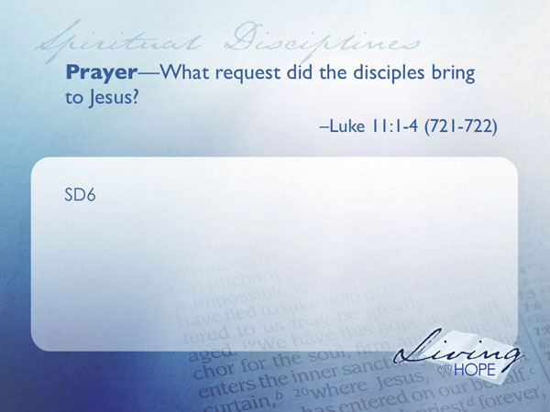
The Old Testament uses two different Hebrew words to convey the idea of meditation and they are used fifty-eight times. Meditation is actually very simple. It is being still so you can hear God’s voice and obey His word.

SD6 Prayer—What request did the disciples bring to Jesus? Luke 11:1-4 (721-722)

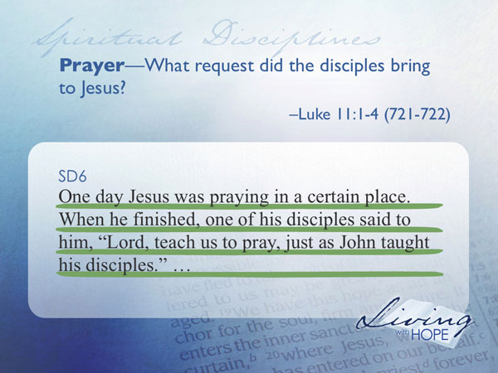
One day Jesus was praying in a certain place. When he finished, one of his disciples said to him, "Lord, teach us to pray, just as John taught his disciples."

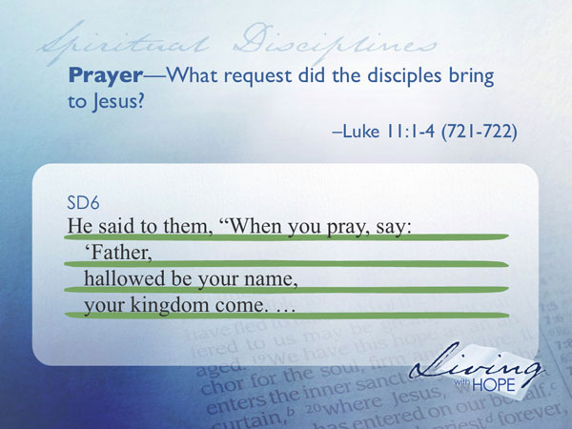
He said to them, "When you pray, say:
" 'Father,
hallowed be your name,
your kingdom come.

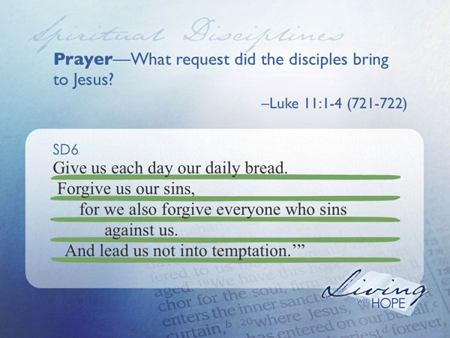
Give us each day our daily bread.
Forgive us our sins,
for we also forgive everyone who sins against us.
And lead us not into temptation.' "

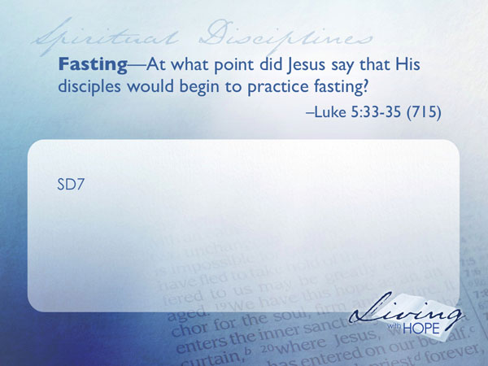
This prayer is commonly known today as “The Lord’s Prayer”. Prayer is talking to God while meditation is listening to God--both are necessary. When you pray in faith God will always answer and give you what is best for you. Sometimes he says ‘No’, because that is best for you. Sometimes he says, ‘Wait’. And sometimes he says ‘Yes’, right away. The important thing is that we spend enough time with God to know Him well enough so that we know what His desires are and pray accordingly.

SD7 Fasting—At what point did Jesus say that His disciples would begin to practice fasting? Luke 5:33-35 (715)

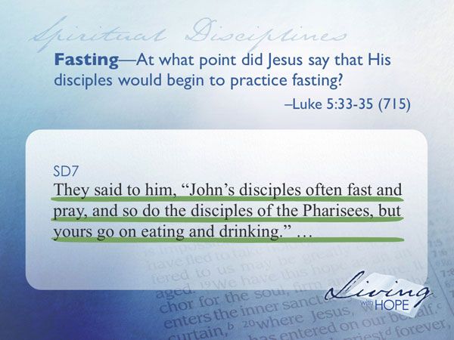
They said to him, "John's disciples often fast and pray, and so do the disciples of the Pharisees, but yours go on eating and drinking."

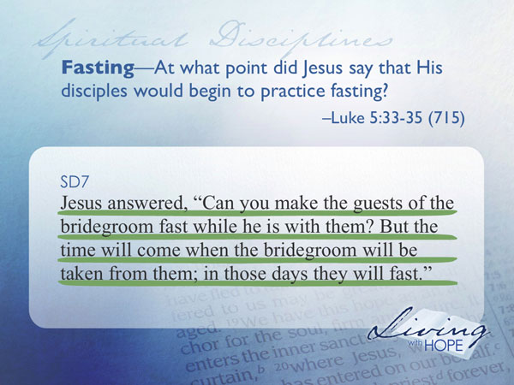
Jesus answered, "Can you make the guests of the bridegroom fast while he is with them? But the time will come when the bridegroom will be taken from them; in those days they will fast."
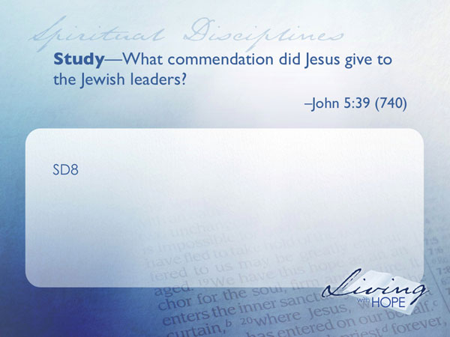
Fasting is the giving up of food and sometimes water for a period of time so as to seek God more fervently. It didn’t make sense for the disciples to fast when Jesus was still in their presence. However he suggested that they would begin the practice of fasting after he departed. Moses, David, Elijah, Esther, Daniel, Anna, Paul, and Jesus are just a few of the people in the Bible who fasted.

SD8 Study—What commendation did Jesus give to the Jewish leaders? John 5:39 (740)

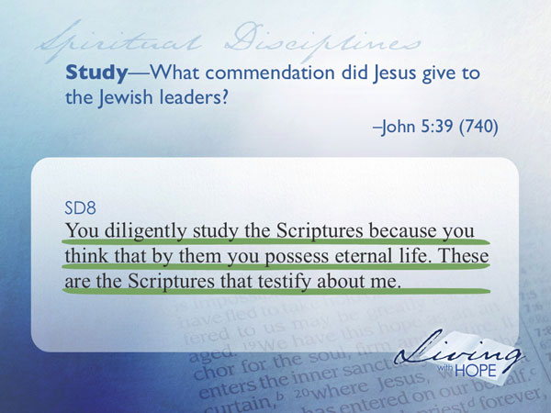
You diligently study the Scriptures because you think that by them you possess eternal life. These are the Scriptures that testify about me.

Study is the intentional reading of Scripture seeking to be transformed by God’s power. There is nothing magical about the paper and ink. The power only comes in studying and being transformed by the Spirit of God who guides you as you read.

Outward Disciplines
The outward disciplines reveal to others that we are a child of God.

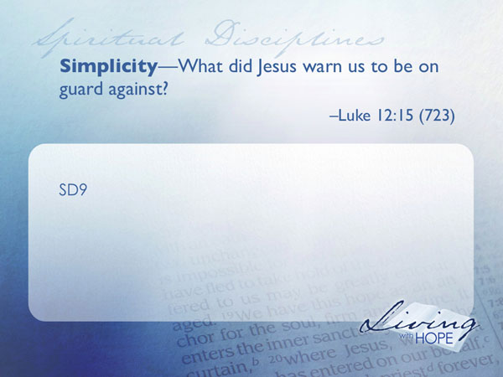
SD9 Simplicity—What did Jesus warn us to be on guard against? Luke 12:15 (723)

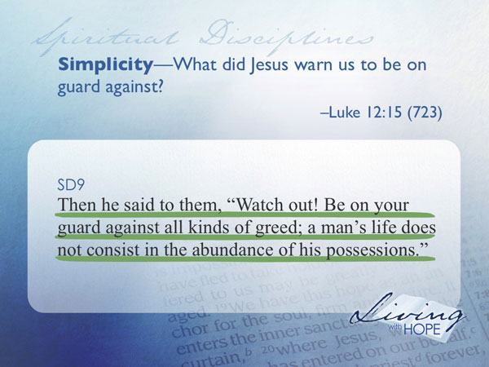
Then he said to them, "Watch out! Be on your guard against all kinds of greed; a man's life does not consist in the abundance of his possessions."

It is only when you have to move your things to a new home that you realize how enslaved you are to material possessions. As you pack you suddenly become conscious of how much stuff you have. Most of us could manage quite well with much less. I have found that simplicity is an inward reality that results in an outward life-style. Don’t make material possessions your god. We can be seduced without realizing it since we live in such a consumer oriented society and are constantly bombarded with advertisements. These are meant to convince us we have a need when in most cases we do not.
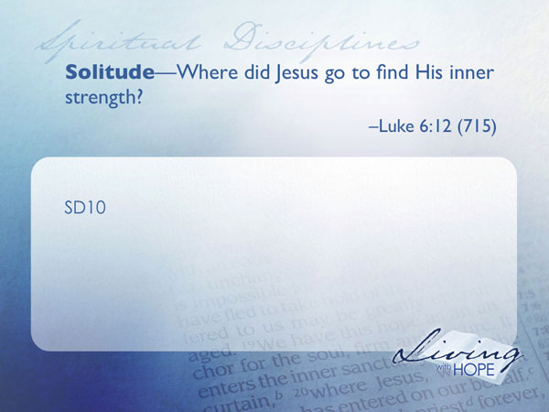
SD10 Solitude—Where did Jesus go to find His inner strength? Luke 6:12 (715)

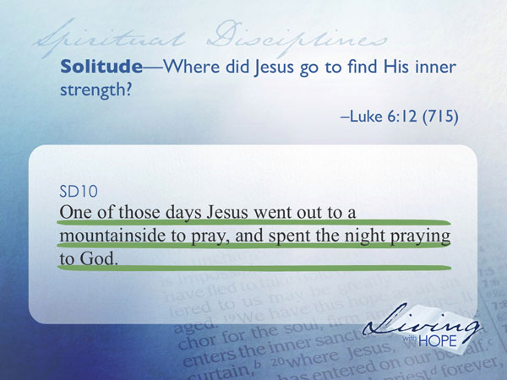
One of those days Jesus went out to a mountainside to pray, and spent the night praying to God.

Leaving the crowds behind, Jesus sought solitude to refill his spiritual reservoir. Solitude is not loneliness. Loneliness is when you feel abandoned, that no one truly cares. Loneliness is inner emptiness, but solitude is inner fulfillment. When we are following God we welcome solitude because it gives us time to examine ourselves. When we are not following God we hate to be alone because then we hear more clearly the voice calling us to repentance. Taking time alone with God allows us to hear him speaking and guiding us and especially growing us to the next level. Let’s take the mp3 headphones out of our ears; Turn off the T.V. Shut down the internet, and “be still and know that I am God.”
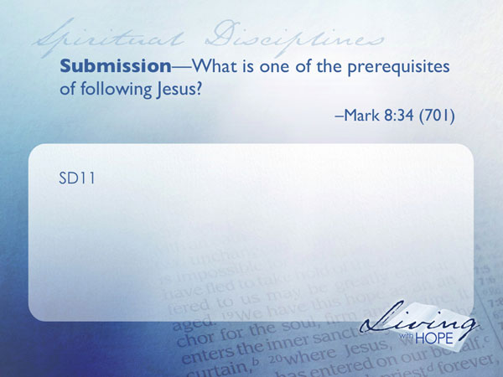
SD11 Submission—What is one of the prerequisites of following Jesus? Mark 8:34 (701)

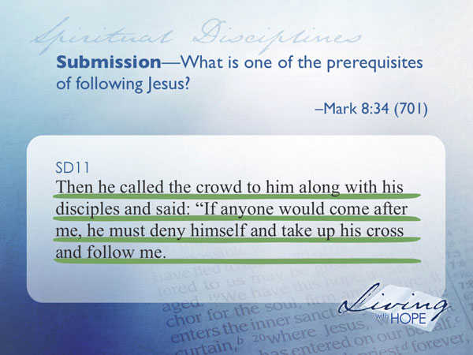
Then he called the crowd to him along with his disciples and said: "If anyone would come after me, he must deny himself and take up his cross and follow me.

Most of us hate to hear the word submit. It conjures up images of slavery and abuse. But the purpose of this discipline is actually freedom. What freedom corresponds to submission? It is the ability to lay down the terrible burden of always needing to get our own way.

Most fights take place because people do not have the freedom to give in to each other. They must be right. Think what this would mean in marriages, in the work place, in government if we didn’t always have to win.

SD12 Service—If we desire to become great, what must we do? Mark 10:43-45 (703)

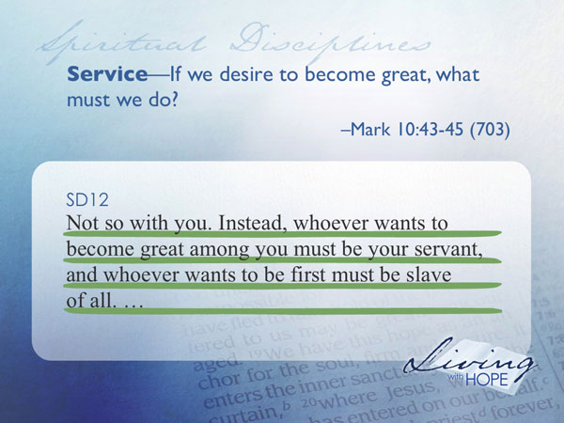
Not so with you. Instead, whoever wants to become great among you must be your servant, and whoever wants to be first must be slave of all.

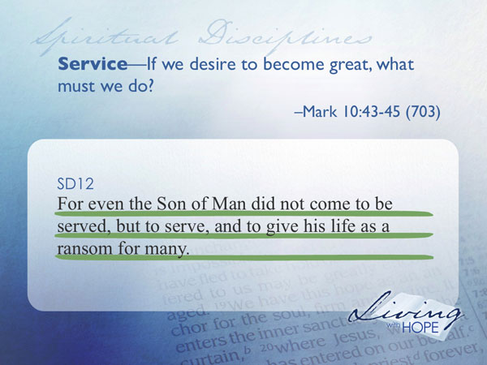
For even the Son of Man did not come to be served, but to serve, and to give his life as a ransom for many."

We are called to serve others not ourselves. James and John came to Jesus requesting the highest positions in the kingdom for themselves. Jesus said they were not ready for such positions. Serving is related to submitting. Serving is placing other first and looking out for their welfare just as Jesus did. Serving is helping to carry the burdens of others.

Corporate Disciplines
The corporate disciplines are what we do together as God’s family.
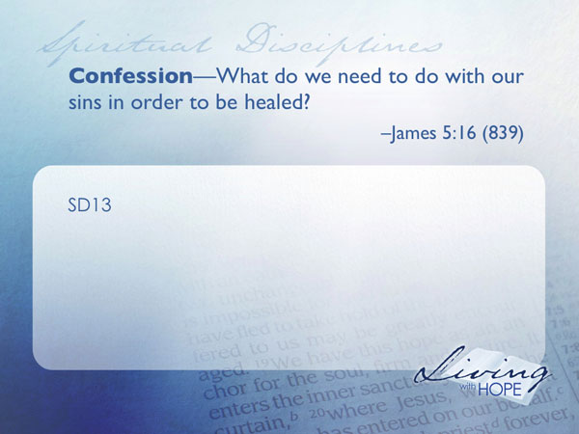
SD13 Confession—What do we need to do with our sins in order to be healed? James 5:16 (839)

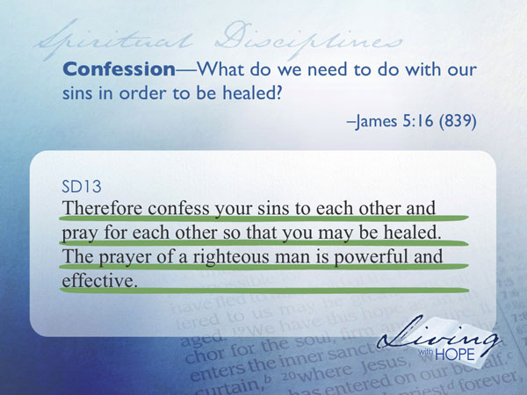
Therefore confess your sins to each other and pray for each other so that you may be healed. The prayer of a righteous man is powerful and effective.

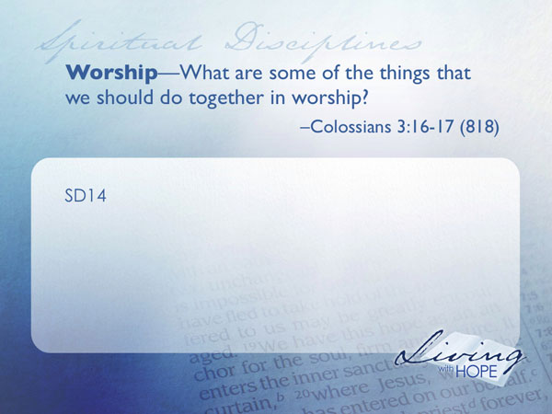
When we think of confession images of police interrogations often flash into our mind. But confession is a vital part of growing the spiritual life. Confession is difficult because it means taking responsibility for one’s actions. It means saying that you are sorry, that you messed up. But it is essential for growth. Confession unites people together. Avoidance of responsibility divides people.

SD14 Worship—What are some of the things that we should do together in worship? Colossians 3:16-17 (818)

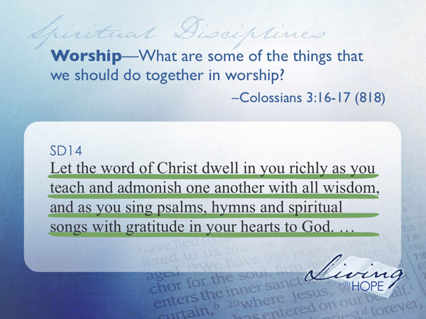
Let the word of Christ dwell in you richly as you teach and admonish one another with all wisdom, and as you sing psalms, hymns and spiritual songs with gratitude in your hearts to God.

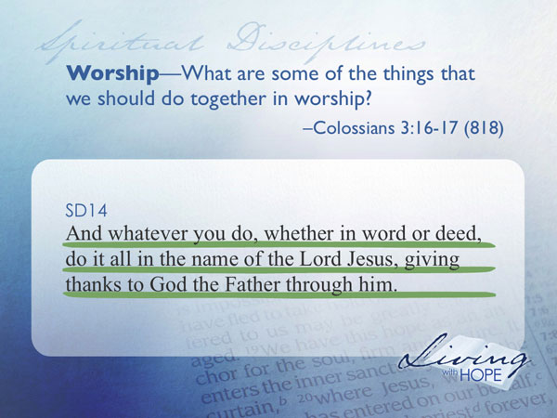
And whatever you do, whether in word or deed, do it all in the name of the Lord Jesus, giving thanks to God the Father through him.

It is very important that we come and celebrate together as God’s family. Worship means giving praise and honor together as brothers and sisters to the God who first created us and then recreated us in Jesus. Family worship allows our individual relationships with God to be affirmed and strengthened by the other members of our family.
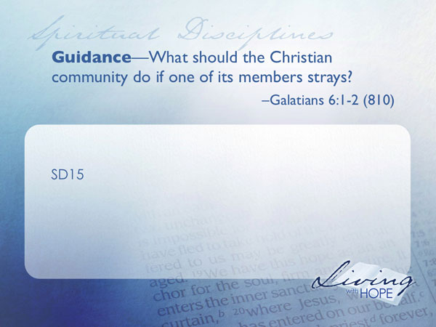
SD15 Guidance—What responsibility does the Christian community have if one of its members strays? Galatians 6:1-2 (810)

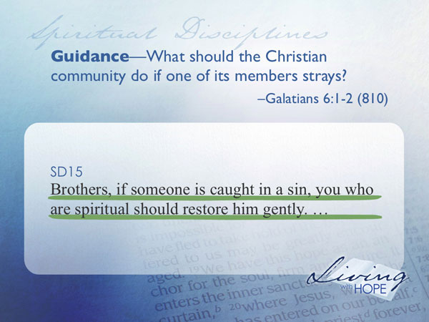

Brothers, if someone is caught in a sin, you who are spiritual should restore him gently.

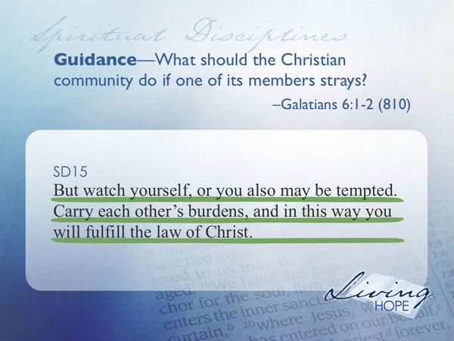
But watch yourself, or you also may be tempted. Carry each other's burdens, and in this way you will fulfill the law of Christ.

The discipline of guidance is not one we hear much of, perhaps because many religions have abused their powers in trying to control people. Nevertheless when we become part of the body of Christ we are stating that we desire a healthy family to gently restore us if we are headed off track. This is where we allow others to offer advice and guidance. Today’s society has become very individualistic. The corporate discipline of guidance gives permission for others to become involved in our lives.

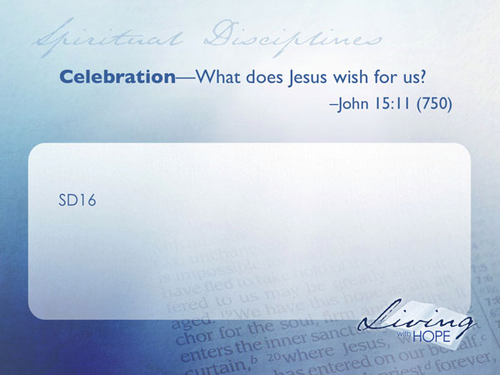
SD16 Celebration—What does Jesus wish for us? John 15:11 (750)

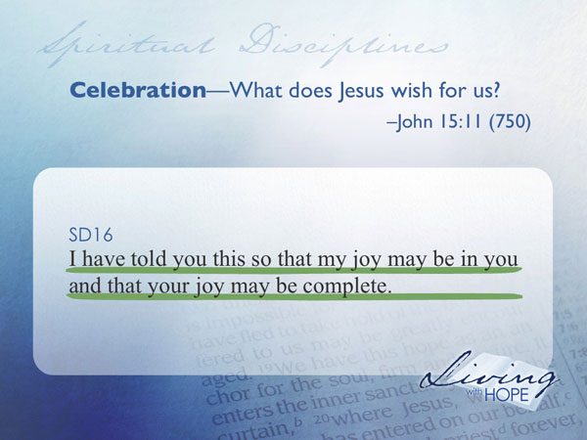
I have told you this so that my joy may be in you and that your joy may be complete.

Celebration is at the very heart of the way of Christ. In Luke 15, Jesus told three consecutive stories that ended with great celebration—that’s how important it is.

So how does celebration differ from worship? Worship includes celebration but also much more. Worship is a group of people giving to God His worth. Celebration is giving thanks in a group, celebrating life, expressing joy over what God has done but does not necessarily focus on God.

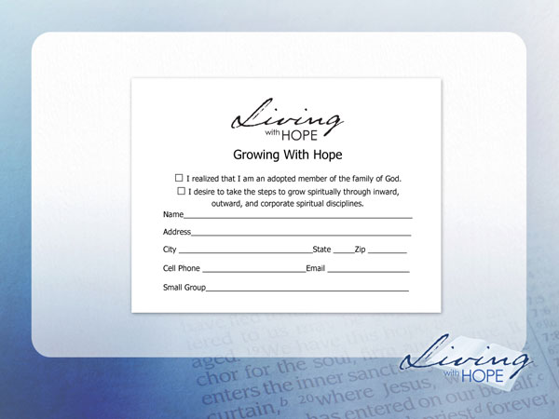
As we began this lesson we came to the understanding that we don’t have to grow in Christ to become a part of His family. Rather, because we are a part of His family we will desire to follow Him. As we grow we will begin to discover a new found freedom to live far beyond anything we could have imagined.

❑ I realize that I am an adopted member of the family of God.
❑ I desire to take the steps to grow spiritually through inward, outward, and corporate spiritual disciplines.
# # #

Craig Barnes is Professor of Leadership and Ministry at Pittsburgh Theological Seminary.
Richard Foster, Celebration of Discipline (San Francisco: HarperCollins, 1998).
While Richard Foster’s work relies heavily on pre-protestant Christian sources some recommended protestant books on the subject of spiritual disciplines include Spiritual Disciplines for the Christian Life by Donald S. Whitney (1991 NavPress) and Spiritual Disciplines within the Church by Donald S. Whitney (1996, Moody).
A slightly longer version is recorded in Matthew 6:9-13.
Richard Foster, 100
Galatians 6:2
A more complete listing of this belief is found in the eleventh fundamental belief of the Seventh-day Adventist Church entitled Growing In Christ. “By His death on the cross Jesus triumphed over the forces of evil. He who subjugated the demonic spirits during His earthly ministry has broken their power and made certain their ultimate doom. Jesus' victory gives us victory over the evil forces that still seek to control us, as we walk with Him in peace, joy, and assurance of His love. Now the Holy Spirit dwells within us and empowers us. Continually committed to Jesus as our Saviour and Lord, we are set free from the burden of our past deeds. No longer do we live in the darkness, fear of evil powers, ignorance, and meaninglessness of our former way of life. In this new freedom in Jesus, we are called to grow into the likeness of His character, communing with Him daily in prayer, feeding on His Word, meditating on it and on His providence, singing His praises, gathering together for worship, and participating in the mission of the Church. As we give ourselves in loving service to those around us and in witnessing to His salvation, His constant presence with us through the Spirit transforms every moment and every task into a spiritual experience. (Ps 1:1, 2; 23:4; 77:11, 12; Col 1:13, 14; 2:6, 14, 15; Luke 10:17-20; Eph 5:19, 20; 6:12-18; 1 Thess 5:23; 2 Peter 2:9; 3:18; 2 Cor. 3:17, 18; Phil 3:7-14; 1 Thess 5:16-18; Matt 20:25-28; John 20:21; Gal 5:22-25; Rom 8:38, 39; 1 John 4:4; Heb 10:25.)”

