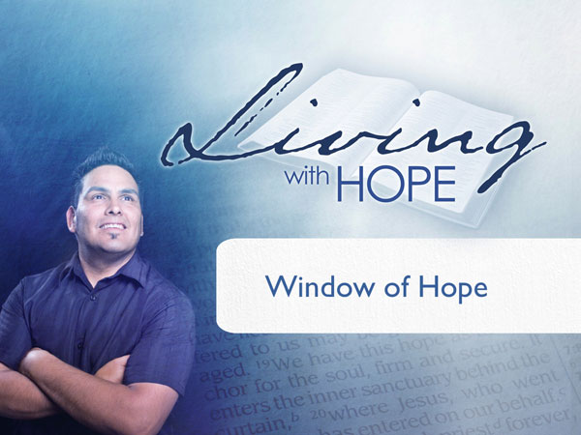
Living With Hope
Presentation 10: The Sanctuary
Window of Hope
Metaphor: Open Window

(Note: icon means “Next Slide,” indicating when to advance to the next slide.)

Rift
Sixteen year old Alex was ready to pick up his girl for a promised date. The only problem was that he didn’t have a car. The only car in the family belonged to his dad. The keys were on his dad’s dresser. His dad was taking a rest on the bed next to the dresser. Alex could have asked his father for permission to use the car for a date except for the fact that he had already abused his car privileges and was grounded for three weeks.

Alex quietly opened the door and eyed the keys on the dresser. Apparently the door squeaked enough to wake up dad. Their eyes met. Dad was big and strong—strong enough to tackle Alex and do some serious whooping on him. Alex was swift—swift enough to run faster than his dad.

Alex made a lighting fast decision. He grabbed the keys and bolted out of the bedroom, down the hall, out the front door. Heavy footsteps followed him as he flew out the door onto the street. He managed to get the car started just as his dad ran in front of the car. Rather than run him over, Alex threw the car into reverse and hit the accelerator. Tires squealed. Neighbors looked out their windows in time to see a grown man running down the street chasing his sixteen year old son who was driving in reverse.

Alex had difficulty enjoying the date that night because the only thing on his mind was how he was going to sneak into his bed without facing the wrath of his father. He wanted to come home but his heart surged with a mixture of pride and fear. What could he do to appease the wrath of his father? The stolen car was an earthquake in their relationship that left a chasm between them.

Fear and Appeasement
Relationships are broken and stressed when one person does something very hurtful and disappointing to the other party. It doesn’t matter what the relationship is, father/son, husband/wife, or God/man.
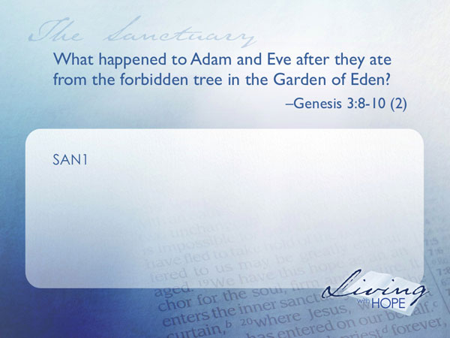
SAN1 What happened to Adam and Even after they ate from the forbidden tree in the Garden of Eden? Genesis 3:8-10 (2)

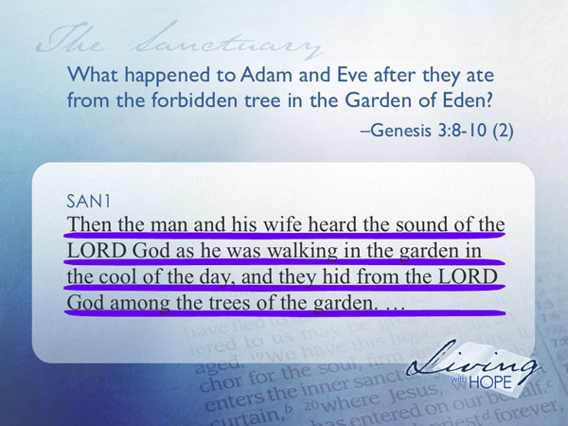
Then the man and his wife heard the sound of the LORD God as he was walking in the garden in the cool of the day, and they hid from the LORD God among the trees of the garden.
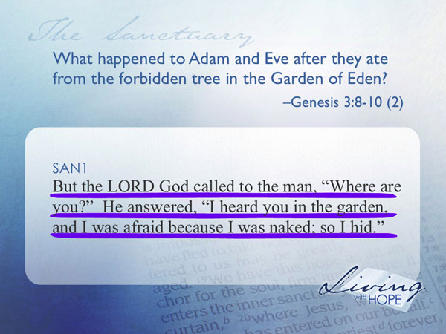
But the LORD God called to the man, "Where are you?" He answered, "I heard you in the garden, and I was afraid because I was naked; so I hid."
Adam and Eve were afraid of God because they had disobeyed him. Since that time mankind has been afraid of God and has tried to devise ways to appease Him. Human sacrifice intended to bring good fortune and to pacify the gods, has been practiced on a number of different occasions and in many different cultures. There is a Chinese legend that says there are thousands of people entombed in the Great Wall of China. An ancient Japanese legends talks about Hitobashira ("human pillar"), in which maidens were buried alive at the base or near some constructions as a prayer to ensure the buildings against disasters or enemy attacks. For the re-consecration of Great Pyramid of Tenochtilan in 1487, the Aztecs reported that they killed about 80,400 prisoners over the course of four days.

The ancient cultures of the eastern Mediterranean were punctuated with the practice of appeasing the gods through human sacrifice. When Abraham arrived in Canaan, he found temples erected on the hillsides with two compartments. The worship practice included sacrificing human children to appease the gods. The hope was that these children could serve as a substitute to take away the wrath of the gods.

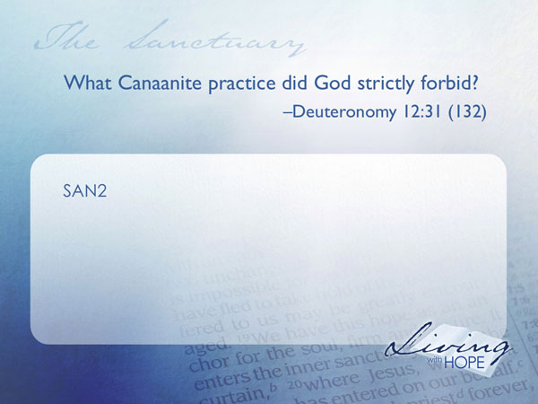
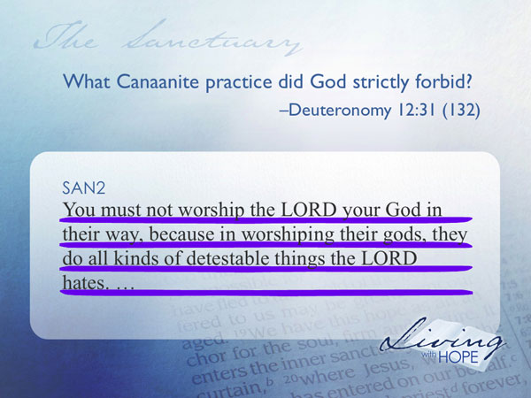
As the Jews entered Canaanite territory the Bible describes a religious sacrificial system that in many ways was similar to the background religious practices. The tabernacle had a holy and most holy place. Sacrifices were part of the religious practice. However there was a difference. In the Jewish system of sacrifices human sacrifice was explicitly forbidden.

SAN2 What Canaanite practice did God strictly forbid? Deuteronomy 12:31 (132)

You must not worship the LORD your God in their way, because in worshiping their gods, they do all kinds of detestable things the LORD hates.

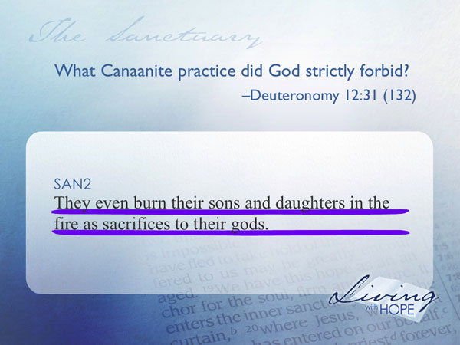
They even burn their sons and daughters in the fire as sacrifices to their gods.

The Sin Offering
The Jewish sacrificial system is outlined in the books of Exodus and Leviticus. There are many different kinds of offerings and sacrifices mentioned but never any human sacrifices.
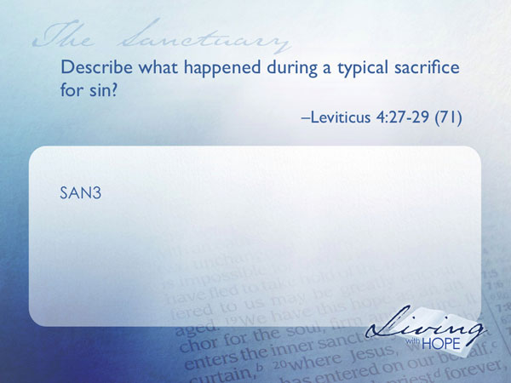
SAN3 Describe what happened during a typical sacrifice for sin? Leviticus 4:27-29 (71)

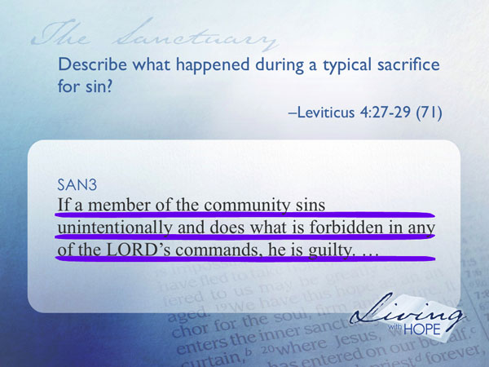
'If a member of the community sins unintentionally and does what is forbidden in any of the LORD's commands, he is guilty.

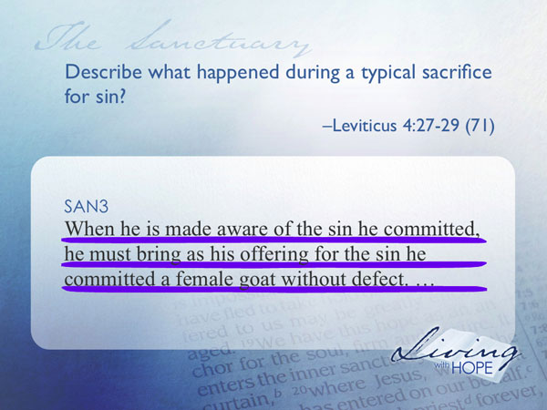
When he is made aware of the sin he committed, he must bring as his offering for the sin he committed a female goat without defect.

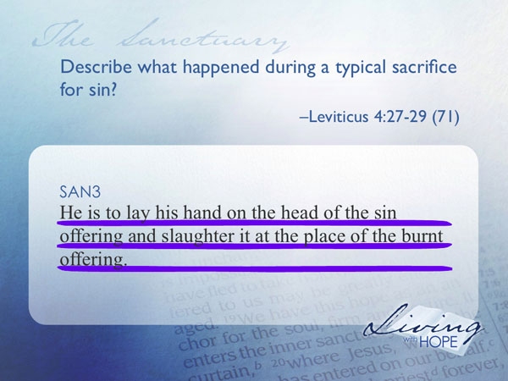
He is to lay his hand on the head of the sin offering and slaughter it at the place of the burnt offering.

For the modern reader the entire idea of animal sacrifice is horrific and primitive. Yet to be fair we have to take note that today’s society sacrifices far more animals for something far less significant. Estimates suggest that there are at least 10 billion chickens sacrificed each year in the United States for food. 32 million cattle are sacrificed each year to satisfy the American diet.

This ancient Jewish custom of animal sacrifice had far more significance than our daily slaughtering of animals for food. Imagine that you are the person who committed a sin. You are to bring a goat or a lamb, place your hand on the head of the lamb and then gently take the life of the animal. It was a powerful object lesson to show that there is a cost to sin.

The Murder of Gonzago
Have you ever read Shakespeare’s Hamlet? In the play, young Prince Hamlet’s father, the king, dies and Hamlet is told that the new king, Claudius, had murdered him with poison that made it look as if he died of natural causes. (The prince couldn’t quite call in Gil Grissom and Nike Stokes of CSI to analyze the crime scene and do an autopsy on the body, could he?) Hamlet is tormented. He wants revenge but isn’t sure what to do. He isn’t even sure that Claudius is the culprit.

So he devises a plan, not unlike the TV show “Lie to Me.” Some court actors are going to stage a play, called “The Murder of Gonzago,” before Claudius, in which the murder of his father is played out. Hamlet is going to watch very closely the reaction of Claudius for any signs of guilt, and if they are there, then he will have good reason to believe that Claudius was guilty. Hamlet’s ploy works, and a distraught Claudius—so upset at what he sees--leaves the play before it is finished.

Hamlet used the play to “catch the conscience of the king.” And, in a sense, the earthly sanctuary was to catch the conscience of the people. It was to show them that sin hurts. When someone sinned they were required to sacrifice a lamb, a goat, a sheep or a bullock. Although it was a humane sacrifice you can be sure that it would make an impression on the one performing the sacrifice. You would not take sin lightly. It was a sandbox illustration of what it takes to reconcile the broken relationship that started way back in the Garden of Eden when Adam and Eve hid after they had disobeyed.

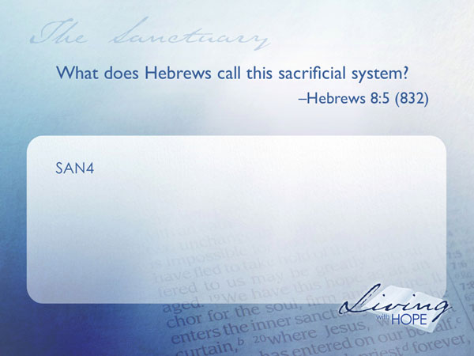
Model of Reconciliation
SAN4 What does Hebrews call this sacrificial system? Hebrews 8:5 (832)

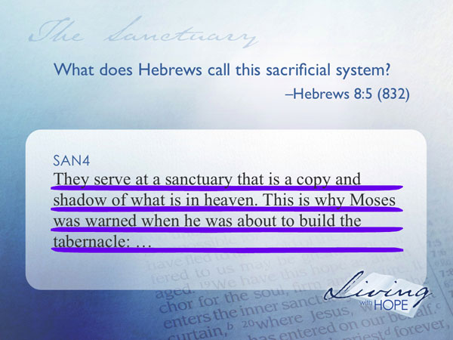
They serve at a sanctuary that is a copy and shadow of what is in heaven. This is why Moses was warned when he was about to build the tabernacle:

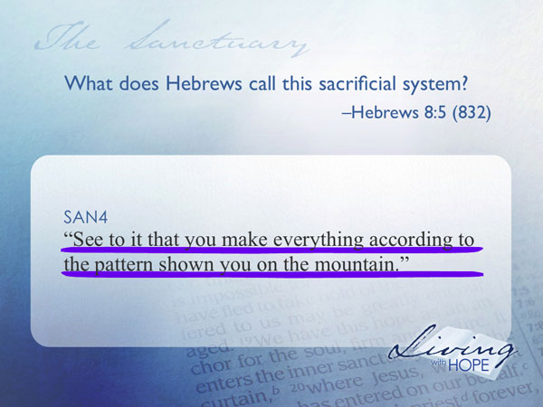
‘See to it that you make everything according to the pattern shown you on the mountain’”

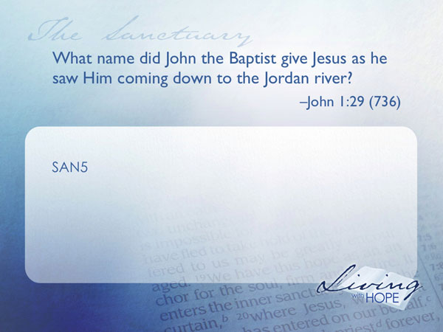
In other words, the Old Testament sanctuary/sacrificial system was an illustration of the great truth of heaven. Models are just that, models—they can’t perform the function of the real thing. They were not meant to. They are mere symbols of it. The Old Testament sacrificial system was only a model of a great heavenly sacrifice. In fact the meaning of the sacrificial system doesn’t really come alive until Jesus came on the scene.

SAN5 What name did John the Baptist give Jesus as he saw Him coming down to the Jordan river? John 1:29 (736)

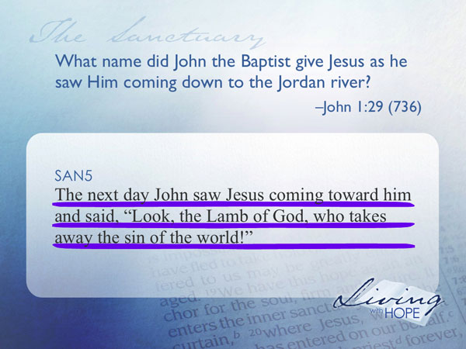
The next day John saw Jesus coming toward him and said, "Look, the Lamb of God, who takes away the sin of the world!

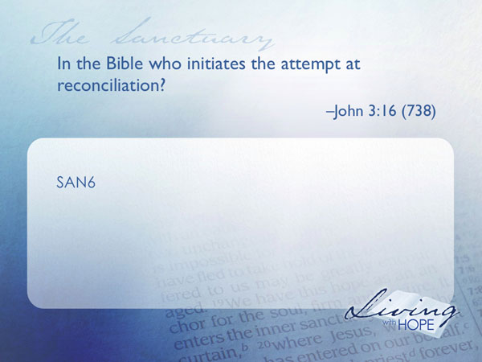
In the pagan culture a man was sacrificed to appease the gods. In the Bible God is sacrificed to appease mankind. In pagan culture it was mankind who initiated the attempt at reconciliation.

SAN6 In the Bible who initiates the attempt at reconciliation? John 3:16 (738)

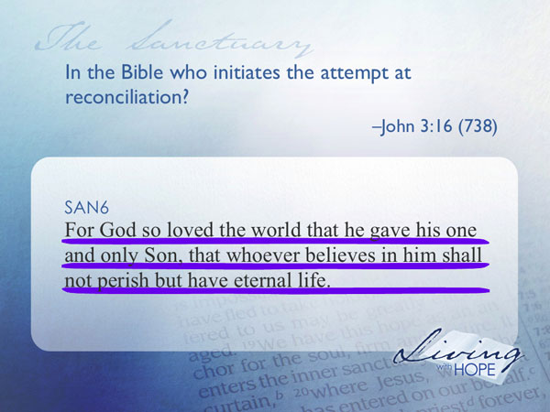
For God so loved the world that he gave his one and only Son,that whoever believes in him shall not perish but have eternal life.

“A Far, Far Better Thing . . . .”
Charles Dicken’s famous novel, A Tale of Two Cities, was set in the background of the French Revolution, or at least the phrase known as The Terror, in which state-inspired mob violence got so bad, with so many folks getting guillotined that the smell of blood, which literally flowed through the streets of Paris, caused a drop in the real estate market in the neighborhoods where the sentences were being carried out.

In Dicken’s tale, among those condemned was a young father named Charles Darnay, whose capital offense was that he belonged to an aristocratic family, a death sentence for many during The Terror.

But then came Sydney Carton, who in Dicken’s story was a lazy, alcoholic lawyer, totally detached and uninterested in anything about anyone, including himself, declaring basically that his life, his existence, was pretty much a waste.

However, by the story’s end, Sydney managed to switch places with Charles, so that Charles could escape and he, Sydney, would die in his stead.

Amid the mob hysteria, the switch went undetected. As the rabble was carrying Sydney down the street, they thought it was Charles. When they hurled insults, they thought it was Charles whom they were insulting. When the head was placed in the guillotine, they thought it was Charles’ head. When the blade fell and took his life, they thought it was Charles’ life they had taken.

“It is a far, far better thing that I do, than I have ever done” thought Charles just before the blade fell, “it is a far, far better rest that I go to than I have ever known.”

Of course, Dicken’s story was merely fiction, a made up tale, something that never happened, or certainly not just as Dicken’s story portrayed it. But what Dicken’s story does do is give a model, an example, in a small way of what the Bible teaches about Jesus and His death in our behalf.
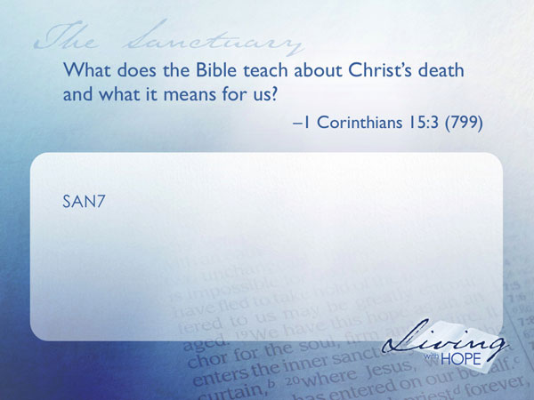

Carried Our Sorrows
SAN7 What does the Bible teach about Christ’s death and what it means for us? 1 Corinthians 15:3 (799)

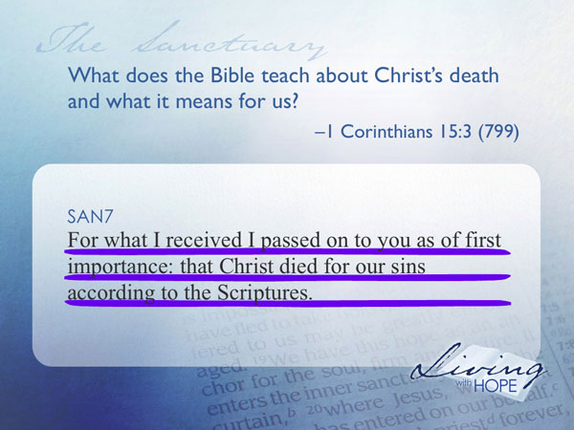
For what I received I passed on to you as of first importance: that Christ died for our sins according to the Scriptures.

Yes, Paul is clear here, and in other places as well: Jesus died for our sins. We are all sinners; we have all done wrong; we have all violated God’s law, and yet, despite all that, Christ died for us, taking upon Himself the punishment for our sins. It was sort of like what Sydney did for Charles, except for a major difference. It was one thing, Sydney dying for Charles because Charles, basically, did nothing wrong (other than have the wrong parents). But suppose Sydney died for Charles even if he knew that Charles was guilty of a crime and deserved death? That’s a whole other matter, isn’t it? And yet, that’s exactly Jesus did for us.

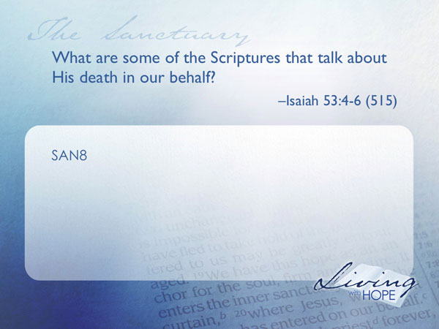
If you notice in the text above, it says that Christ died for our sins “according to the Scriptures.”

SAN8 What are some of the Scriptures that talk about His death in our behalf? Isaiah 53:4-6 (515)

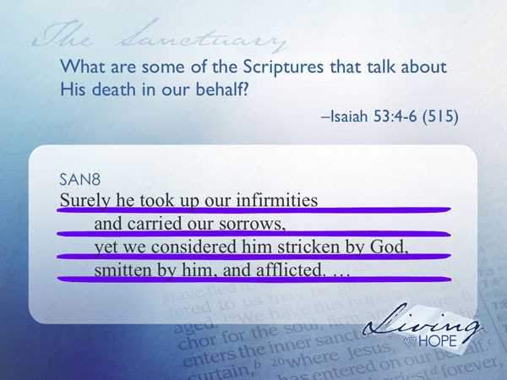
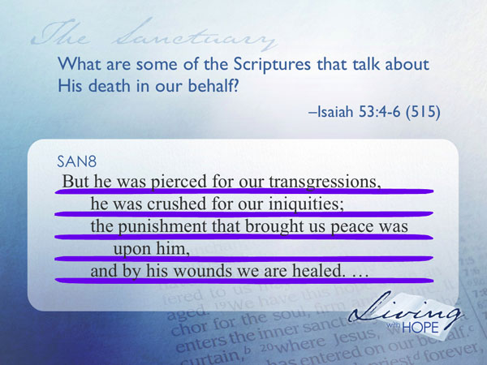
Surely he took up our infirmities
and carried our sorrows,
yet we considered him stricken by God,
smitten by him, and afflicted.
But he was pierced for our transgressions,
he was crushed for our iniquities;
the punishment that brought us peace was upon him, and by his wounds we are healed.
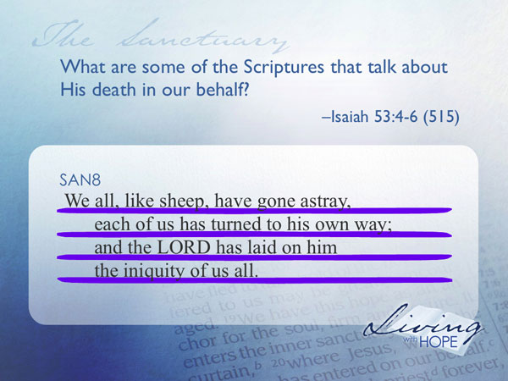
We all, like sheep, have gone astray,
each of us has turned to his own way;
and the LORD has laid on him
the iniquity of us all.

These texts in Isaiah, written about 700 years before Christ, are some of the most famous in all the Bible that dealt with Christ bearing our sins. The rest of the chapter makes it clear, too, that not only did He bear our sin and iniquity, He died in the process, the substitute who paid the penalty for us so that we don’t have to pay it ourselves.

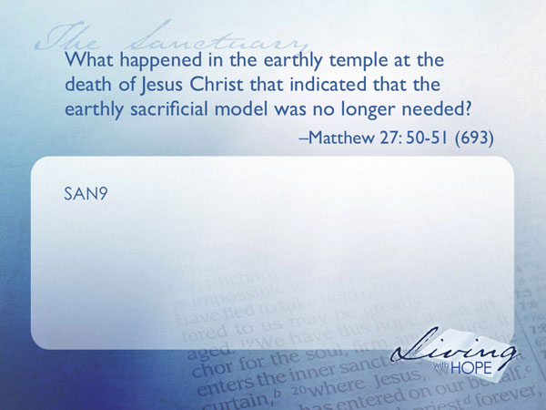
Model meets Original
SAN9 What happened in the earthly temple at the death of Jesus Christ that indicated that the earthly sacrificial model was no longer needed? Matthew 27: 50-51 (693)

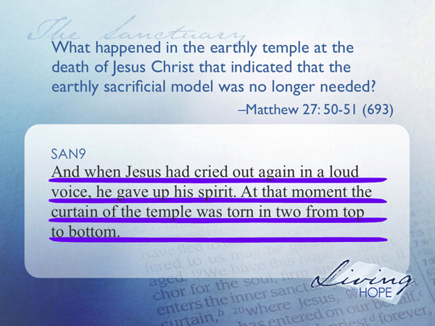
And when Jesus had cried out again in a loud voice, he gave up his spirit. At that moment the curtain of the temple was torn in two from top to bottom.

Matthew makes a special point to tell us that the curtain of the temple was torn. The sandbox illustration of reconciliation was no longer needed. Jesus was the Lamb of God; in fact Jesus was God, who sacrificed Himself in order to show how much He loved mankind. Yet there is even more meaning in the Old Testament sacrificial system.
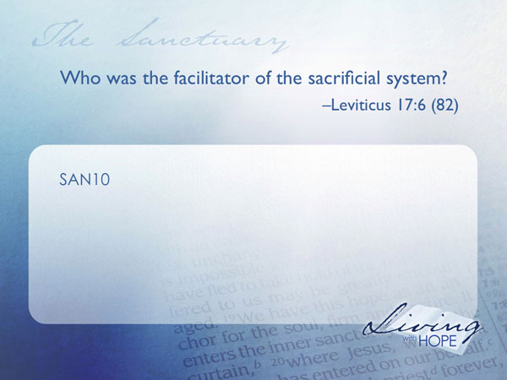
High Priest of Heaven
SAN10Who was the facilitator of the sacrificial system? Leviticus 17:6 (82)

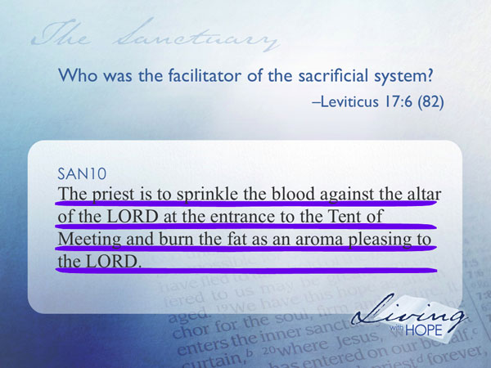
The priest is to sprinkle the blood against the altar of the LORD at the entrance to the Tent of Meeting and burn the fat as an aroma pleasing to the LORD.

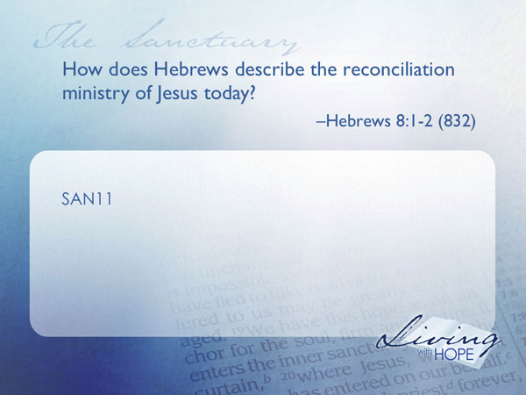
The sacrificial system was not a self-serve operation. The meaning was too rich for individuals alone to figure it out. The priest stood by to assist the person who desired to atone for sin. The priest prefigured the reconciliation assistance provided by Jesus Christ.

SAN11How does Hebrews describe the reconciliation ministry of Jesus today? Hebrews 8:1-2 (832)

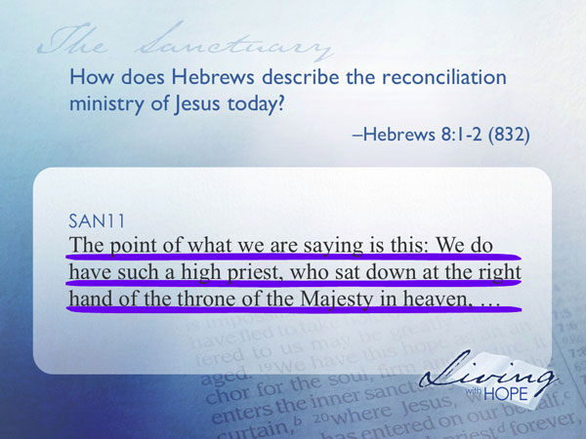
The point of what we are saying is this: We do have such a high priest, who sat down at the right hand of the throne of the Majesty in heaven,

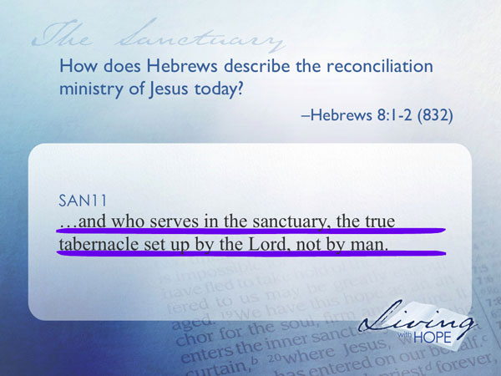
and who serves in the sanctuary, the true tabernacle set up by the Lord, not by man.

WIJD (What is Jesus Doing?)
Remember that fad of kids wearing a bracelet with the letters WWJD on it? What would Jesus do? Well, we need another one, with the letters WJID, standing for, What Jesus is doing. He stands by to assist us in reconciliation.
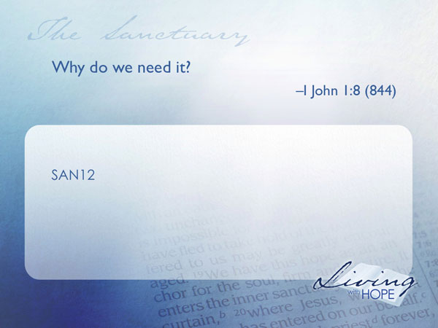
SAN12Why do we need it? I John 1:8 (844)

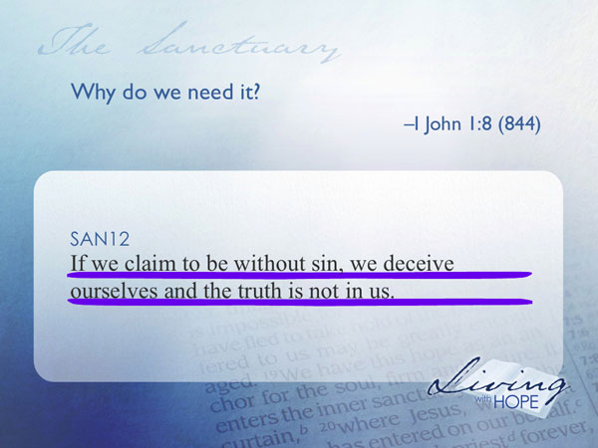
If we claim to be without sin, we deceive ourselves and the truth is not in us.

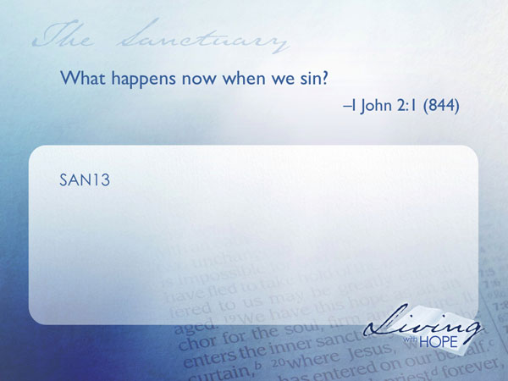
Yes, we are all sinners, and even after we come to Jesus, we still sometimes sin. But as Christians, we have no need to fear for our salvation, because we can go to Jesus, whose death supplied all the merits we ever need for salvation. And not only that, Jesus stands before the Father in our behalf, just as the high priest did in the earthly model. Only this isn’t a model. This is real.

SAN13What happens now when we sin? I John 2:1 (844)

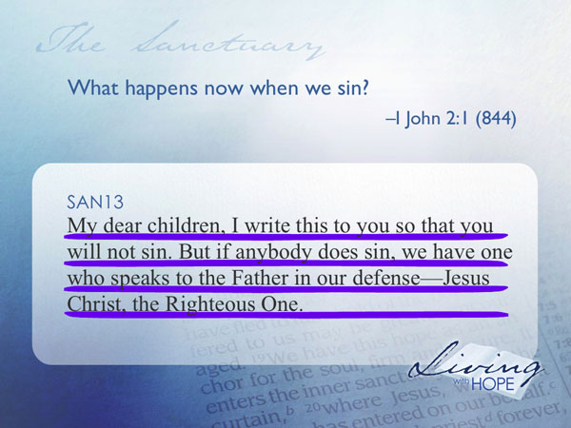
My dear children, I write this to you so that you will not sin. But if anybody does sin, we have one who speaks to the Father in our defense—Jesus Christ, the Righteous One.

Here, in a nutshell, is WJID. Jesus is our advocate with the Father. Jesus is our mediator with the Father. Jesus is our substitute before the Father. Thus, with Him being all these things “for us,” we can have assurance of salvation as long as we cling to Jesus to Him in faith, even after we fall.

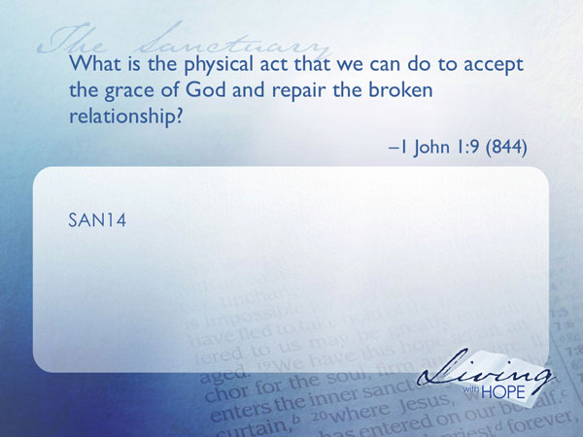
Even as the one who felt far away from God in the Old Testament could repair that relationship with the help of the a priest in performing the sacrifice so we in the New Testament can enlist the services of the Priest who is the Sacrifice, Jesus Christ to take us by the hand and bring us closer to the Father.

SAN14What is the physical act that we can do to accept the grace of God and repair the broken relationship? I John 1:9 (844)

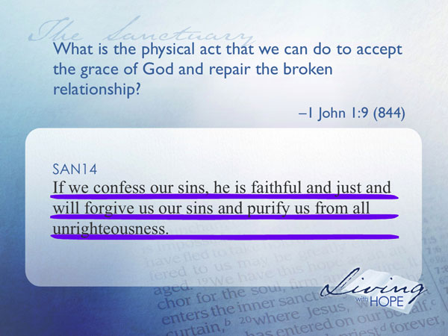
If we confess our sins, he is faithful and just and will forgive us our sins and purify us from all unrighteousness.

Sin is just as hard on our relationship with God as it was in the Old Testament. When we disobey God it makes it hard for us to want to be near Him. We feel distant and perhaps even afraid. God is offering to repair that relationship and has offered His life at the cross to show us how much he wants that relationship to be repaired.

Even as the penitent in the Old Testament placed their hands on the head of the sacrifice, we too can place our hands on the head of Jesus, confess our sins, and know that He has forgiven us. Confession breaks the ice, and takes away the barrier that we feel toward God.


As Alex drove around that night after stealing his dad’s car he didn’t know what to do. He was too proud (and too scared) to go home. But he loved and missed his family, and even his dad. So he parked the car quietly down the street. The lights of the house were all out. His plan was to sneak in the back window so no one would see him. But he remembered that he had taken off so quickly that he hadn’t had time to unlock and open the back window.
Nevertheless he crawled around the back of the house and was surprised to find the back window open. He quietly slipped in, gently slid under the covers and waited for the inevitable. All night he tossed and turned but nothing happened.

Finally morning came and his mom called the big family of nine for breakfast. Everyone was there, including dad. Usually if one of the kids got into trouble they would tease each other but not this time. Nothing was said. Not that day. Not for fifteen more years.

After Alex was grown and well into his career as a preacher he pulled his dad aside and started a conversation. “Dad, do you remember when…”

Dad knew exactly what he was talking about. “Yes son I remember…

“Why didn’t you do anything to punish me?”

“Son, said the dad, “I spent that night praying for you. I thought for sure that your pride was so big and your fear was so great after what you had done that you would never come home again. I just prayed that you would return and I even left the window open for you. And I’m so glad you came home.”

God could punish us for the sins that we commit but there is usually enough intrinsic punishment from the sin itself. He doesn’t need to do anymore. In fact He takes the consequences of sin on Himself, in order to leave the window of hope open for reconciliation. His greatest wish is that we can be one again, forever.

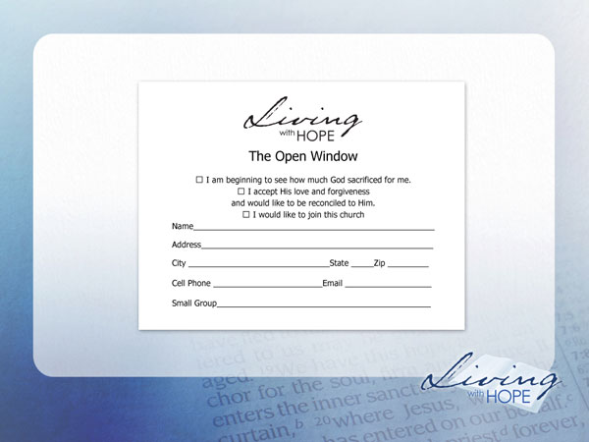
❑ I am beginning to see how much God sacrificed for me.
❑ I accept His love and forgiveness and would like to be reconciled to Him.
❑ I would like to join this church.

###

http://en.wikipedia.org/wiki/Human_sacrifice
http://www.claudemariottini.com/blog/2006/11/canaan-in-patriarchal-times-part-2.html
Here is the teaching of the Seventh-day Adventist Church: “There is a sanctuary in heaven, the true tabernacle which the Lord set up and not man. In it Christ ministers on our behalf, making available to believers the benefits of His atoning sacrifice offered once for all on the cross. He was inaugurated as our great High Priest and began His intercessory ministry at the time of His ascension. In 1844, at the end of the prophetic period of 2300 days, He entered the second and last phase of His atoning ministry. It is a work of investigative judgment which is part of the ultimate disposition of all sin, typified by the cleansing of the ancient Hebrew sanctuary on the Day of Atonement. In that typical service the sanctuary was cleansed with the blood of animal sacrifices, but the heavenly things are purified with the perfect sacrifice of the blood of Jesus. The investigative judgment reveals to heavenly intelligences who among the dead are asleep in Christ and therefore, in Him, are deemed worthy to have part in the first resurrection. It also makes manifest who among the living are abiding in Christ, keeping the commandments of God and the faith of Jesus, and in Him, therefore, are ready for translation into His everlasting kingdom. This judgment vindicates the justice of God in saving those who believe in Jesus. It declares that those who have remained loyal to God shall receive the kingdom. The completion of this ministry of Christ will mark the close of human probation before the Second Advent. (Heb. 8:1-5; 4:14-16; 9:11-28; 10:19-22; 1:3; 2:16, 17; Dan. 7:9-27; 8:13, 14; 9:24-27; Num. 14:34; Eze. 4:6; Lev. 16; Rev. 14:6, 7; 20:12; 14:12; 22:12.)”

